ANTENNA Q721E1XL
PERFORMANCES: (No loss condition)
TYPE | ELE | L (mm) | G (dBi) | F/B (dB) | F/Sh (dBi) | F/Sv (dBi) | Hor (◦) | Ver (◦) | Temp (◦K) | G/T (dB) | ΔF * (kHz)
Q721E1XL | 21 | 5675 | 18,38 | 43,10 | 19,85 | 18,74 | 24,6 | 25,1 | 18,1 | +5,80 | 6500
* ΔF given for SWR=1,5

PERFORMANCES: (Losses included)
Element material | G (dBi) | Temp (◦K) | G/T (dB)
Aluminum rods | 18,31 | 23,0 | +4,69
Silvered rods | 18,33 | 21,3 | +5,06

DIMENSIONS:
 | Ref | De | D1 | D2 | D3 | D4 | D5 | D6 | D7 | D8 | D9 | D10 | D11
Pos | 0 | 123 | 214 | 409 | 651 | 940 | 1231 | 1556 | 1859 | 2189 | 2483 | 2839 | 3145
Length | 245 | 223 | 215 | 205 | 196 | 190 | 184 | 180 | 178 | 175 | 171 | 167 | 163
 | D12 | D13 | D14 | D15 | D16 | D17 | D18 | D19 | - All elements made of Al rods Ǿ4 mm  - The height of all rectangles is 135 mm  - All dimensions given in milimetres
Pos | 3475 | 3812 | 4133 | 4462 | 4792 | 5098 | 5423 | 5675
Length | 159 | 156 | 156 | 156 | 152 | 152 | 152 | 152

COMPARISON
Antenna | Boomlength (mm) | Material | Gain (dBi) | TA (◦K) | G/T (dB) | Bandwidth  (MHz)
Q721E1XL | 5675 | No loss | 18,38 | 18,1 | +5,80 | 428,900-435,400
Q721E1XL | 5675 | Aluminum | 18,31 | 23,0 | +4,69 | 428,900-435,400
Q721E1XL | 5675 | Silver | 18,33 | 21,3 | +5,06 | 428,900-435,400
EF7021-5 | 5300 | No loss | 18,73 | 20,8 | +5,56 | 426,650-433,980
EF7021-5 | 5300 | Aluminum | 18,65 | 26,3 | +4,45 | 426,650-433,980
EF7021-5 | 5300 | Silver | 18,68 | 24,2 | +4,84 | 426,650-433,980

DIAGRAMS
NO LOSS INCLUDED
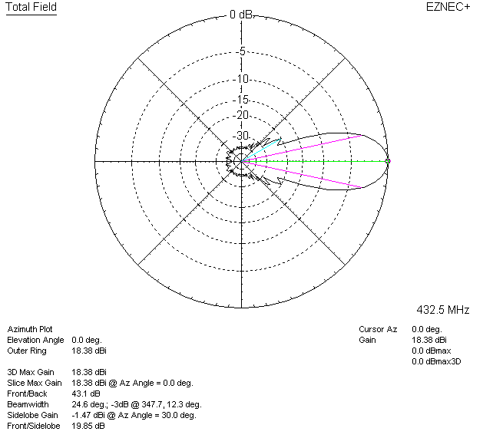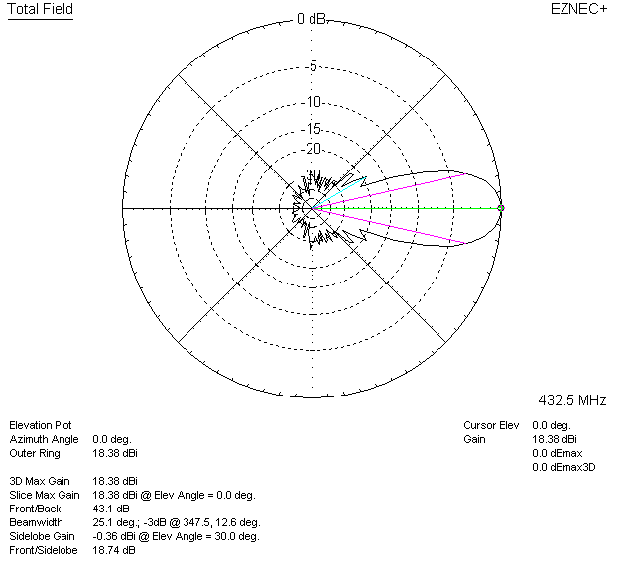

LOSSES INCLUDED (aluminum)
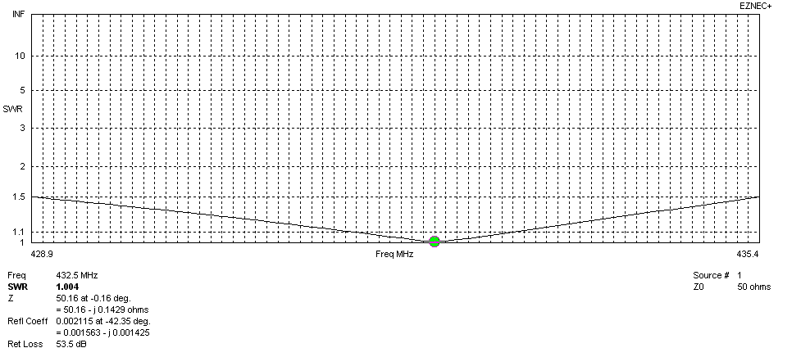
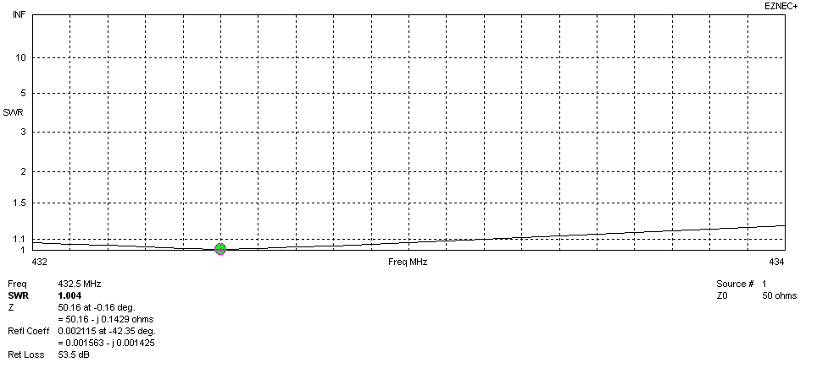
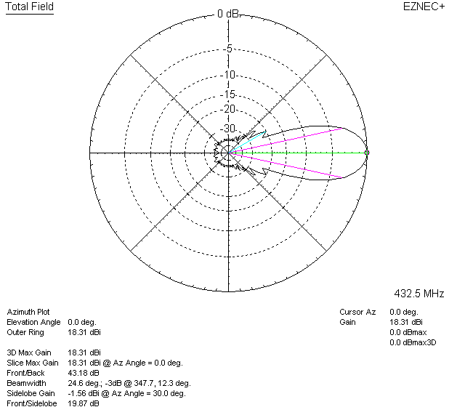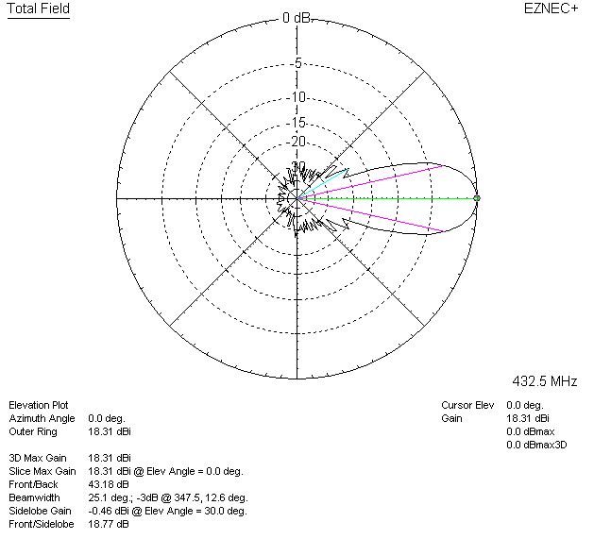

LOSSES INCLUDED (silver)
