ANTENNA Q721D9XL
PERFORMANCES: (No loss condition)
TYPE | ELE | L (mm) | G (dBi) | F/B (dB) | F/Sh (dBi) | F/Sv (dBi) | Hor (◦) | Ver (◦) | Temp (◦K) | G/T (dB) | ΔF * (kHz)
Q721D9XL | 21 | 5285 | 18,91 | 39,73 | 20,44 | 19,14 | 22,8 | 23,4 | 16,6 | +6,70 | 7250
* ΔF given for SWR=1,5

PERFORMANCES: (Losses included)
Element material | G (dBi) | Temp (◦K) | G/T (dB)
Aluminum rods | 18,87 | 19,3 | +6,01
Silvered rods | 18,89 | 18,3 | +6,26

DIMENSIONS:
 | Ref | De | D1 | D2 | D3 | D4 | D5 | D6 | D7 | D8 | D9 | D10 | D11 | D12
Pos | 0 | 120 | 200 | 351 | 484 | 691 | 939 | 1223 | 1519 | 1831 | 2139 | 2457 | 2769 | 3089
Length | 286 | 259 | 247 | 225 | 221 | 219 | 213 | 207 | 202 | 198 | 196 | 192 | 189 | 184
 | D13 | D14 | D15 | D16 | D17 | D18 | D19 | - All elements made of Al rods Ǿ10,0 mm  - The height of all rectangles is 100 mm  - All dimensions given in milimetres
Pos | 3416 | 3734 | 4065 | 4378 | 4706 | 5023 | 5285
Length | 182 | 180 | 178 | 176 | 174 | 172 | 170

COMPARISON
Antenna | Boomlength (mm) | Material | Gain (dBi) | TA (◦K) | G/T (dB) | Bandwidth  (MHz)
Q721D9XL | 5285 | No loss | 18,91 | 16,6 | +6,70 | 427,600-434,850
Q721D9XL | 5285 | Aluminum | 18,87 | 19,3 | +6,01 | 427,600-434,850
Q721D9XL | 5285 | Silver | 18,89 | 18,3 | +6,26 | 427,600-434,850
EF7021-5 | 5300 | No loss | 18,73 | 20,8 | +5,56 | 426,650-433,980
EF7021-5 | 5300 | Aluminum | 18,65 | 26,3 | +4,45 | 426,650-433,980
EF7021-5 | 5300 | Silver | 18,68 | 24,2 | +4,84 | 426,650-433,980

DIAGRAMS
NO LOSS INCLUDED
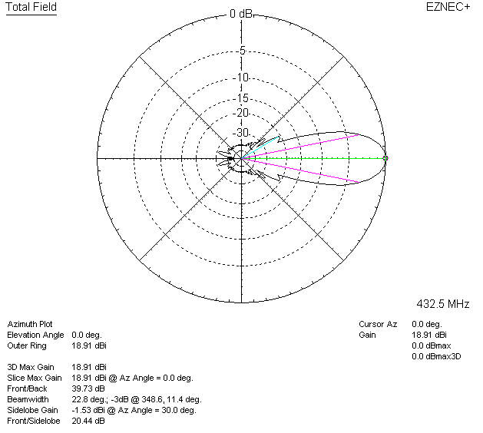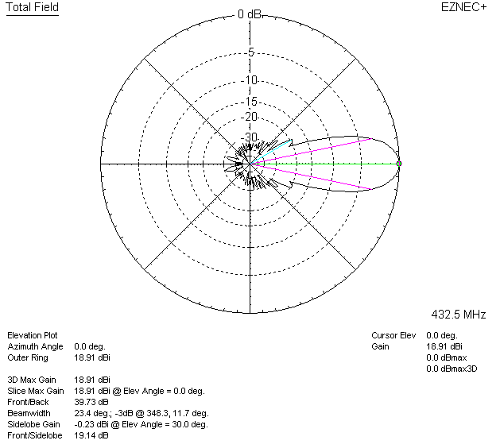

LOSSES INCLUDED (aluminum)
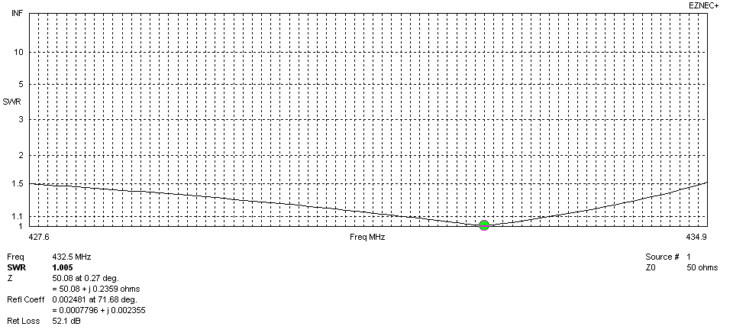
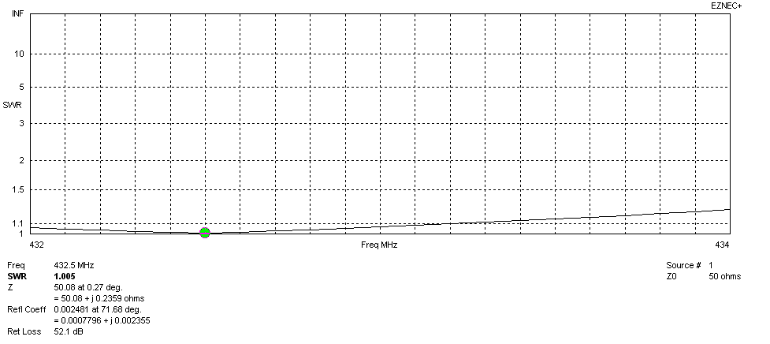
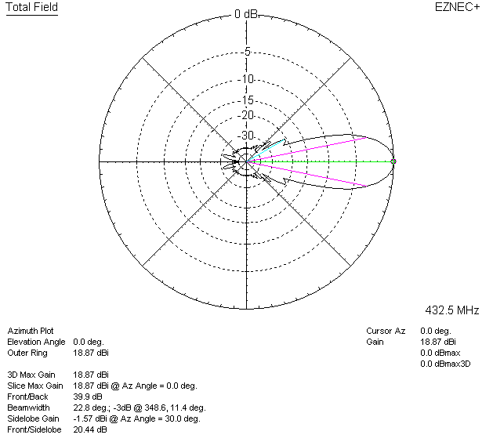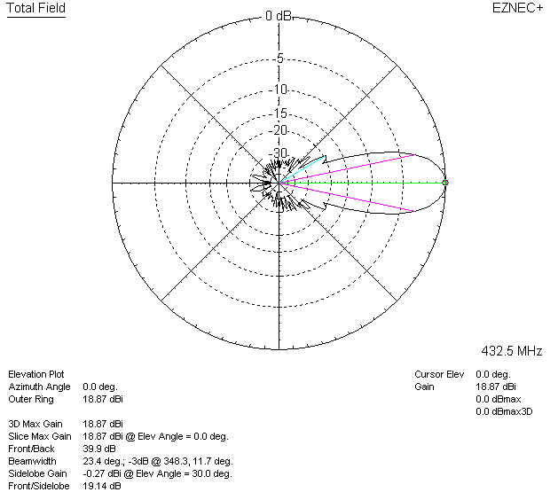
LOSSES INCLUDED (silver)
