ANTENNA Q721D7XL
PERFORMANCES: (No loss condition)
TYPE | ELE | L (mm) | G (dBi) | F/B (dB) | F/Sh (dBi) | F/Sv (dBi) | Hor (◦) | Ver (◦) | Temp (◦K) | G/T (dB) | ΔF * (kHz)
Q721D7XL | 21 | 5305 | 19,07 | 26,15 | 18,24 | 17,17 | 21,8 | 22,4 | 17,8 | +6,57 | 5600
* ΔF given for SWR=1,5

PERFORMANCES: (Losses included)
Element material | G (dBi) | Temp (◦K) | G/T (dB)
Aluminum rods | 19,01 | 21,3 | +5,72
Silvered rods | 19,03 | 20,0 | +6,02

DIMENSIONS:
 | Ref | De | D1 | D2 | D3 | D4 | D5 | D6 | D7 | D8 | D9 | D10 | D11 | D12
Pos | 0 | 121 | 194 | 351 | 486 | 689 | 938 | 1226 | 1525 | 1828 | 2136 | 2454 | 2769 | 3088
Length | 283 | 261 | 247 | 227 | 224 | 221 | 215 | 209 | 205 | 202 | 198 | 196 | 194 | 192
 | D13 | D14 | D15 | D16 | D17 | D18 | D19 | - All elements made of Al rods Ǿ8,0 mm  - The height of all rectangles is 100 mm  - All dimensions given in milimetres
Pos | 3405 | 3727 | 4055 | 4374 | 4703 | 5021 | 5305
Length | 190 | 186 | 182 | 181 | 179 | 178 | 177

COMPARISON
Antenna | Boomlength (mm) | Material | Gain (dBi) | TA (◦K) | G/T (dB) | Bandwidth  (MHz)
Q721D7XL | 5305 | No loss | 19,07 | 17,8 | +6,57 | 428,700-434,300
Q721D7XL | 5305 | Aluminum | 19,01 | 21,3 | +5,72 | 428,700-434,300
Q721D7XL | 5305 | Silver | 19,03 | 20,0 | +6,02 | 428,700-434,300
EF7021-5 | 5300 | No loss | 18,73 | 20,8 | +5,56 | 426,650-433,980
EF7021-5 | 5300 | Aluminum | 18,65 | 26,3 | +4,45 | 426,650-433,980
EF7021-5 | 5300 | Silver | 18,68 | 24,2 | +4,84 | 426,650-433,980

DIAGRAMS
NO LOSS INCLUDED
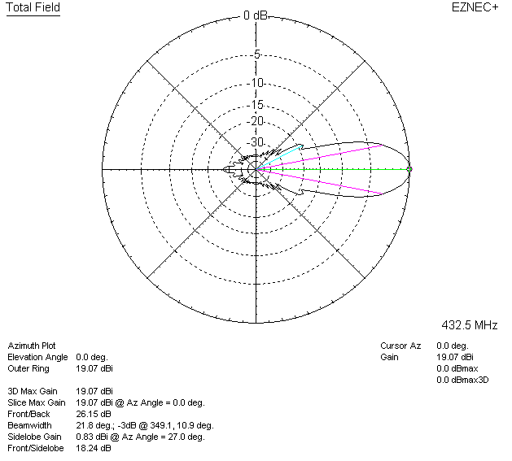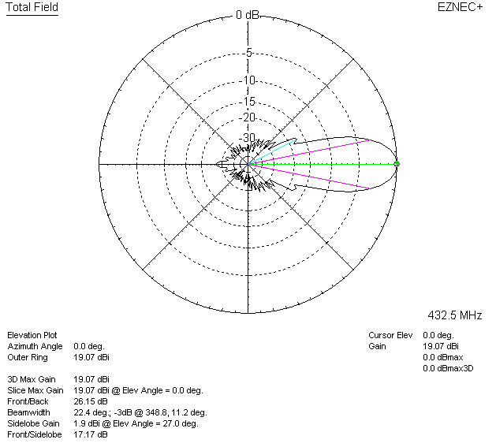

LOSSES INCLUDED (aluminum)
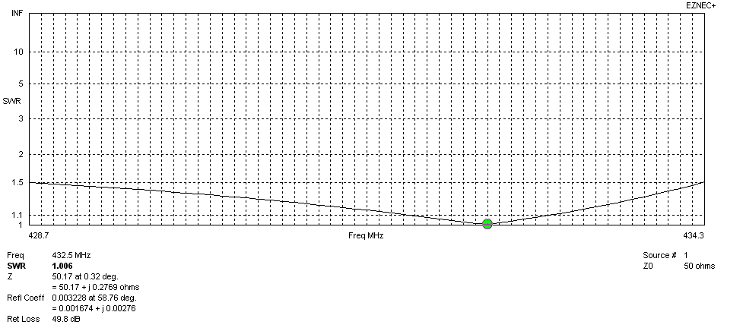
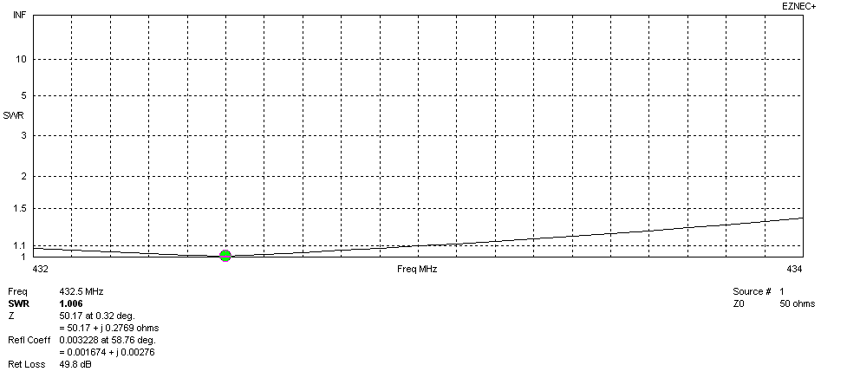
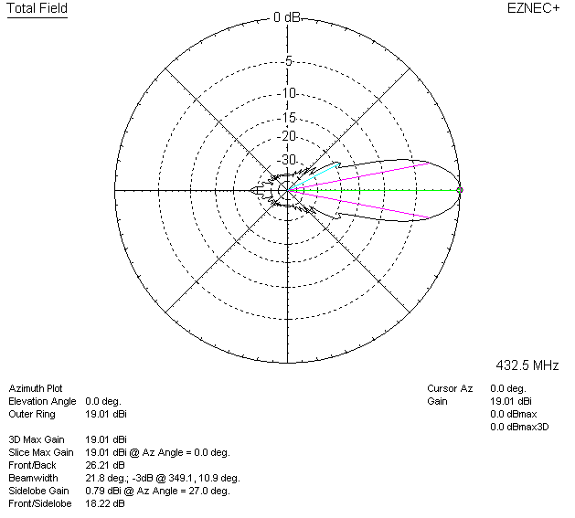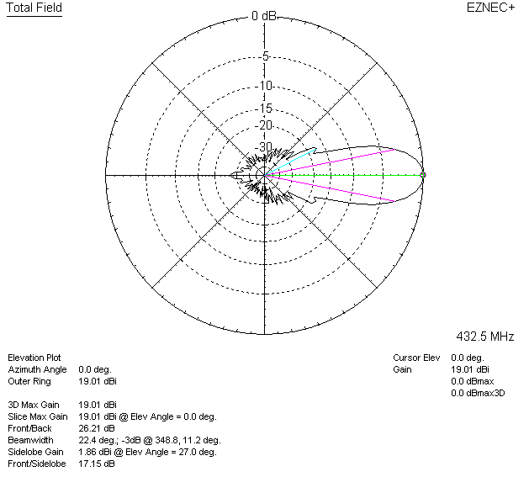

LOSSES INCLUDED (silver)
