ANTENNA Q721D4XL
PERFORMANCES: (No loss condition)
TYPE | ELE | L (mm) | G (dBi) | F/B (dB) | F/Sh (dBi) | F/Sv (dBi) | Hor  (◦) | Ver  (◦) | Temp (◦K) | G/T (dB) | ΔF * (kHz)
Q721D4XL | 21 | 5205 | 18,45 | 33,91 | 22,84 | 21,53 | 24,6 | 25,2 | 16,4 | +6,29 | 7000
* ΔF given for SWR=1,5

PERFORMANCES: (Losses included)
Element material | G (dBi) | Temp (◦K) | G/T (dB)
Aluminum rods | 18,39 | 20,6 | +5,26
Silvered rods | 18,41 | 19,1 | +5,60

DIMENSIONS:
 | Ref | De | D1 | D2 | D3 | D4 | D5 | D6 | D7 | D8 | D9 | D10 | D11
Pos | 0 | 118 | 169 | 298 | 482 | 682 | 916 | 1188 | 1481 | 1784 | 2093 | 2403 | 2720
Length | 279 | 255 | 245 | 234 | 225 | 220 | 216 | 212 | 206 | 202 | 199 | 194 | 190
 | D12 | D13 | D14 | D15 | D16 | D17 | D18 | D19 | - All elements made of Al rods Ǿ5 mm  - The height of all rectangles is 100 mm  - All dimensions given in milimetres
Pos | 3038 | 3363 | 3673 | 4009 | 4312 | 4635 | 4945 | 5205
Length | 187 | 183 | 181 | 179 | 177 | 175 | 173 | 172

COMPARISON
Antenna | Boomlength (mm) | Material | Gain (dBi) | TA (◦K) | G/T (dB) | Bandwidth  (MHz)
Q721D4XL | 5805 | No loss | 18,45 | 16,4 | +6,29 | 428,800-435,600
Q721D4XL | 5805 | Aluminum | 18,39 | 20,6 | +5,26 | 428,800-435,600
Q721D4XL | 5805 | Silver | 18,41 | 19,1 | +5,60 | 428,800-435,600
EF7021-5 | 5300 | No loss | 18,73 | 20,8 | +5,56 | 426,650-433,980
EF7021-5 | 5300 | Aluminum | 18,65 | 26,3 | +4,45 | 426,650-433,980
EF7021-5 | 5300 | Silver | 18,68 | 24,2 | +4,84 | 426,650-433,980

DIAGRAMS
NO LOSS INCLUDED
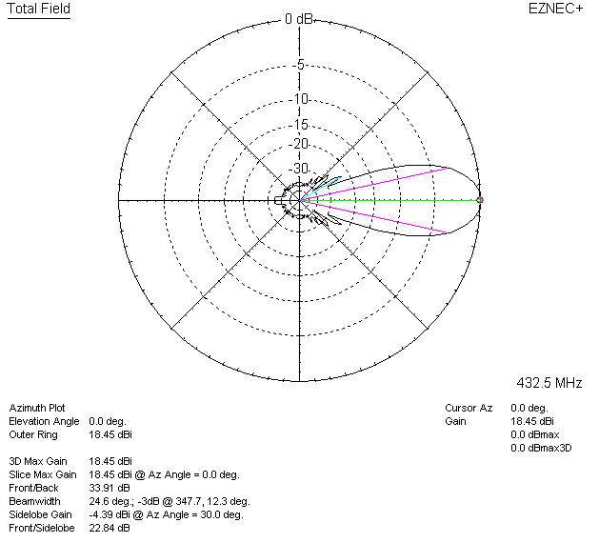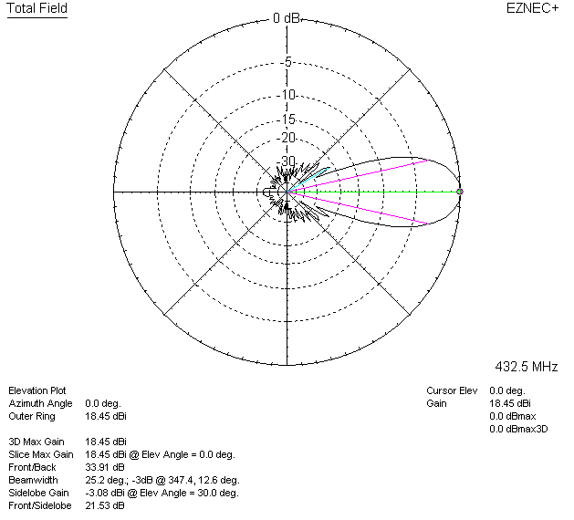

LOSSES INCLUDED (aluminum)
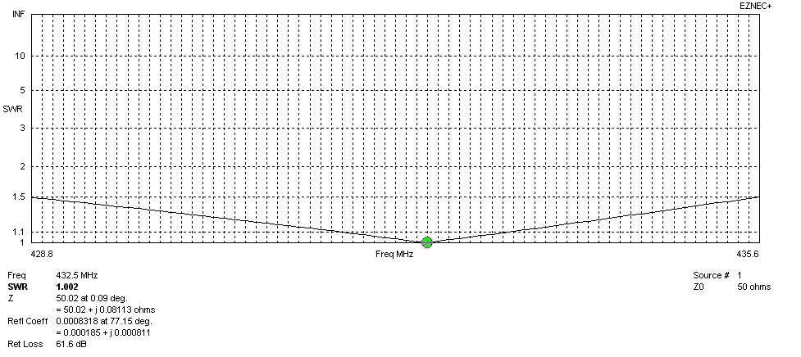
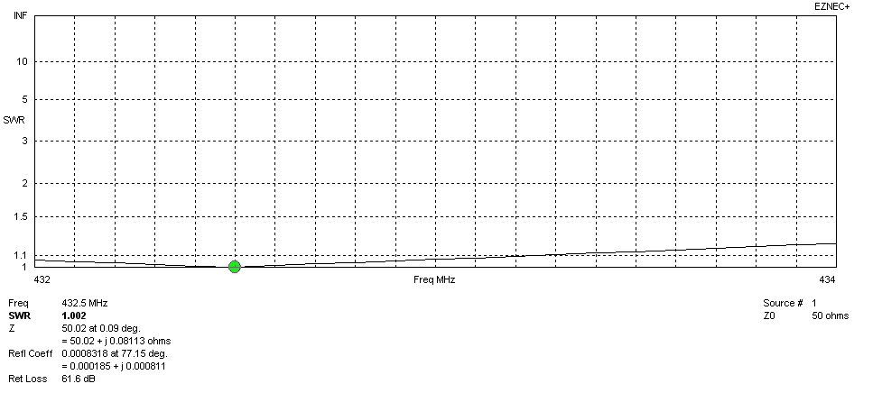
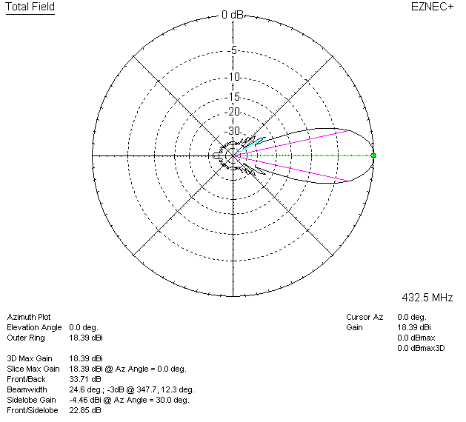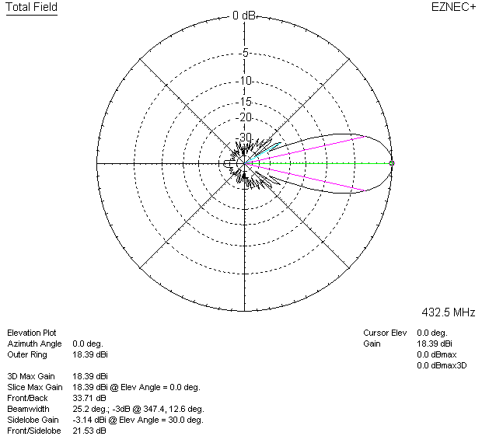

LOSSES INCLUDED (silver)
