ANTENNA Q720B1XL
PERFORMANCES: (No loss condition)
TYPE | ELE | L (mm) | G (dBi) | F/B (dB) | F/Sh (dBi) | F/Sv (dBi) | Hor (◦) | Ver (◦) | Temp (◦K) | G/T (dB) | ΔF * (kHz)
Q720B1XL | 20 | 4990 | 18,58 | 26,18 | 20,23 | 18,67 | 23,8 | 24,6 | 18,2 | +5,98 | 2830
* ΔF given for SWR=1,5

PERFORMANCES: (Losses included)
Element material | G (dBi) | Temp (◦K) | G/T (dB)
Aluminum rods | 18,52 | 22,3 | +5,05
Silvered rods | 18,54 | 20,7 | +5,37

DIMENSIONS:
 | Ref | De | D1 | D2 | D3 | D4 | D5 | D6 | D7 | D8 | D9 | D10
Pos | 0 | 156 | 222 | 333 | 481 | 687 | 936 | 1207 | 1510 | 1809 | 2125 | 2450
Length | 314 | 292 | 287 | 263 | 262 | 256 | 251 | 246 | 241 | 237 | 232 | 229
 | D11 | D12 | D13 | D14 | D15 | D16 | D17 | D18 | - All elements made of Al rods Ǿ5 mm  - The height of all rectangles is 46 mm  - All dimensions given in milimetres
Pos | 2766 | 3088 | 3411 | 3747 | 4059 | 4375 | 4715 | 4990
Length | 227 | 224 | 222 | 219 | 217 | 213 | 210 | 208

COMPARISON
Antenna | Boomlength (mm) | Material | Gain (dBi) | TA (◦K) | G/T (dB) | Bandwidth  (MHz)
Q720B1XL | 4990 | No loss | 18,58 | 18,2 | +5,98 | 430,660-433,490
Q720B1XL | 4990 | Aluminum | 18,52 | 22,3 | +5,05 | 430,660-433,490
Q720B1XL | 4990 | Silver | 18,54 | 20,7 | +5,37 | 430,660-433,490
EF7021-5 | 5300 | No loss | 18,73 | 20,8 | +5,56 | 426,650-433,980
EF7021-5 | 5300 | Aluminum | 18,65 | 26,3 | +4,45 | 426,650-433,980
EF7021-5 | 5300 | Silver | 18,68 | 24,2 | +4,84 | 426,650-433,980

DIAGRAMS
NO LOSS INCLUDED
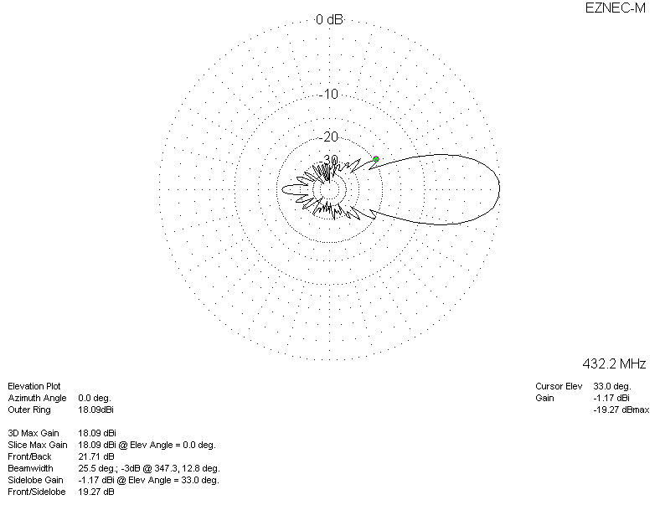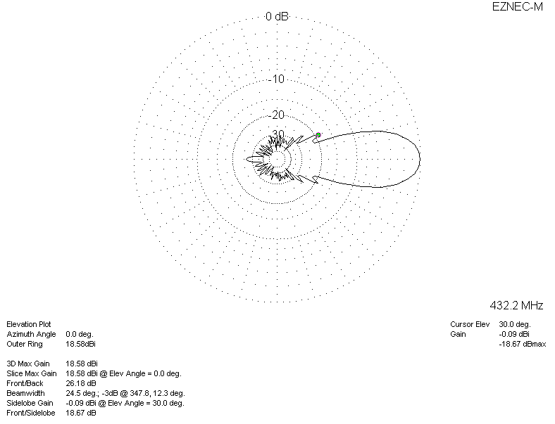

LOSSES INCLUDED (aluminum)
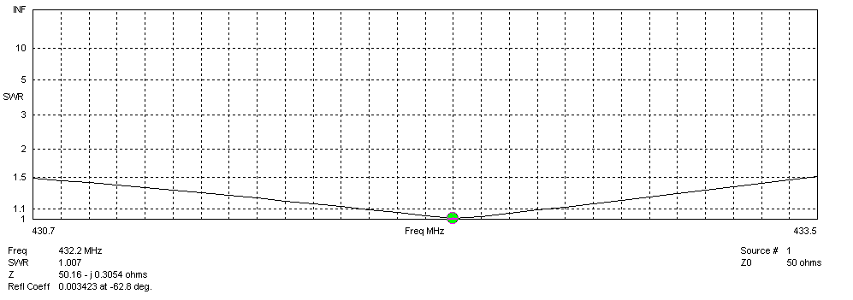
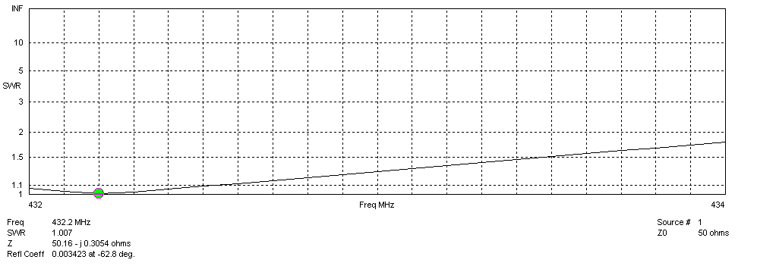
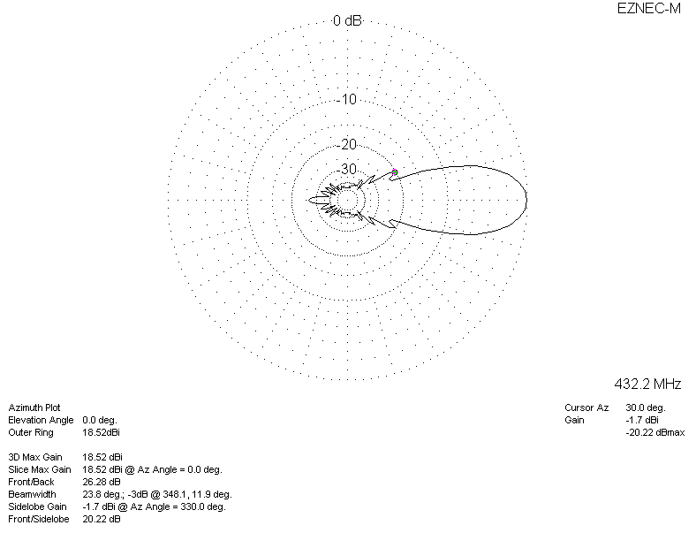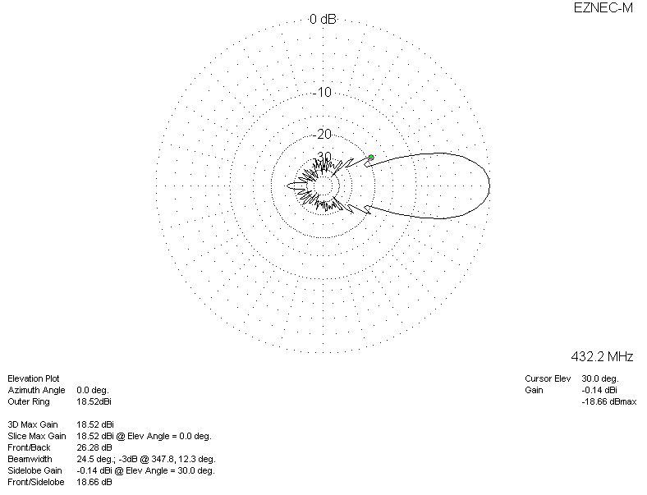

LOSSES INCLUDED (silver)
