ANTENNA Q719D4XL
PERFORMANCES: (No loss condition)
TYPE | ELE | L (mm) | G (dBi) | F/B (dB) | F/Sh (dBi) | F/Sv (dBi) | Hor (◦) | Ver (◦) | Temp (◦K) | G/T (dB) | ΔF * (kHz)
Q719D4XL | 19 | 4575 | 18,07 | 39,40 | 22,53 | 20,97 | 25,4 | 26,2 | 16,9 | +5,79 | 6450
* ΔF given for SWR=1,5

PERFORMANCES: (Losses included)
Element material | G (dBi) | Temp (◦K) | G/T (dB)
Aluminum rods | 18,01 | 21,1 | +4,77
Silvered rods | 18,03 | 19,6 | +5,12

DIMENSIONS:
 | Ref | De | D1 | D2 | D3 | D4 | D5 | D6 | D7 | D8 | D9 | D10
Pos | 0 | 117 | 169 | 298 | 481 | 684 | 918 | 1192 | 1485 | 1787 | 2096 | 2409
Length | 279 | 255 | 245 | 235 | 226 | 221 | 215 | 212 | 206 | 202 | 199 | 194
 | D11 | D12 | D13 | D14 | D15 | D16 | D17 | - All elements made of Al rods Ǿ5,0 mm  - The height of all rectangles is 100 mm  - All dimensions given in milimetres
Pos | 2719 | 3048 | 3368 | 3665 | 4016 | 4312 | 4575
Length | 190 | 187 | 183 | 181 | 178 | 176 | 175

COMPARISON
Antenna | Boomlength (mm) | Material | Gain (dBi) | TA (◦K) | G/T (dB) | Bandwidth  (MHz)
Q719D4XL | 4575 | No loss | 18,07 | 16,9 | +5,79 | 428,900-435,350
Q719D4XL | 4575 | Aluminum | 18,01 | 21,1 | +4,77 | 428,900-435,350
Q719D4XL | 4575 | Silver | 18,03 | 19,6 | +5,12 | 428,900-435,350
EF7019-5 | 4692 | No loss | 18,21 | 20,4 | +5,11 | 429,700-433,800
EF7019-5 | 4692 | Aluminum | 18,12 | 26,0 | +3,98 | 429,700-433,800
EF7019-5 | 4692 | Silver | 18,16 | 23,9 | +4,38 | 429,700-433,800

DIAGRAMS
NO LOSS INCLUDED
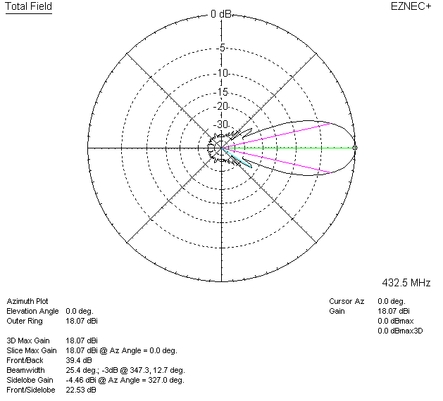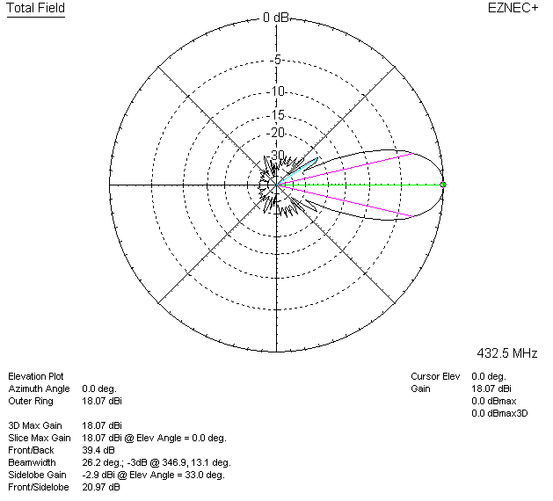

LOSSES INCLUDED (aluminum)
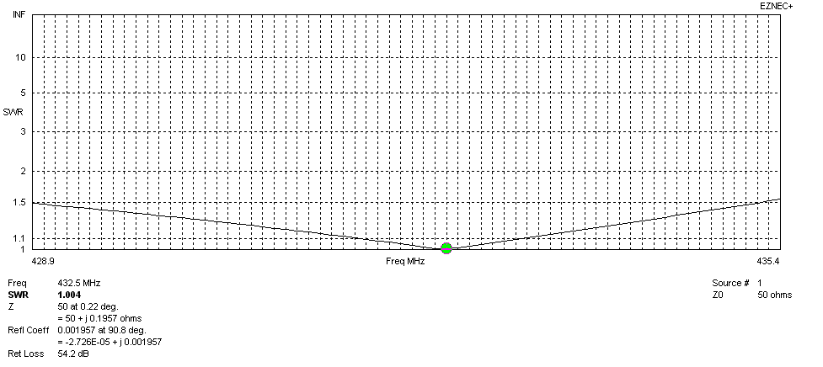
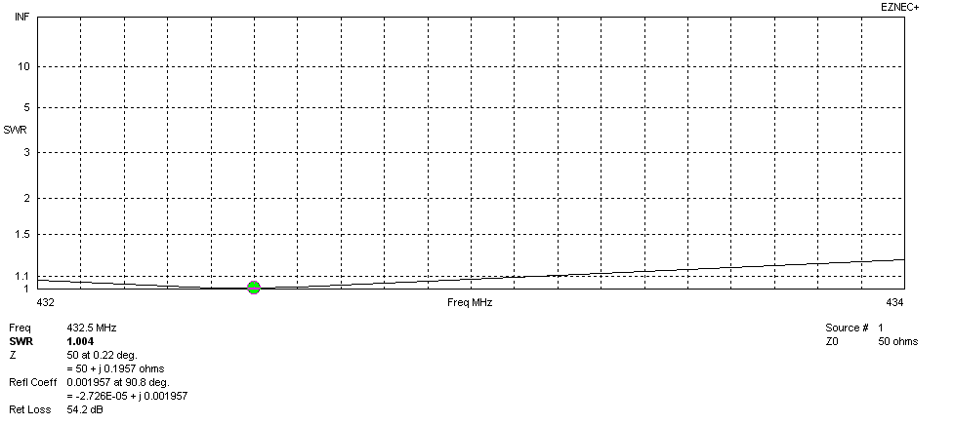
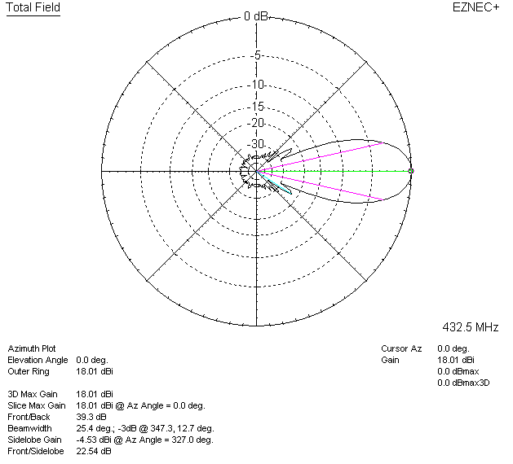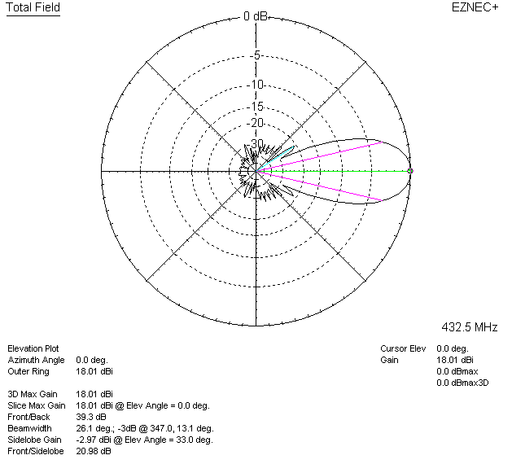

LOSSES INCLUDED (silver)
