ANTENNA Q718D4XL
PERFORMANCES: (No loss condition)
TYPE | ELE | L (mm) | G (dBi) | F/B (dB) | F/Sh (dBi) | F/Sv (dBi) | Hor (◦) | Ver (◦) | Temp (◦K) | G/T (dB) | ΔF * (kHz)
Q718D4XL | 18 | 4715 | 17,86 | 38,83 | 21,77 | 20,20 | 25,8 | 26,7 | 17,1 | +5,54 | 6150
* ΔF given for SWR=1,5

PERFORMANCES: (Losses included)
Element material | G (dBi) | Temp (◦K) | G/T (dB)
Aluminum rods | 17,80 | 21,3 | +4,51
Silvered rods | 17,82 | 19,7 | +4,87

DIMENSIONS:
 | Ref |  | De |  | D1 |  | D2 | D3 | D4 | D5 | D6 | D7 | D8 | D9 | D10
Pos | 0 |  | 117 |  | 168 |  | 298 | 481 | 684 | 918 | 1192 | 1485 | 1787 | 2096 | 2409
Length | 279 |  | 235 |  | 245 |  | 235 | 226 | 221 | 215 | 212 | 206 | 202 | 199 | 194
 |  | D11 |  | D12 |  | D13 | D14 | D15 | D16 | - All elements made of Al rods Ǿ5,0 mm  - The height of all rectangles is 100 mm  - All dimensions given in milimetres
Pos |  | 2719 |  | 3048 |  | 3365 | 3659 | 4006 | 4258
Length |  | 190 |  | 187 |  | 183 | 181 | 178 | 175

COMPARISON
Antenna | Boomlength (mm) | Material | Gain (dBi) | TA (◦K) | G/T (dB) | Bandwidth  (MHz)
Q718D4XL | 4715 | No loss | 17,86 | 17,1 | +5,54 | 429,000-435,150
Q718D4XL | 4715 | Aluminum | 17,80 | 21,3 | +4,51 | 429,000-435,150
Q718D4XL | 4715 | Silver | 17,82 | 19,7 | +4,87 | 429,000-435,150
EF7018-5 | 4373 | No loss | 18,05 | 21,4 | +4,75 | 430,600-433,600
EF7018-5 | 4373 | Aluminum | 17,96 | 27,3 | +3,60 | 430,600-433,600
EF7018-5 | 4373 | Silver | 18,00 | 25,1 | +4,00 | 430,600-433,600

DIAGRAMS
NO LOSS INCLUDED

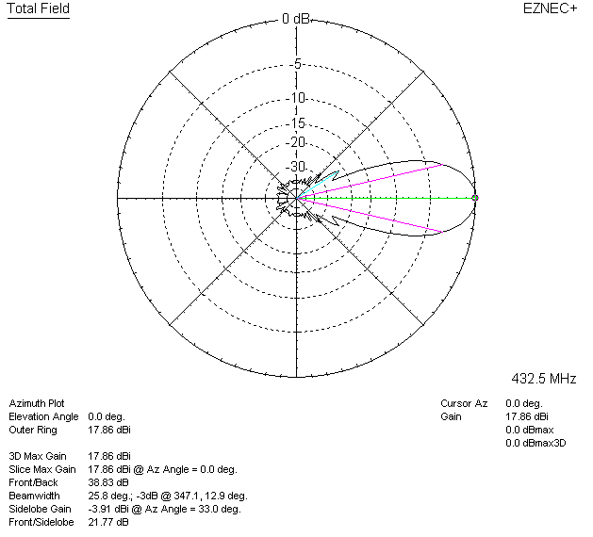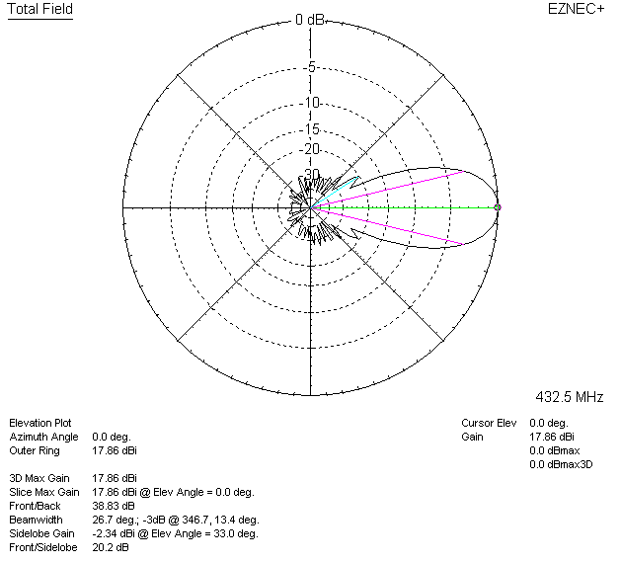

LOSSES INCLUDED (aluminum)
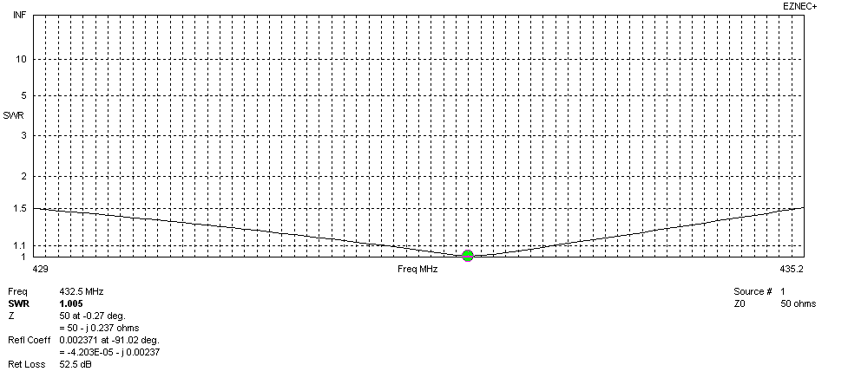
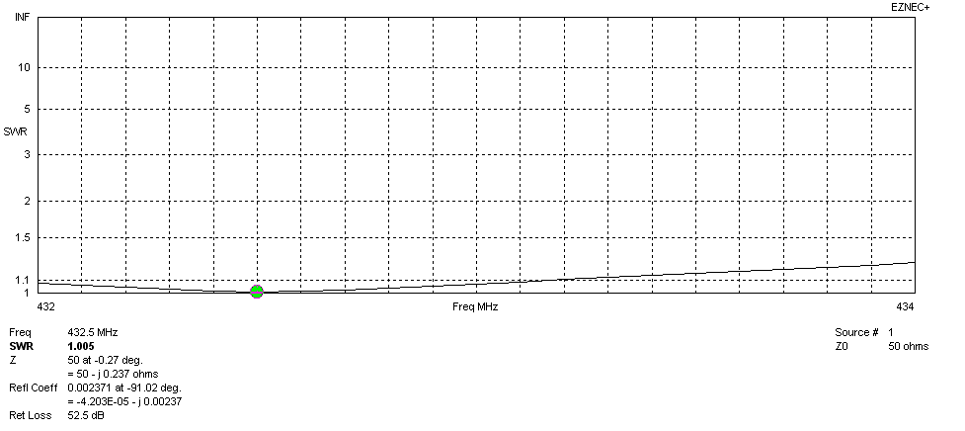
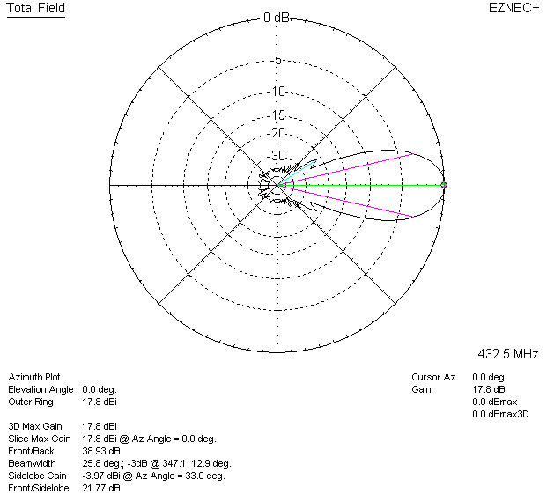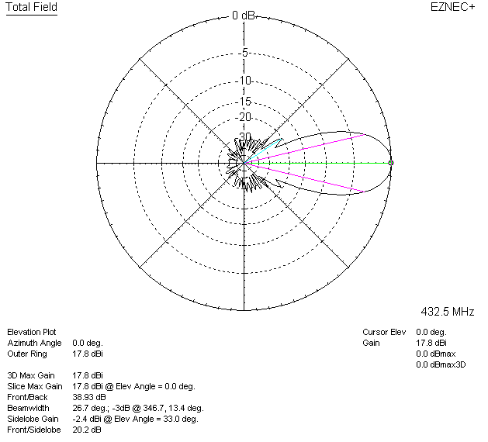

LOSSES INCLUDED (silver)
