ANTENNA Q717D9XL
PERFORMANCES: (No loss condition)
TYPE | ELE | L (mm) | G (dBi) | F/B (dB) | F/Sh (dBi) | F/Sv (dBi) | Hor (◦) | Ver (◦) | Temp (◦K) | G/T (dB) | ΔF * (kHz)
Q717D9XL | 17 | 4005 | 17,96 | 23,71 | 19,52 | 17,94 | 25,0 | 25,8 | 18,7 | +5,25 | 7220
* ΔF given for SWR=1,5

PERFORMANCES: (Losses included)
Element material | G (dBi) | Temp (◦K) | G/T (dB)
Aluminum rods | 17,93 | 21,1 | +4,69
Silvered rods | 17,94 | 20,2 | +4,89

DIMENSIONS:
 | Ref | De | D1 | D2 | D3 | D4 | D5 | D6 | D7 | D8 | D9 | D10 | D11 | D12
Pos | 0 | 120 | 199 | 352 | 484 | 691 | 939 | 1223 | 1519 | 1831 | 2139 | 2456 | 2769 | 3089
Length | 285 | 259 | 246 | 224 | 222 | 219 | 213 | 206 | 201 | 196 | 193 | 191 | 189 | 184
 | D13 | D14 | D15 | - All elements made of Al rods Ǿ10,0 mm  - The height of all rectangles is 100 mm  - All dimensions given in milimetres
Pos | 3416 | 3713 | 4005
Length | 182 | 180 | 178

COMPARISON
Antenna | Boomlength (mm) | Material | Gain (dBi) | TA (◦K) | G/T (dB) | Bandwidth  (MHz)
Q717D9XL | 4005 | No loss | 17,96 | 18,7 | +5,25 | 428,850-434,940
Q717D9XL | 4005 | Aluminum | 17,93 | 21,1 | +4,69 | 428,850-434,940
Q717D9XL | 4005 | Silver | 17,94 | 20,2 | +4,89 | 428,850-434,940
EF7017-5 | 4130 | No loss | 17,64 | 21,20 | +4,37 | 429,700-433,620
EF7017-5 | 4130 | Aluminum | 17,55 | 27,0 | +3,24 | 429,700-433,620
EF7017-5 | 4130 | Silver | 17,58 | 24,8 | +3,63 | 429,700-433,620

DIAGRAMS
NO LOSS INCLUDED

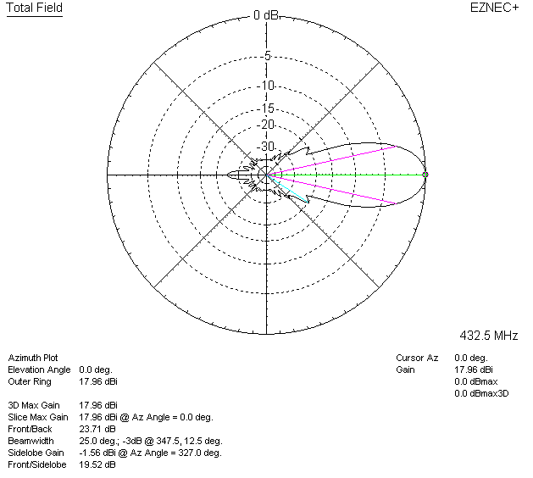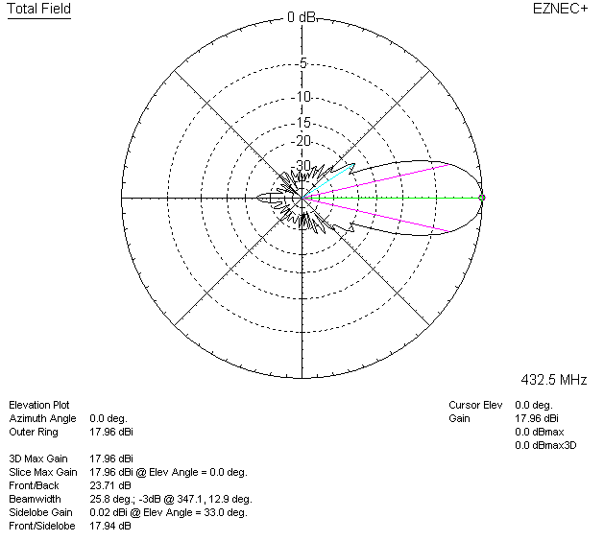

LOSSES INCLUDED (aluminum)
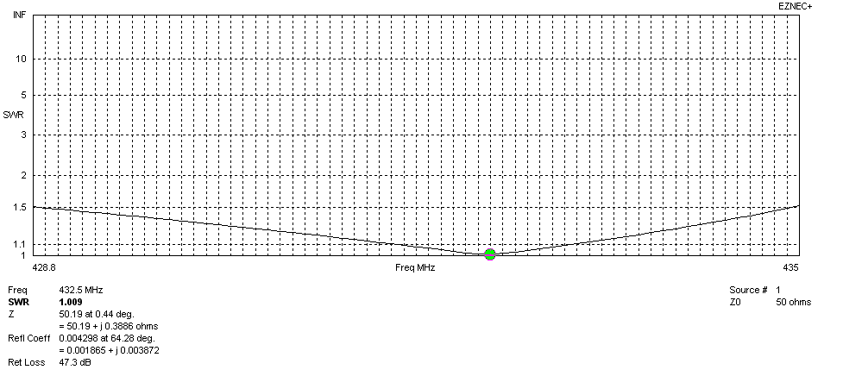
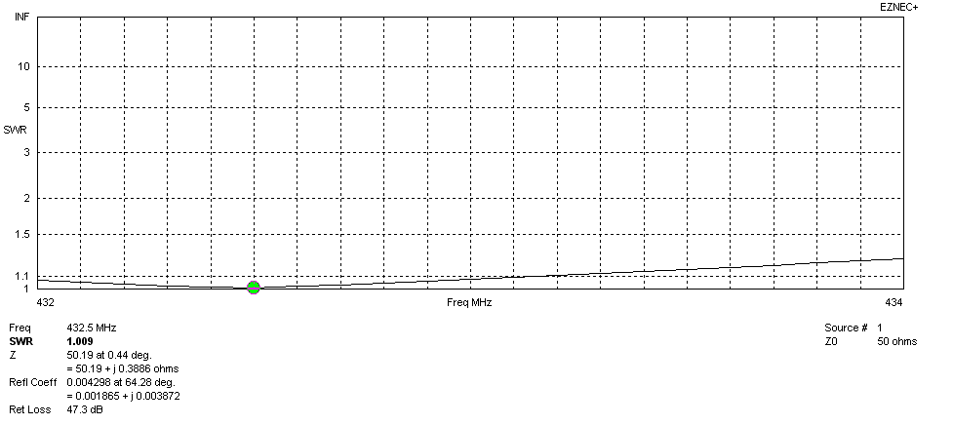
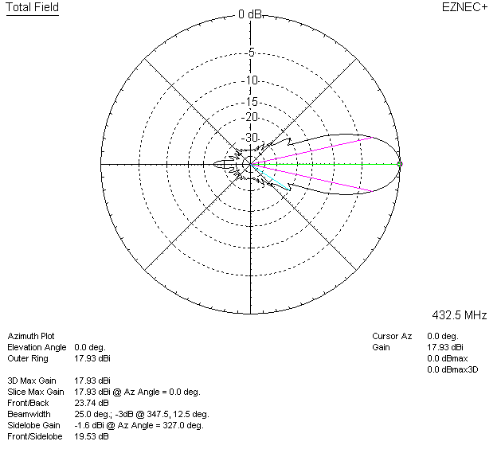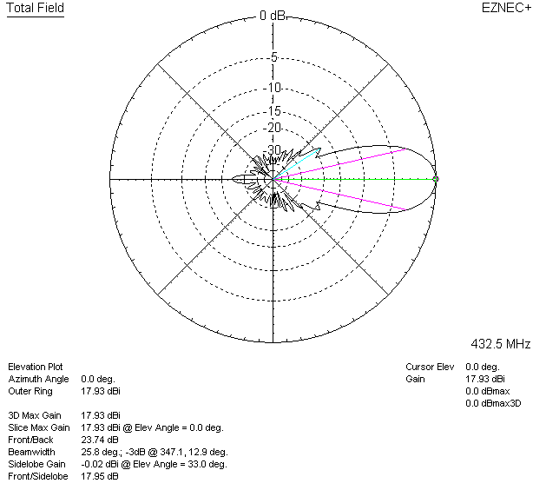

LOSSES INCLUDED (silver)
