ANTENNA Q717D4XL
PERFORMANCES: (No loss condition)
TYPE | ELE | L (mm) | G (dBi) | F/B (dB) | F/Sh (dBi) | F/Sv (dBi) | Hor (◦) | Ver (◦) | Temp (◦K) | G/T (dB) | ΔF * (kHz)
Q717D4XL | 17 | 3940 | 17,66 | 41,80 | 21,20 | 19,64 | 26,2 | 27,2 | 17,8 | +5,17 | 5450
* ΔF given for SWR=1,5

PERFORMANCES: (Losses included)
Element material | G (dBi) | Temp (◦K) | G/T (dB)
Aluminum rods | 17,60 | 21,8 | +4,21
Silvered rods | 17,62 | 20,3 | +4,55

DIMENSIONS:
 | Ref | De | D1 | D2 | D3 | D4 | D5 | D6 | D7 | D8 | D9
Pos | 0 | 117 | 171 | 299 | 483 | 685 | 919 | 1191 | 1485 | 1790 | 2096
Length | 280 | 253 | 243 | 234 | 225 | 220 | 216 | 212 | 206 | 202 | 199
 | D10 | D11 | D12 | D13 | D14 | D15 | - All elements made of Al rods Ǿ5.0 mm  - The height of all rectangles is 100 mm  - All dimensions given in milimetres
Pos | 2407 | 2719 | 3046 | 3363 | 3550 | 3940
Length | 194 | 190 | 187 | 183 | 181 | 177

COMPARISON
Antenna | Boomlength (mm) | Material | Gain (dBi) | TA (◦K) | G/T (dB) | Bandwidth  (MHz)
Q717D4XL | 3940 | No loss | 17,66 | 17,8 | +5,17 | 429,500 - 434,650
Q717D4XL | 3940 | Aluminum | 17,60 | 21,8 | +4,21 | 429,500 - 434,650
Q717D4XL | 3940 | Silver | 17,62 | 20,3 | +4,55 | 429,500 - 434,650
EF7017-5 | 4130 | No loss | 17,64 | 21,20 | +4,37 | 429,700-433,620
EF7017-5 | 4130 | Aluminum | 17,55 | 27,0 | +3,24 | 429,700-433,620
EF7017-5 | 4130 | Silver | 17,58 | 24,8 | +3,63 | 429,700-433,620

DIAGRAMS
NO LOSS INCLUDED

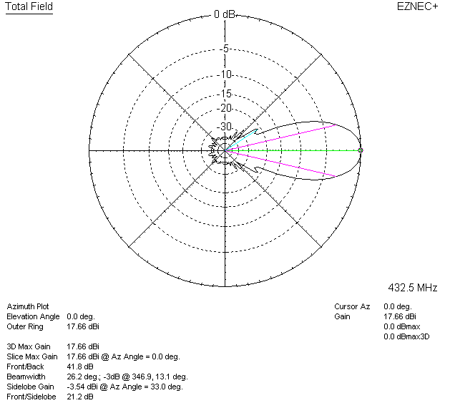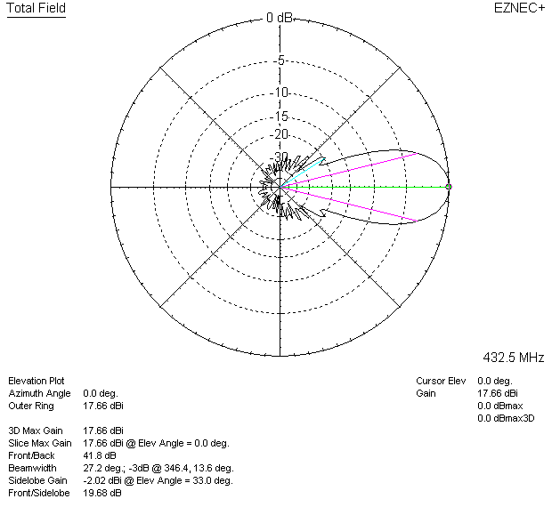

LOSSES INCLUDED (aluminum)
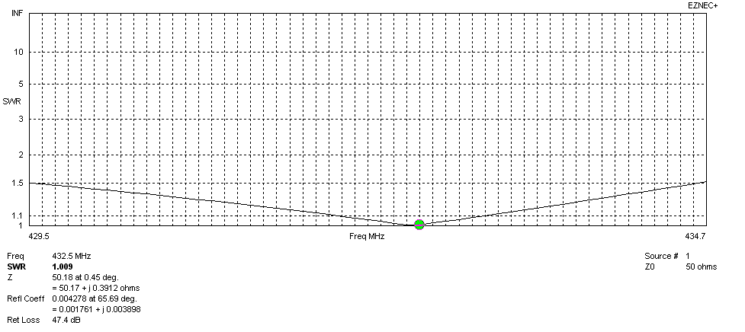
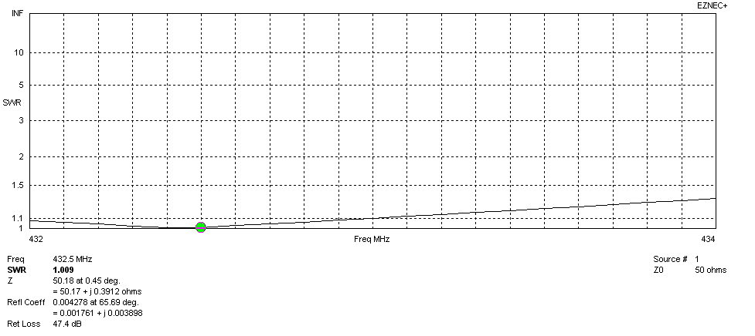
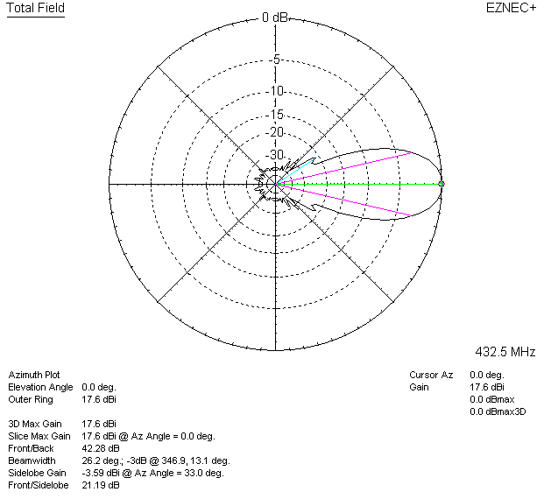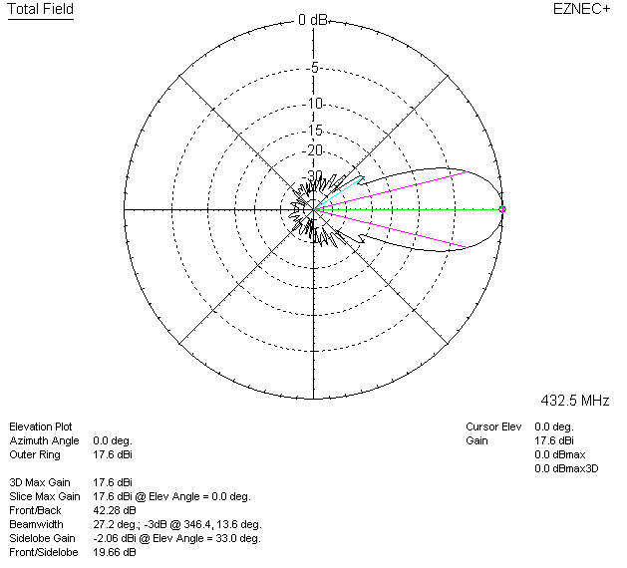

LOSSES INCLUDED (silver)
