ANTENNA Q716G1XL
PERFORMANCES: (No loss condition)
TYPE | ELE | L (mm) | G (dBi) | F/B (dB) | F/Sh (dBi) | F/Sv (dBi) | Hor (◦) | Ver (◦) | Temp (◦K) | G/T (dB) | ΔF * (kHz)
Q716G1XL | 16 | 3695 | 17,27 | 32,56 | 18,75 | 17,41 | 27,6 | 28,2 | 20,8 | +4,09 | 13350
* ΔF given for SWR=1,5

PERFORMANCES: (Losses included)
Element material | G (dBi) | Temp (◦K) | G/T (dB)
Aluminum rods | 17,20 | 25,7 | +3,10
Silvered rods | 17,23 | 23,8 | +3,46

DIMENSIONS:
 | Ref |  | De | D1 | D2 | D3 | D4 | D5 | D6 | D7 | D8 | D9 | D10
Pos | 0 |  | 119 | 205 | 308 | 438 | 675 | 965 | 1256 | 1553 | 1865 | 2178 | 2498
Length | 227 |  | 207 | 198 | 187 | 186 | 181 | 175 | 171 | 169 | 165 | 162 | 159
 |  | D11 | D12 | D13 | D14 | - All elements made of Al rods Ǿ4 mm  - The height of all rectangles is 156 mm  - All dimensions given in milimetres
Pos |  | 2803 | 3121 | 3418 | 3695
Length |  | 157 | 155 | 153 | 151

COMPARISON
Antenna | Boomlength (mm) | Material | Gain (dBi) | TA (◦K) | G/T (dB) | Bandwidth  (MHz)
Q716G1XL | 3695 | No loss | 17,27 | 20,8 | +4,09 | 424,500-437,850
Q716G1XL | 3695 | Aluminum | 17,20 | 25,7 | +3,10 | 424,500-437,850
Q716G1XL | 3695 | Silver | 17,23 | 23,8 | +3,46 | 424,500-437,850
EF7016-5 | 3763 | No loss | 17,45 | 21,1 | +4,20 | 430,300-433,550
EF7016-5 | 3763 | Aluminum | 17,36 | 27,0 | +3,05 | 430,300-433,550
EF7016-5 | 3763 | Silver | 17,39 | 24,9 | +3,44 | 430,300-433,550

DIAGRAMS
NO LOSS INCLUDED

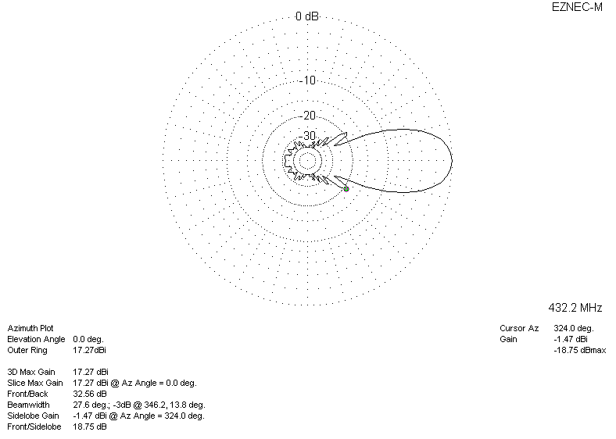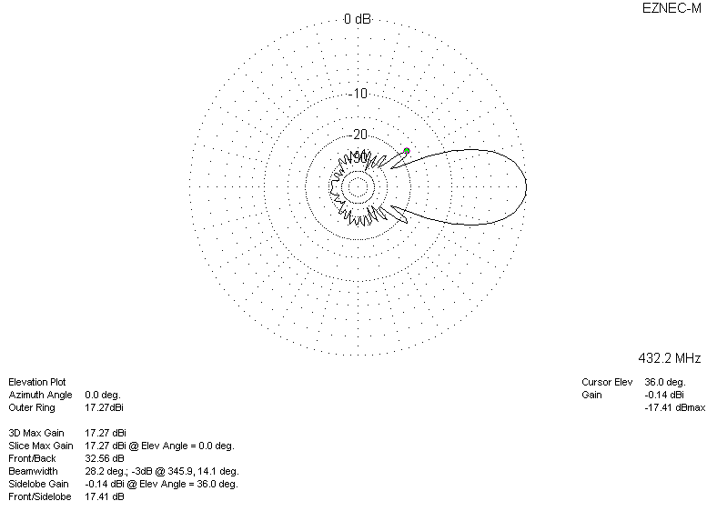

LOSSES INCLUDED (aluminum)
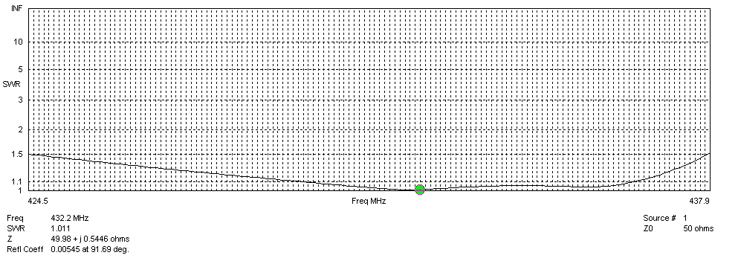
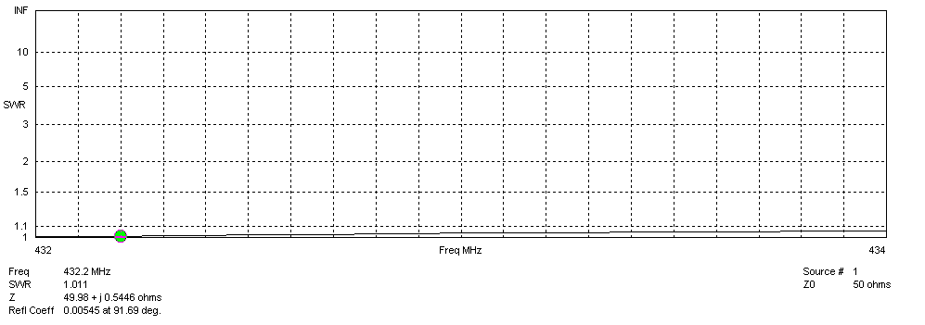
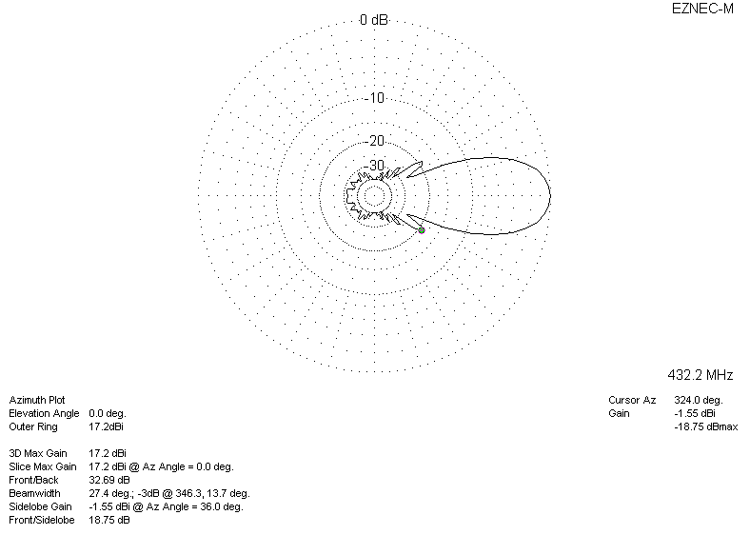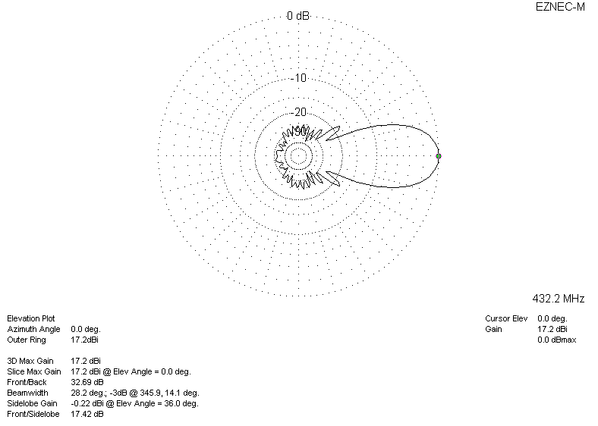

LOSSES INCLUDED (silver)
