ANTENNA Q716E6XL
PERFORMANCES: (No loss condition)
TYPE | ELE | L (mm) | G (dBi) | F/B (dB) | F/Sh (dBi) | F/Sv (dBi) | Hor (◦) | Ver (◦) | Temp (◦K) | G/T (dB) | ΔF * (kHz)
Q716E6XL | 16 | 3888 | 17,31 | 28,12 | 21,54 | 19,64 | 27,6 | 28,8 | 18,4 | +4,67 | 5450
* ΔF given for SWR=1,5

PERFORMANCES: (Losses included)
Element material | G (dBi) | Temp (◦K) | G/T (dB)
Aluminum rods | 17,25 | 22,0 | +3,82
Silvered rods | 17,28 | 20,7 | +4,11

DIMENSIONS:
 | Ref | De | D1 | D2 | D3 | D4 | D5 | D6 | D7 | D8 | D9 | D10 | D11
Pos | 0 | 101 | 196 | 376 | 616 | 884 | 1178 | 1488 | 1785 | 2116 | 2422 | 2735 | 3045
Length | 276 | 250 | 243 | 228 | 221 | 214 | 206 | 201 | 197 | 189 | 185 | 184 | 183
 | D12 | D13 | D14 | - All elements made of Al rods Ǿ5,0 mm  - The height of all rectangles is 100 mm  - All dimensions given in milimetres
Pos | 3349 | 3644 | 3888
Length | 182 | 181 | 180

COMPARISON
Antenna | Boomlength (mm) | Material | Gain (dBi) | TA (◦K) | G/T (dB) | Bandwidth  (MHz)
Q716E6XL | 3888 | No loss | 17,31 | 18,4 | +4,67 | 429,700-435,150
Q716E6XL | 3888 | Aluminum | 17,25 | 22,0 | +3,82 | 429,700-435,150
Q716E6XL | 3888 | Silver | 17,28 | 20,7 | +4,11 | 429,700-435,150
EF7016-5 | 3763 | No loss | 17,45 | 21,1 | +4,20 | 430,300-433,550
EF7016-5 | 3763 | Aluminum | 17,36 | 27,0 | +3,05 | 430,300-433,550
EF7016-5 | 3763 | Silver | 17,39 | 24,9 | +3,44 | 430,300-433,550

DIAGRAMS
NO LOSS INCLUDED
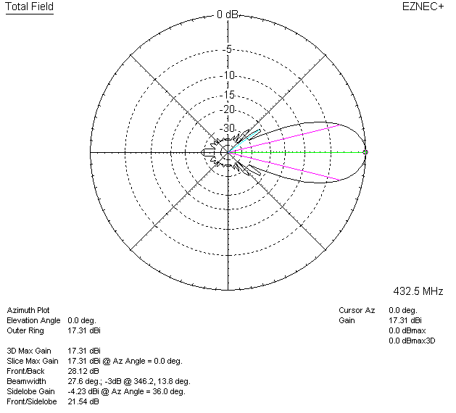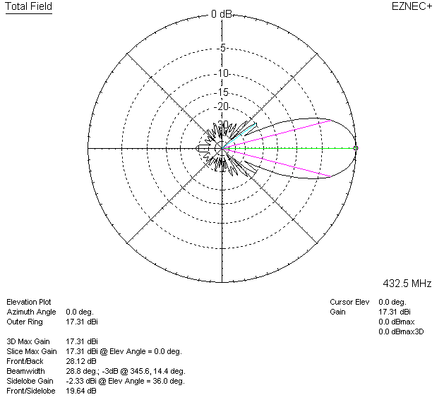

LOSSES INCLUDED (aluminum)
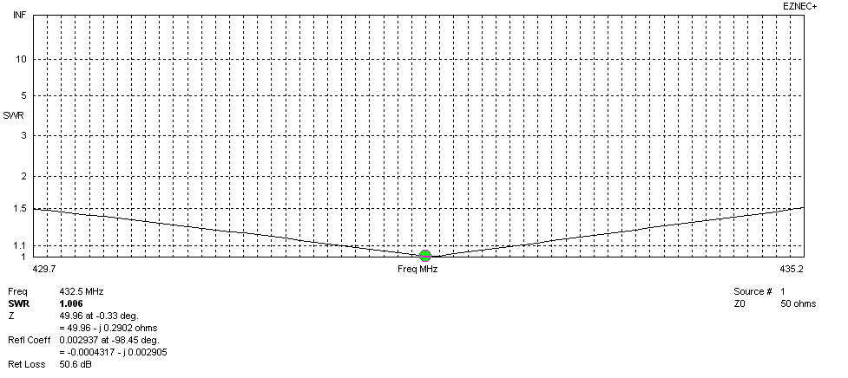
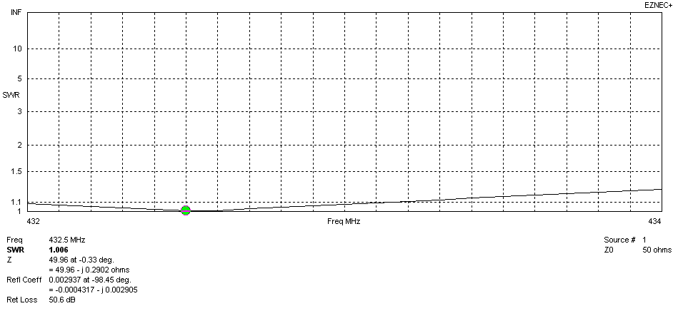
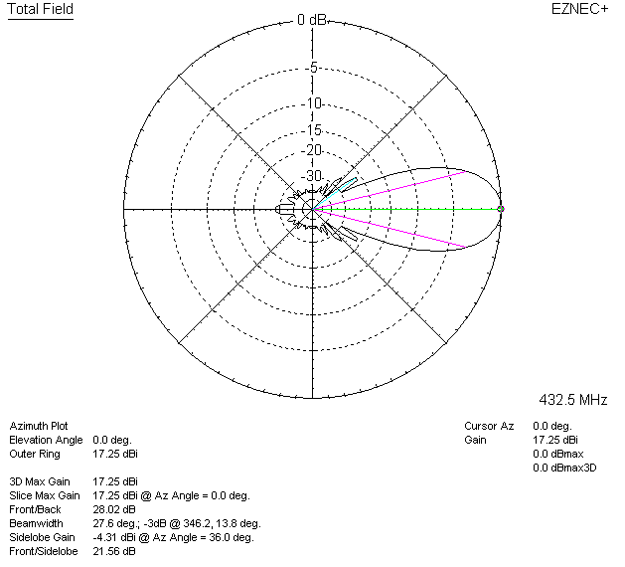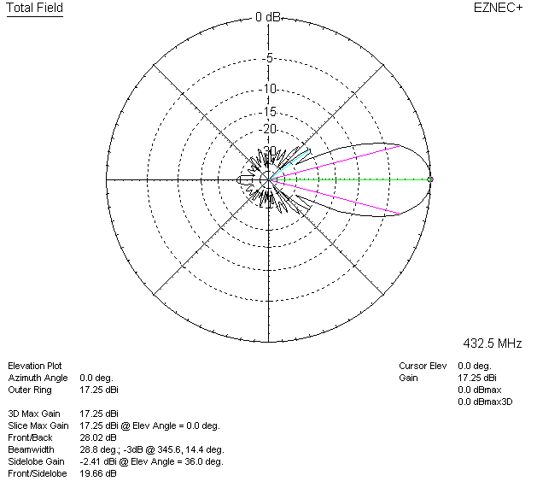

LOSSES INCLUDED (silver)
