ANTENNA Q716E3XL
PERFORMANCES: (No loss condition)
TYPE | ELE | L (mm) | G (dBi) | F/B (dB) | F/Sh (dBi) | F/Sv (dBi) | Hor (◦) | Ver (◦) | Temp (◦K) | G/T (dB) | ΔF * (kHz)
Q716E3XL | 14 | 4070 | 17,32 | 37,07 | 21,43 | 19,85 | 27,6 | 28,5 | 19,0 | +4,53 | 6210
* ΔF given for SWR=1,5

PERFORMANCES: (Losses included)
Element material | G (dBi) | Temp (◦K) | G/T (dB)
Aluminum rods | 17,23 | 25,1 | +3,23
Silvered rods | 17,26 | 22,9 | +3,67

DIMENSIONS:
 | Ref | De | D1 | D2 | D3 | D4 | D5 | D6 | D7 | D8 | D9 | D10
Pos | 0 | 121 | 209 | 395 | 646 | 918 | 1219 | 1535 | 1846 | 2157 | 2477 | 2776
Length | 243 | 222 | 215 | 205 | 198 | 192 | 185 | 180 | 179 | 175 | 171 | 167
 | D11 | D12 | D13 | D14 | - All elements made of Al rods Ǿ3,2 mm  - The height of all rectangles is 135 mm  - All dimensions given in milimetres
Pos | 3139 | 3380 | 3830 | 4070
Length | 162 | 160 | 156 | 154

COMPARISON
Antenna | Boomlength (mm) | Material | Gain  (dBi) | TA  (◦K) | G/T  (dB) | Bandwidth  (MHz)
Q716E3XL | 4070 | No loss | 17,32 | 19,0 | +4,53 | 429,050-435,300
Q716E3XL | 4070 | Aluminum | 17,23 | 25,1 | +3,23 | 429,050-435,300
Q716E3XL | 4070 | Silver | 17,26 | 22,9 | +3,67 | 429,050-435,300
EF7016-5 | 3763 | No loss | 17,45 | 21,1 | +4,20 | 430,300-433,550
EF7016-5 | 3763 | Aluminum | 17,36 | 27,0 | +3,05 | 430,300-433,550
EF7016-5 | 3763 | Silver | 17,39 | 24,9 | +3,44 | 430,300-433,550

DIAGRAMS
NO LOSS INCLUDED
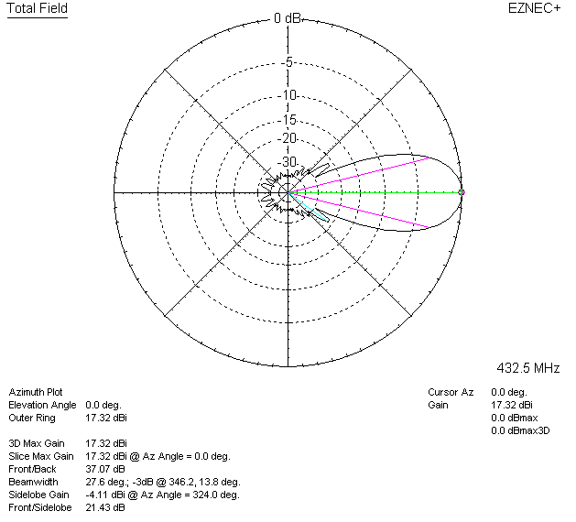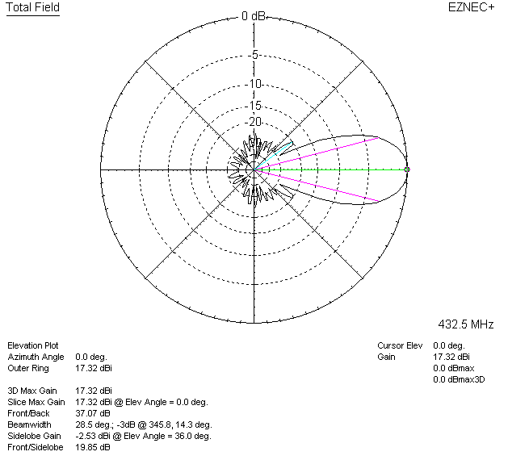

LOSSES INCLUDED (aluminum)
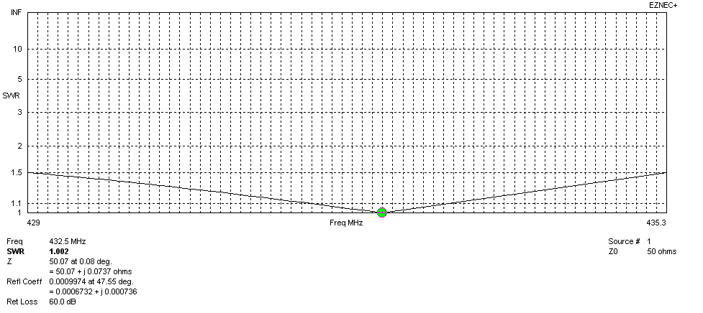
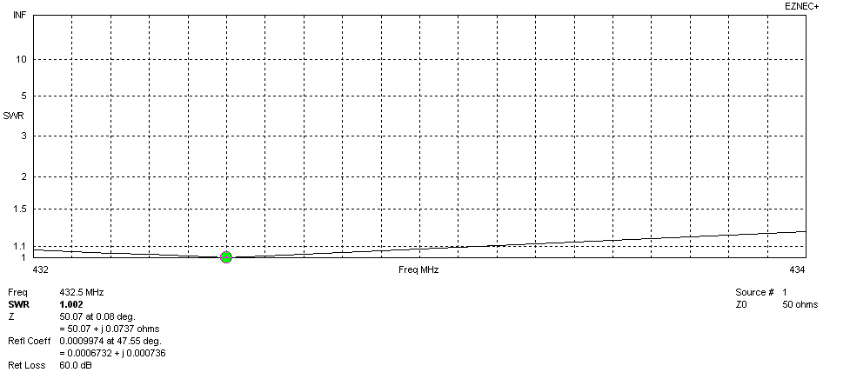
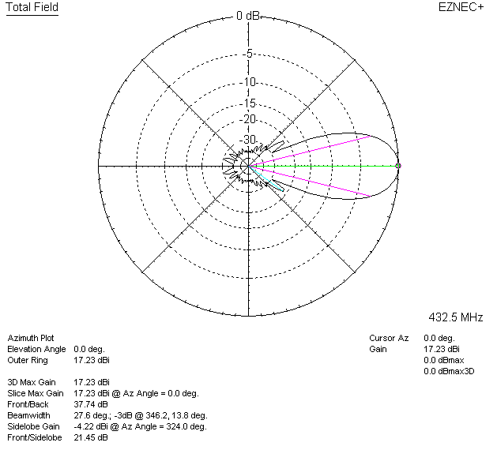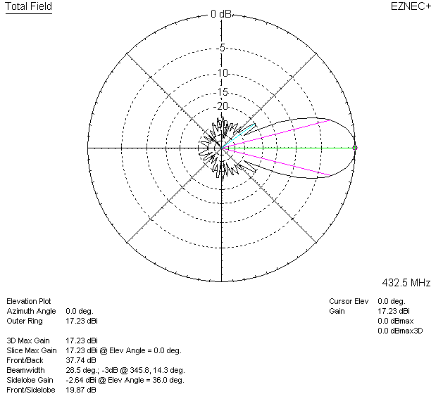

LOSSES INCLUDED (silver)
