ANTENNA Q716E2XL
PERFORMANCES: (No loss condition)
TYPE | ELE | L (mm) | G (dBi) | F/B (dB) | F/Sh (dBi) | F/Sv (dBi) | Hor (◦) | Ver (◦) | Temp (◦K) | G/T (dB) | ΔF * (kHz)
Q716E2XL | 16 | 4075 | 17,57 | 26,61 | 20,48 | 19,13 | 26,8 | 27,5 | 19,2 | +4,73 | 4450
* ΔF given for SWR=1,5

PERFORMANCES: (Losses included)
Element material | G (dBi) | Temp (◦K) | G/T (dB)
Aluminum rods | 17,50 | 24,3 | +3,64
Silvered rods | 17,52 | 22,4 | +4,01

DIMENSIONS:
 | Ref | De | D1 | D2 | D3 | D4 | D5 | D6 | D7 | D8 | D9 | D10
Pos | 0 | 125 | 207 | 397 | 645 | 925 | 1226 | 1545 | 1848 | 2167 | 2466 | 2842
Length | 244 | 222 | 214 | 205 | 197 | 191 | 185 | 181 | 179 | 175 | 171 | 167
 | D11 | D12 | D13 | D14 | - All elements made of Al rods Ǿ4 mm  - The height of all rectangles is 135 mm  - All dimensions given in milimetres
Pos | 3116 | 3476 | 3789 | 4075
Length | 162 | 159 | 157 | 155

COMPARISON
Antenna | Boomlength (mm) | Material | Gain (dBi) | TA (◦K) | G/T (dB) | Bandwidth  (MHz)
Q716E2XL | 4075 | No loss | 17,57 | 19,2 | +4,73 | 429,950-434,400
Q716E2XL | 4075 | Aluminum | 17,50 | 24,3 | +3,64 | 429,950-434,400
Q716E2XL | 4075 | Silver | 17,52 | 22,4 | +4,01 | 429,950-434,400
EF7016-5 | 3763 | No loss | 17,45 | 21,1 | +4,20 | 430,300-433,550
EF7016-5 | 3763 | Aluminum | 17,36 | 27,0 | +3,05 | 430,300-433,550
EF7016-5 | 3763 | Silver | 17,39 | 24,9 | +3,44 | 430,300-433,550

DIAGRAMS
NO LOSS INCLUDED

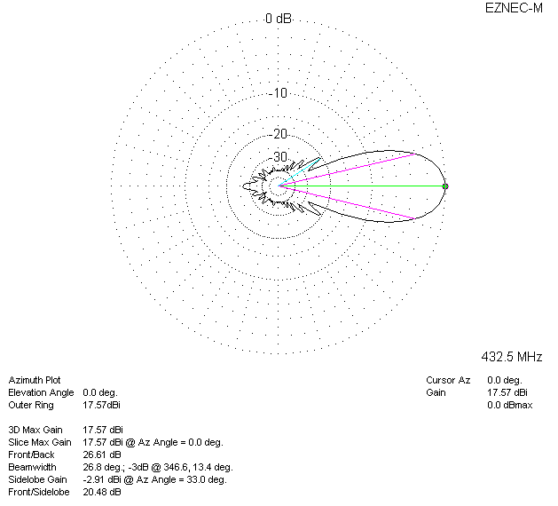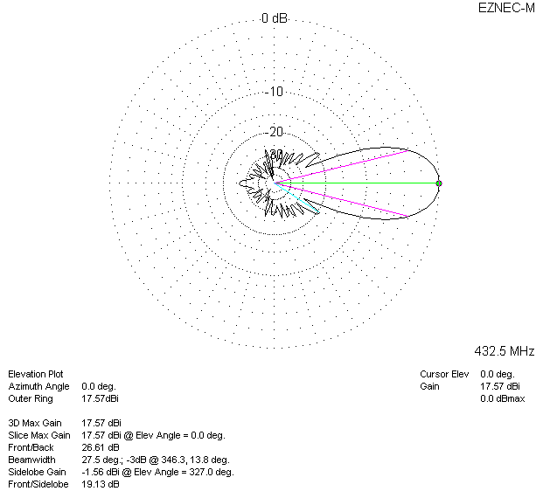

LOSSES INCLUDED (aluminum)
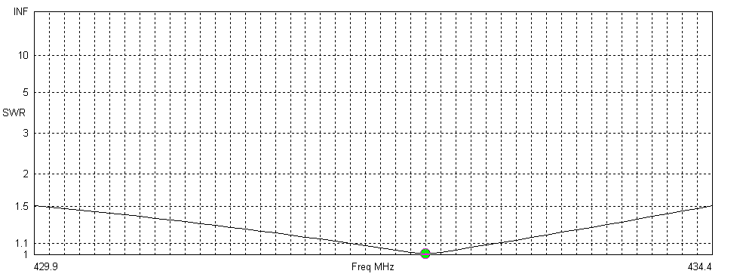
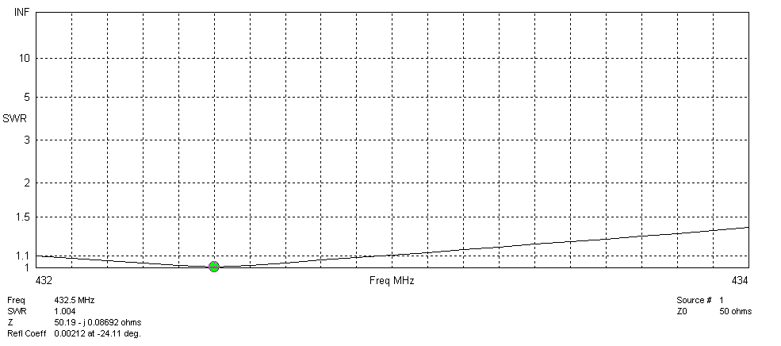
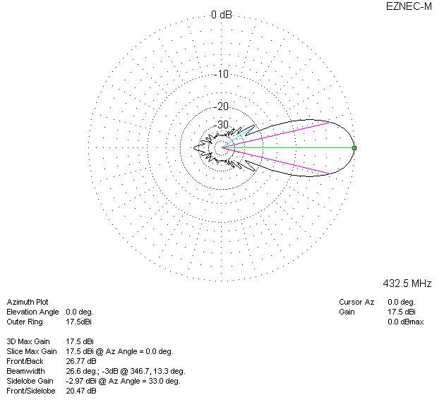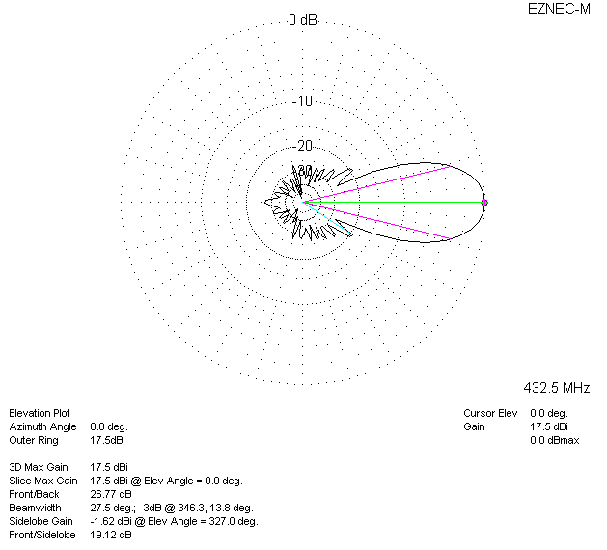

LOSSES INCLUDED (silver)
