ANTENNA Q714G1XL
PERFORMANCES: (No loss condition)
TYPE | ELE | L (mm) | G (dBi) | F/B (dB) | F/Sh (dBi) | F/Sv (dBi) | Hor (◦) | Ver (◦) | Temp (◦K) | G/T (dB) | ΔF * (kHz)
Q714G1XL | 14 | 3068 | 16,74 | 35,00 | 18,77 | 17,18 | 29,2 | 30,1 | 21,9 | +3,34 | 8900
* ΔF given for SWR=1,5

PERFORMANCES: (Losses included)
Element material | G (dBi) | Temp (◦K) | G/T (dB)
Aluminum rods | 16,66 | 26,8 | +2,38
Silvered rods | 16,69 | 25,0 | +2,71

DIMENSIONS:
 | Ref | De | D1 | D2 | D3 | D4 | D5 | D6 | D7 | D8 | D9 | D10 | D11 | D12
Pos | 0 | 117 | 194 | 306 | 439 | 675 | 965 | 1256 | 1553 | 1865 | 2178 | 2498 | 2772 | 3068
Length | 226 | 207 | 197 | 186 | 185 | 181 | 175 | 171 | 169 | 165 | 162 | 160 | 158 | 156
- All elements made of Al rods Ǿ4 mm - The height of all rectangles is 156 mm - All dimensions given in milimetres

COMPARISON
Antenna | Boomlength (mm) | Material | Gain (dBi) | TA (◦K) | G/T (dB) | Bandwidth  (MHz)
Q714G1XL | 3068 | No loss | 16,74 | 21,9 | +3,34 | 427,500-436,400
Q714G1XL | 3068 | Aluminum | 16,66 | 26,8 | +2,38 | 427,500-436,400
Q714G1XL | 3068 | Silver | 16,69 | 25,0 | +2,71 | 427,500-436,400
EF7014-5 | 3050 | No loss | 16,78 | 22,9 | +3,17 | 430,450-433,650
EF7014-5 | 3050 | Aluminum | 16,70 | 28,4 | +2,16 | 430,450-433,650
EF7014-5 | 3050 | Silver | 16,73 | 26,4 | +2,52 | 430,450-433,650

DIAGRAMS
NO LOSS INCLUDED

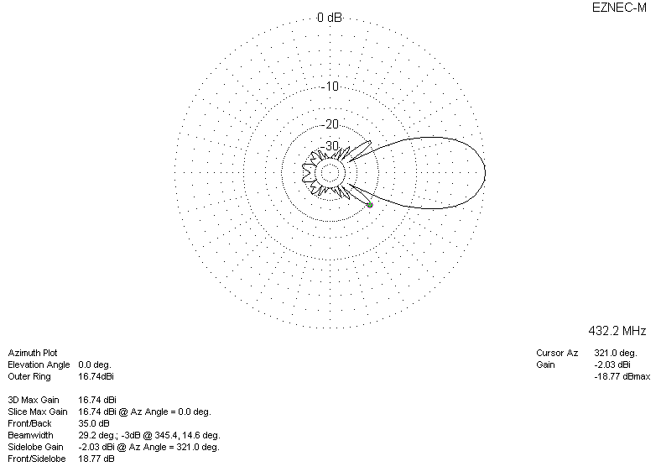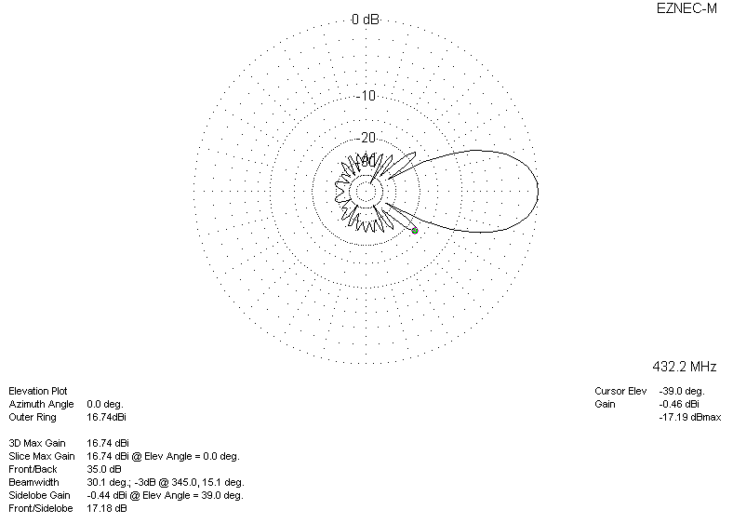

LOSSES INCLUDED (aluminum)
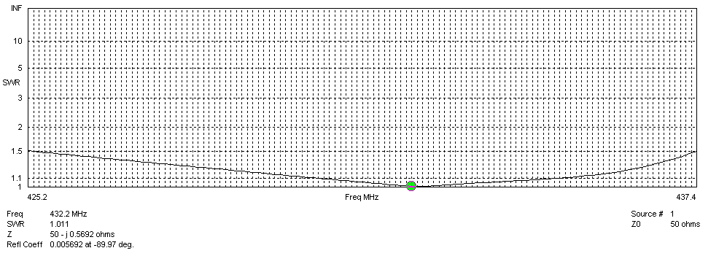
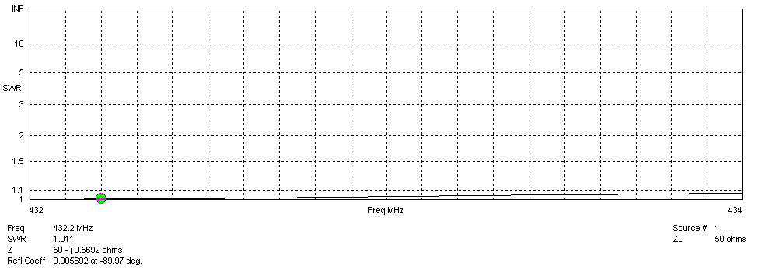
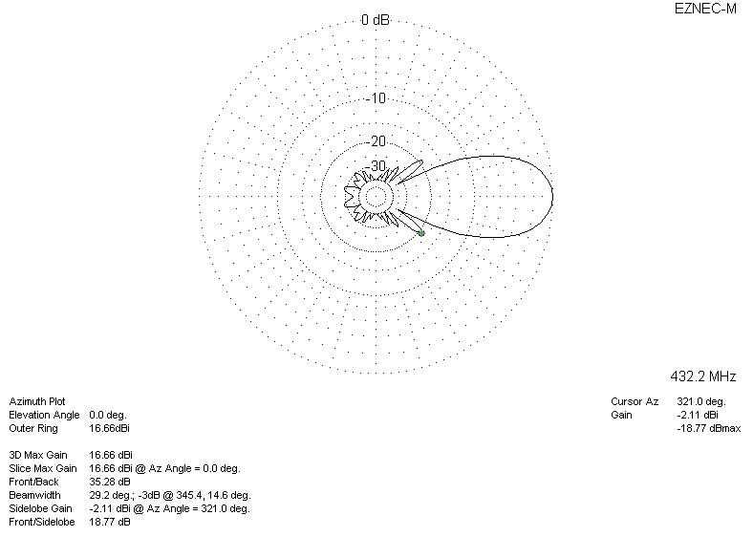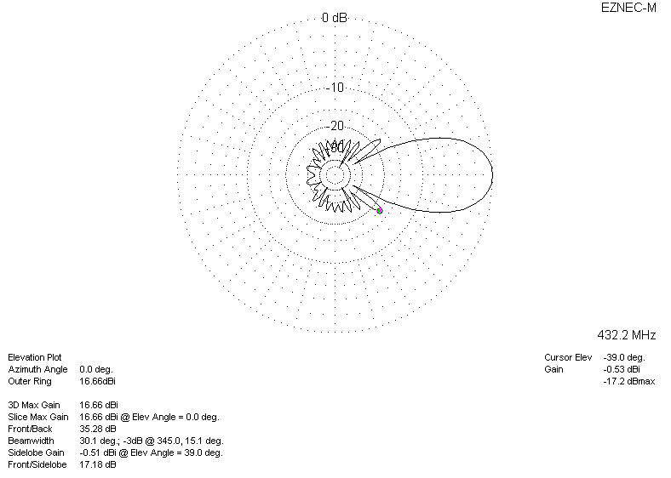

LOSSES INCLUDED (silver)
