ANTENNA Q714D7XL
PERFORMANCES: (No loss condition)
TYPE | ELE | L (mm) | G (dBi) | F/B (dB) | F/Sh (dBi) | F/Sv (dBi) | Hor (◦) | Ver (◦) | Temp (◦K) | G/T (dB) | ΔF * (kHz)
Q714D7XL | 14 | 3035 | 16,88 | 21,33 | 20,13 | 18,24 | 28,2 | 29,5 | 19,4 | +4,00 | 7600
* ΔF given for SWR=1,5

PERFORMANCES: (Losses included)
Element material | G (dBi) | Temp (◦K) | G/T (dB)
Aluminum rods | 16,84 | 22,3 | +3,35
Silvered rods | 16,86 | 21,2 | +3,59

DIMENSIONS:
 | Ref | De | D1 | D2 | D3 | D4 | D5 | D6 | D7 | D8 | D9 | D10 | D11 | D12
Pos | 0 | 111 | 197 | 352 | 482 | 689 | 938 | 1223 | 1519 | 1825 | 2135 | 2451 | 2754 | 3035
Length | 282 | 258 | 247 | 223 | 221 | 220 | 214 | 208 | 203 | 198 | 194 | 190 | 186 | 182
- All elements made of Al tubes Ǿ8,0 mm - The height of all rectangles is 100 mm - All dimensions given in milimetres

COMPARISON
Antenna | Boomlength (mm) | Material | Gain (dBi) | TA (◦K) | G/T (dB) | Bandwidth  (MHz)
Q714D7XL | 3035 | No loss | 16,88 | 19,4 | +4,00 | 427,600-435,200
Q714D7XL | 3035 | Aluminum | 16,84 | 22,8 | +2,83 | 427,600-435,200
Q714D7XL | 3035 | Silver | 16,86 | 21,2 | +3,59 | 427,600-435,200
EF7014-5 | 3050 | No loss | 16,78 | 22,9 | +3,17 | 430,450-433,650
EF7014-5 | 3050 | Aluminum | 16,70 | 28,4 | +2,16 | 430,450-433,650
EF7014-5 | 3050 | Silver | 16,73 | 26,4 | +2,52 | 430,450-433,650

DIAGRAMS
NO LOSS INCLUDED)

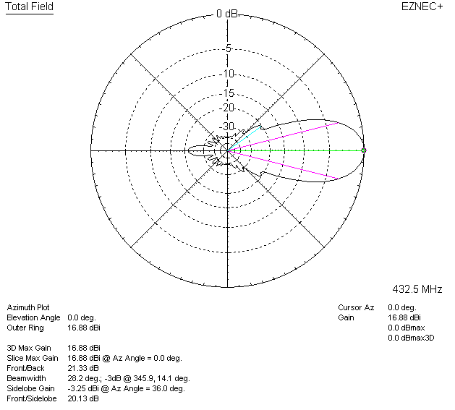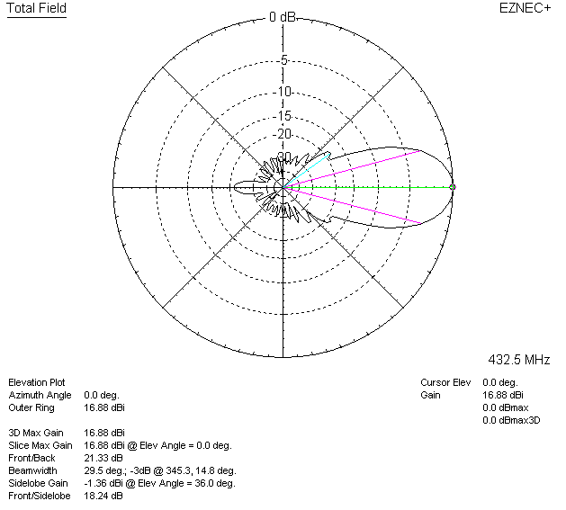

LOSSES INCLUDED (aluminum)
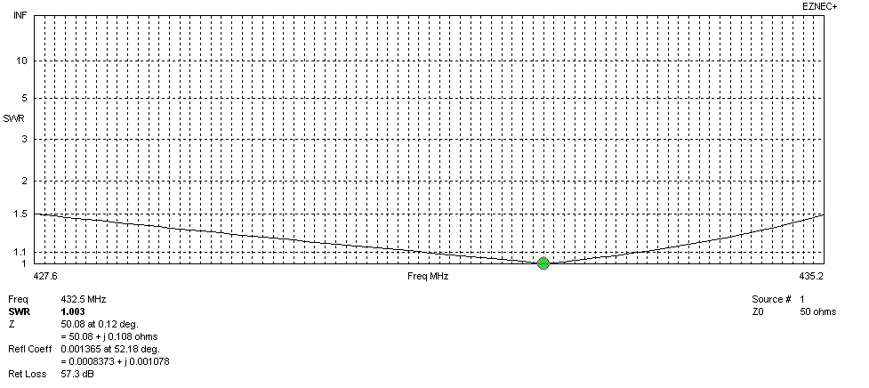
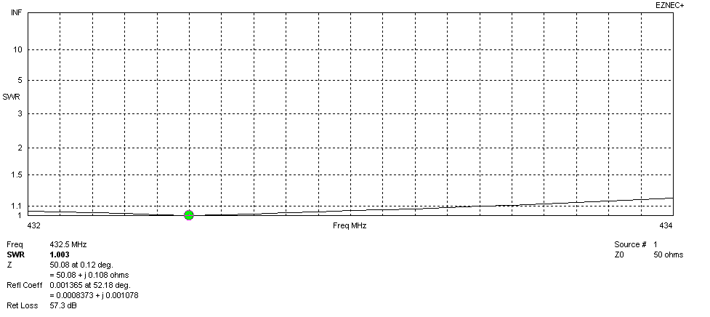
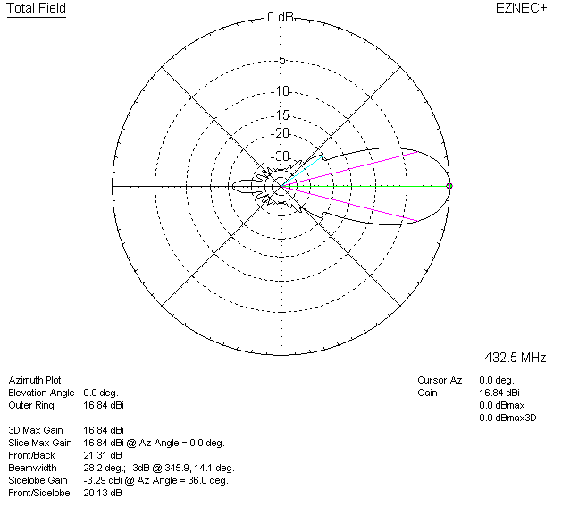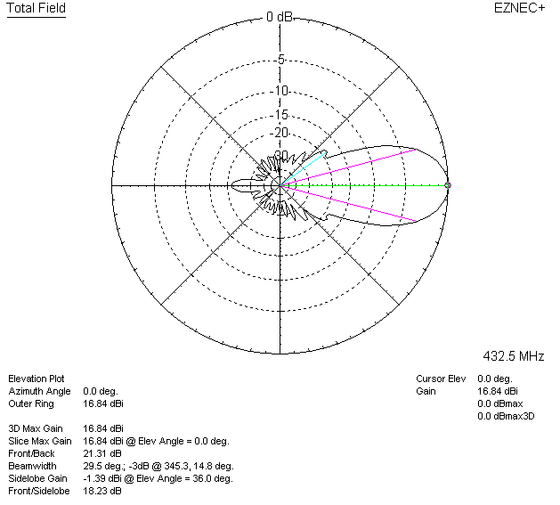

LOSSES INCLUDED (silver)
