ANTENNA Q713D7XL
PERFORMANCES: (No loss condition)
TYPE | ELE | L (mm) | G (dBi) | F/B (dB) | F/Sh (dBi) | F/Sv (dBi) | Hor (◦) | Ver (◦) | Temp (◦K) | G/T (dB) | ΔF * (kHz)
Q713D7XL | 13 | 2715 | 16,45 | 22,04 | 20,53 | 18,27 | 29,6 | 30,9 | 20,0 | +3,43 | 9550
* ΔF given for SWR=1,5

PERFORMANCES: (Losses included)
Element material | G (dBi) | Temp (◦K) | G/T (dB)
Aluminum rods | 16,41 | 22,8 | +2,83
Silvered rods | 16,43 | 21,8 | +3,05

DIMENSIONS:
 | Ref | De | D1 | D2 | D3 | D4 | D5 | D6 | D7 | D8 | D9 | D10 | D11
Pos | 0 | 113 | 199 | 351 | 481 | 689 | 938 | 1223 | 1519 | 1825 | 2135 | 2431 | 2715
Length | 284 | 259 | 247 | 223 | 221 | 220 | 214 | 207 | 203 | 197 | 192 | 189 | 185
- All elements made of Al rods Ǿ8,0 mm - The height of all rectangles is 100 mm - All dimensions given in milimetres

COMPARISON
Antenna | Boomlength (mm) | Material | Gain (dBi) | TA (◦K) | G/T (dB) | Bandwidth  (MHz)
Q713D7XL | 2715 | No loss | 16,45 | 20,0 | +3,43 | 426,000-435,550
Q713D7XL | 2715 | Aluminum | 16,41 | 22,8 | +2,83 | 426,000-435,550
Q713D7XL | 2715 | Silver | 16,43 | 21,8 | +3,05 | 426,000-435,550
EF7013-5 | 2725 | No loss | 16,45 | 24,4 | +2,58 | 430,670-433,620
EF7013-5 | 2725 | Aluminum | 16,36 | 29,8 | +1,62 | 430,670-433,620
EF7013-5 | 2725 | Silver | 16,39 | 27,8 | +1,95 | 430,670-433,620

DIAGRAMS
NO LOSS INCLUDED

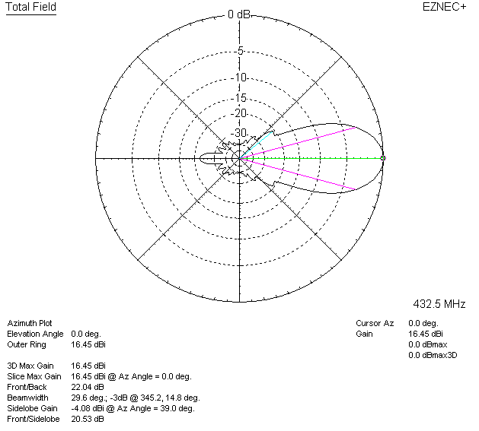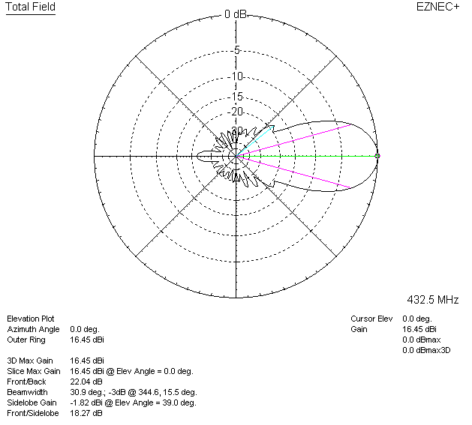

LOSSES INCLUDED (aluminum)
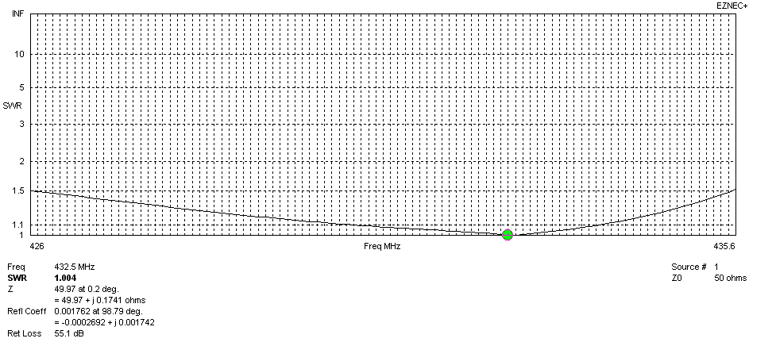
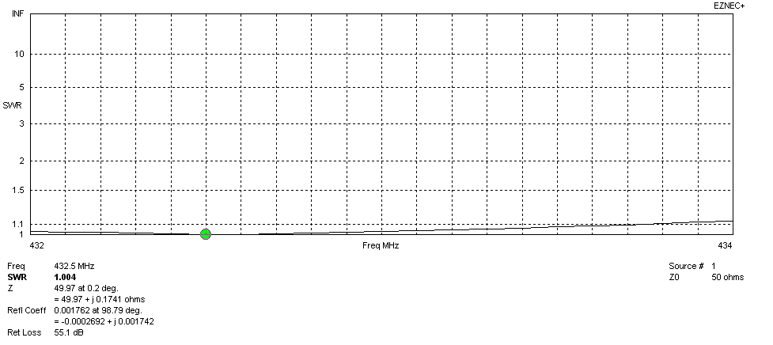
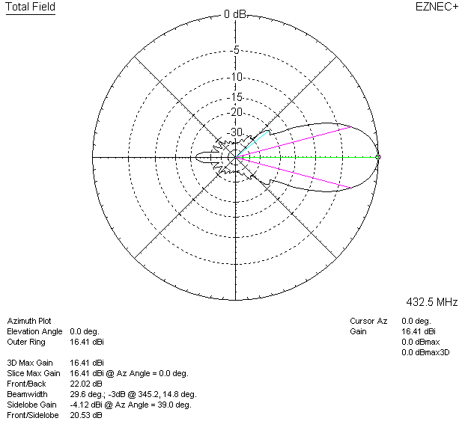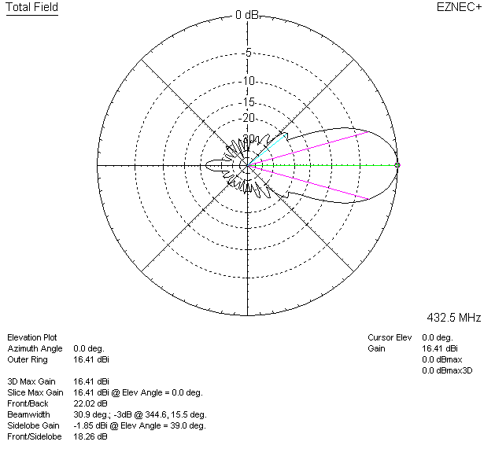

LOSSES INCLUDED (silver)
