ANTENNA Q712E6XL
PERFORMANCES: (No loss condition)
TYPE | ELE | L (mm) | G (dBi) | F/B (dB) | F/Sh (dBi) | F/Sv (dBi) | Hor (◦) | Ver (◦) | Temp (◦K) | G/T (dB) | ΔF * (kHz)
Q712E6XL | 12 | 2684 | 16,07 | 29,13 | 22,27 | 19,65 | 31,6 | 33,3 | 18,2 | +3,46 | 6550
* ΔF given for SWR=1,5

PERFORMANCES: (Losses included)
Element material | G (dBi) | Temp (◦K) | G/T (dB)
Aluminum rods | 16,02 | 21,6 | +2,67
Silvered rods | 16,04 | 20,4 | +2,95

DIMENSIONS:
 | Ref | De | D1 | D2 | D3 | D4 | D5 | D6 | D7 | D8
Pos | 0 | 101 | 193 | 376 | 618 | 884 | 1180 | 1488 | 1786 | 2118 | 2419 | 2684
Length | 277 | 252 | 243 | 228 | 219 | 214 | 204 | 198 | 194 | 186 | 183 | 181
- All elements made of Al rods Ǿ5,0 mm - The height of all rectangles is 100 mm - All dimensions given in milimetres

COMPARISON
Antenna | Boomlength (mm) | Material | Gain (dBi) | TA (◦K) | G/T (dB) | Bandwidth  (MHz)
Q712E6XL | 2684 | No loss | 16,07 | 18,2 | +3,46 | 429,200-435,750
Q712E6XL | 2684 | Aluminum | 16,02 | 21,6 | +2,67 | 429,200-435,750
Q712E6XL | 2684 | Silver | 16,04 | 20,4 | +2,95 | 429,200-435,750
EF7012-5 | 2417 | No loss | 15,93 | 24,1 | +2,12 | 429,200-434,120
EF7012-5 | 2417 | Aluminum | 15,86 | 28,7 | +1,28 | 429,200-434,120
EF7012-5 | 2417 | Silver | 15,89 | 27,0 | +1,58 | 429,200-434,120

DIAGRAMS
NO LOSS INCLUDED
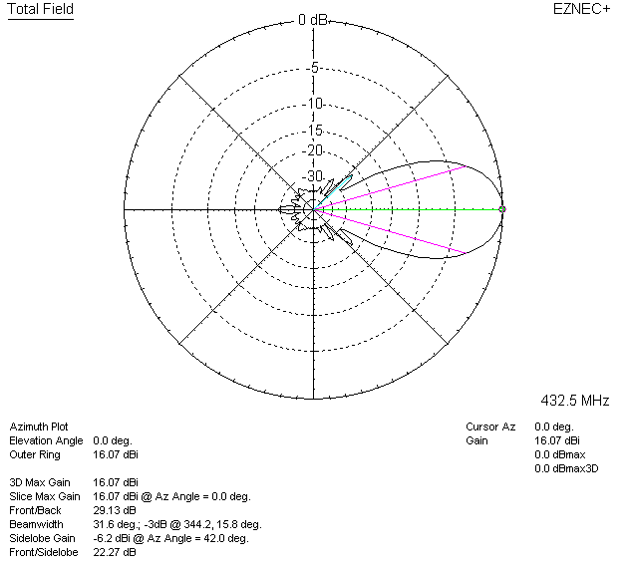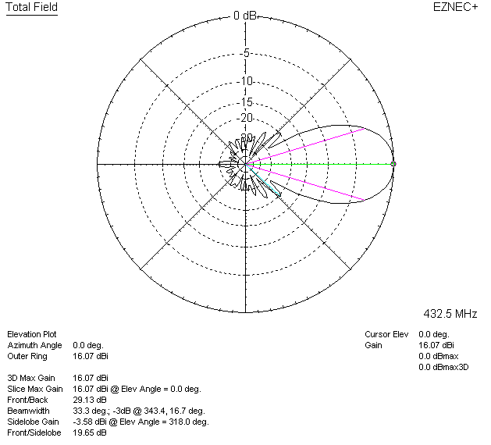

LOSSES INCLUDED (aluminum)
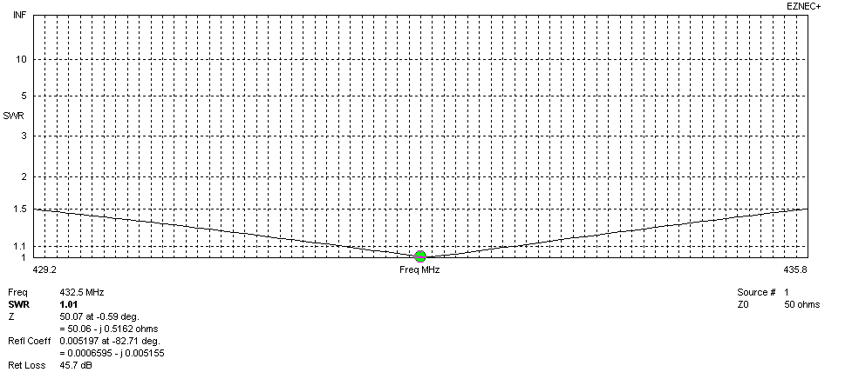
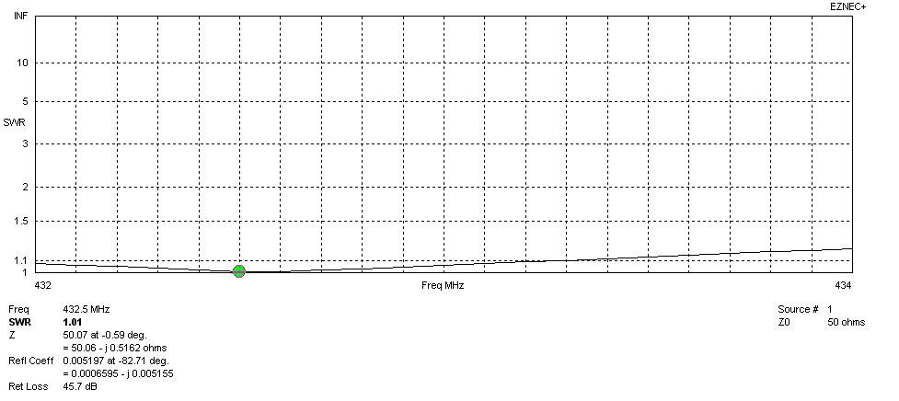
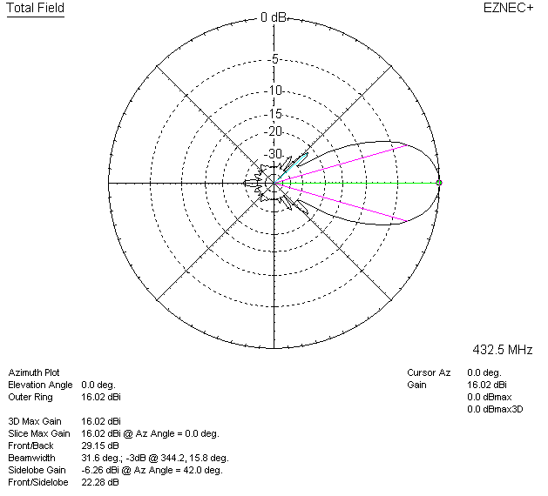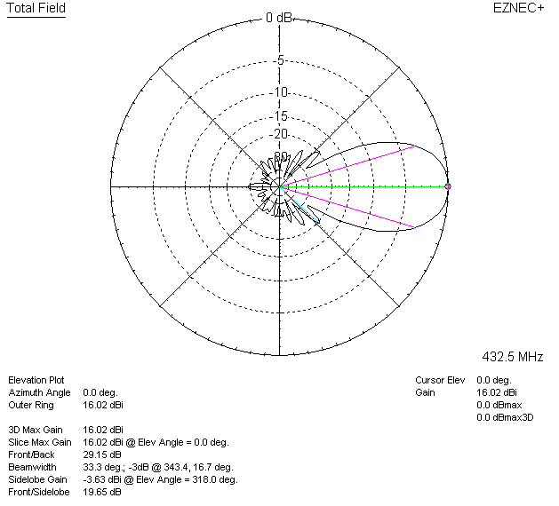

LOSSES INCLUDED (silver)
