ANTENNA Q712E4XL
PERFORMANCES: (No loss condition)
TYPE | ELE | L (mm) | G (dBi) | F/B (dB) | F/Sh (dBi) | F/Sv (dBi) | Hor (◦) | Ver  (◦) | Temp (◦K) | G/T (dB) | ΔF * (kHz)
Q712E4XL | 12 | 2645 | 16,17 | 38,39 | 20,34 | 18,13 | 31,2 | 32,4 | 20,5 | +3,04 | 8700
* ΔF given for SWR=1,5

PERFORMANCES: (Losses included)
Element material | G (dBi) | Temp (◦K) | G/T (dB)
Aluminum rods | 16,10 | 25,1 | +2,11
Silvered rods | 16,12 | 23,4 | +2,43

DIMENSIONS:
 | Ref | De | D1 | D2 | D3 | D4 | D5 | D6 | D7 | D8
Pos | 0 | 104 | 186 | 373 | 623 | 889 | 1195 | 1498 | 1799 | 2109 | 2409 | 2645
Length | 244 | 223 | 214 | 204 | 198 | 191 | 182 | 178 | 176 | 172 | 172 | 170
- All elements made of Al rods Ǿ4,0 mm - The height of all rectangles is 135 mm - All dimensions given in milimetres

COMPARISON
Antenna | Boomlength (mm) | Material | Gain  (dBi) | TA  (◦K) | G/T  (dB) | Bandwidth  (MHz)
Q712E4XL | 2645 | No loss | 16,17 | 20,5 | +3,04 | 428,300-437,000
Q712E4XL | 2645 | Aluminum | 16,10 | 25,1 | +2,11 | 428,300-437,000
Q712E4XL | 2645 | Silver | 16,12 | 23,4 | +2,43 | 428,300-437,000
EF7012-5 | 2417 | No loss | 15,93 | 24,1 | +2,12 | 429,200-434,120
EF7012-5 | 2417 | Aluminum | 15,86 | 28,7 | +1,28 | 429,200-434,120
EF7012-5 | 2417 | Silver | 15,89 | 27,0 | +1,58 | 429,200-434,120

DIAGRAMS
NO LOSS INCLUDED
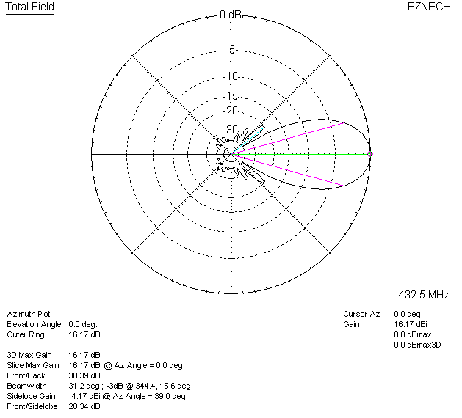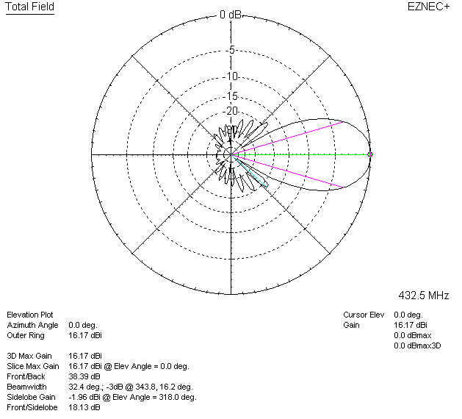

LOSSES INCLUDED (aluminum)
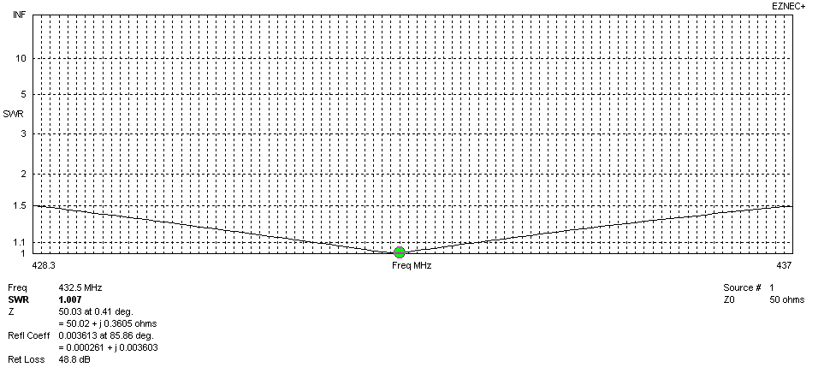
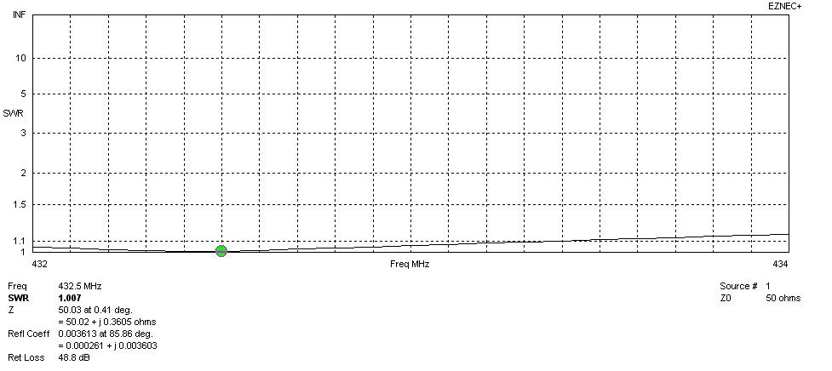
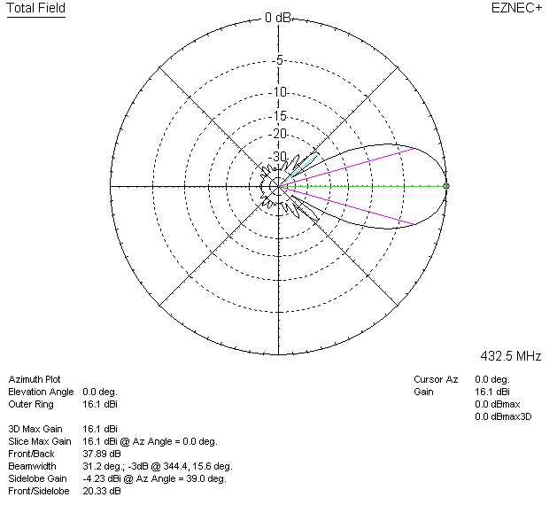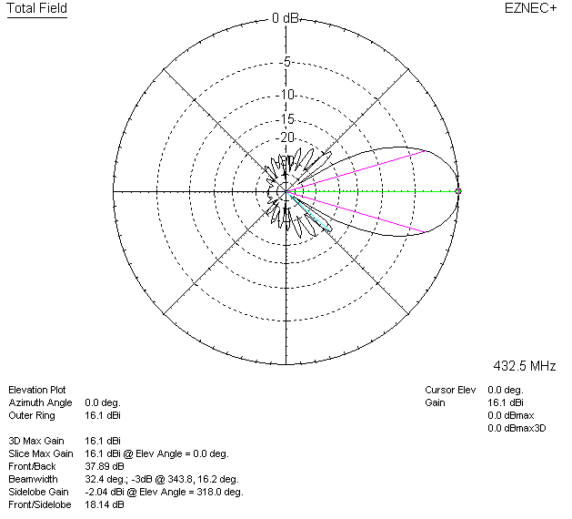

LOSSES INCLUDED (silver)
