ANTENNA Q712E3XL
PERFORMANCES: (No loss condition)
TYPE | ELE | L (mm) | G (dBi) | F/B (dB) | F/Sh (dBi) | F/Sv (dBi) | Hor (◦) | Ver (◦) | Temp (◦K) | G/T (dB) | ΔF * (kHz)
Q712E3XL | 12 | 2675 | 16,22 | 34,67 | 20,62 | 18,41 | 31,2 | 32,3 | 19,9 | +3,24 | 9800
* ΔF given for SWR=1,5

PERFORMANCES: (Losses included)
Element material | G (dBi) | Temp (◦K) | G/T (dB)
Aluminum rods | 16,13 | 25,8 | +2,01
Silvered rods | 16,16 | 23,6 | +2,43

DIMENSIONS:
 | Ref | De | D1 | D2 | D3 | D4 | D5 | D6 | D7 | D8
Pos | 0 | 106 | 187 | 373 | 625 | 895 | 1196 | 1504 | 1795 | 2110 | 2407 | 2675
Length | 242 | 223 | 215 | 205 | 198 | 193 | 185 | 180 | 178 | 174 | 171 | 167
- All elements made of Al rods Ǿ3,2 mm - The height of all rectangles is 135 mm - All dimensions given in milimetres

COMPARISON
Antenna | Boomlength (mm) | Material | Gain (dBi) | TA (◦K) | G/T (dB) | Bandwidth  (MHz)
Q712E3XL | 2394 | No loss | 15,80 | 21,7 | +2,45 | 428,000-437,800
Q712E3XL | 2394 | Aluminum | 15,76 | 24,5 | +1,87 | 428,000-437,800
Q712E3XL | 2394 | Silver | 15,77 | 23,4 | +2,07 | 428,000-437,800
EF7012-5 | 2417 | No loss | 15,93 | 24,1 | +2,12 | 429,200-434,120
EF7012-5 | 2417 | Aluminum | 15,86 | 28,7 | +1,28 | 429,200-434,120
EF7012-5 | 2417 | Silver | 15,89 | 27,0 | +1,58 | 429,200-434,120

DIAGRAMS
NO LOSS INCLUDED
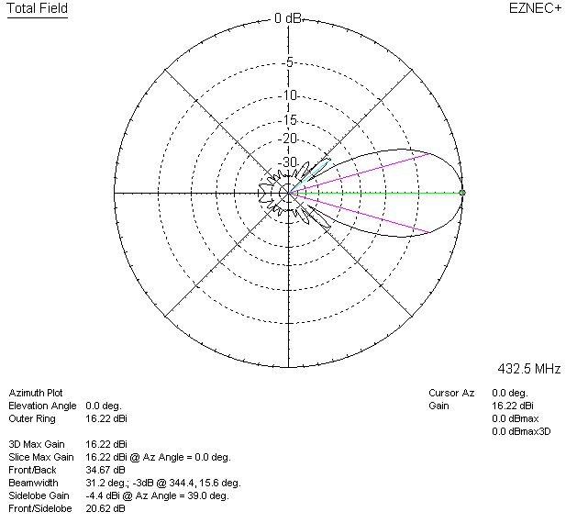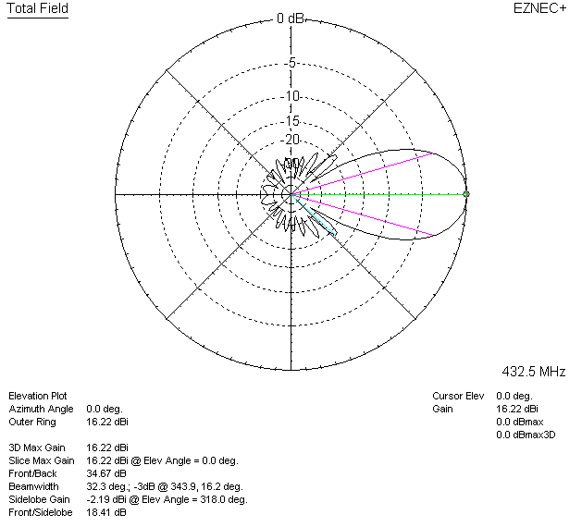

LOSSES INCLUDED (aluminum)
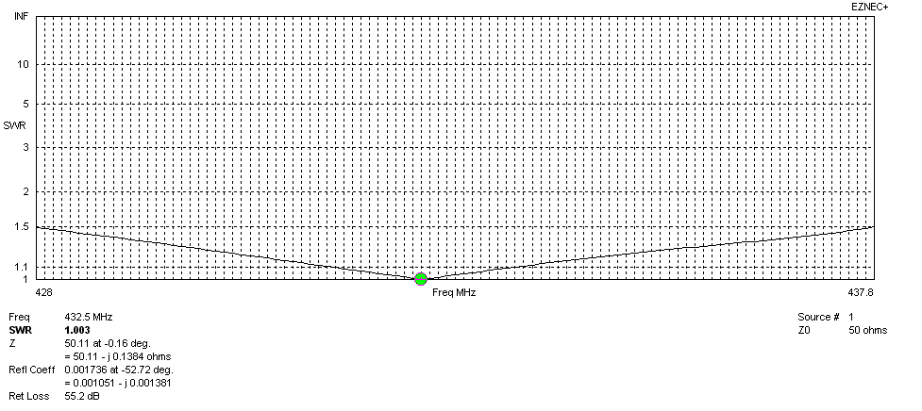
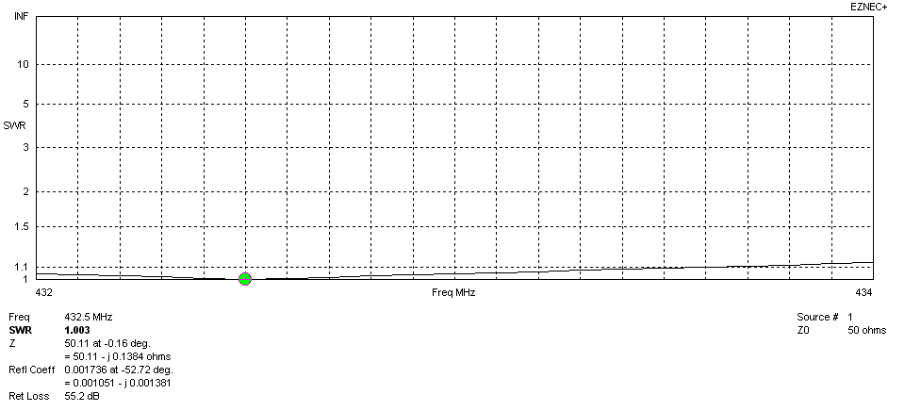
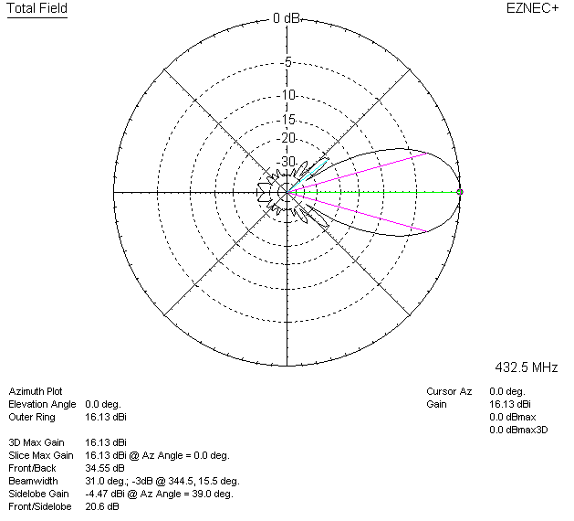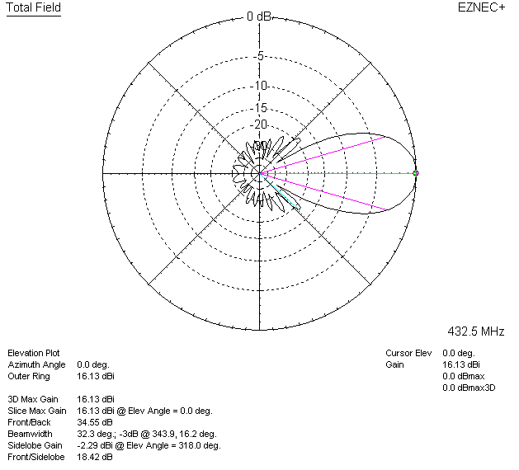

LOSSES INCLUDED (silver)
