ANTENNA Q712D9XL
PERFORMANCES: (No loss condition)
TYPE | ELE | L (mm) | G (dBi) | F/B (dB) | F/Sh (dBi) | F/Sv (dBi) | Hor (◦) | Ver (◦) | Temp (◦K) | G/T (dB) | ΔF * (kHz)
Q712D9XL | 12 | 2395 | 16,01 | 22,02 | 21,08 | 18,36 | 31,2 | 32,6 | 20,7 | +2,86 | 11400
* ΔF given for SWR=1,5

PERFORMANCES: (Losses included)
Element material | G (dBi) | Temp (◦K) | G/T (dB)
Aluminum rods | 15,98 | 22,7 | +2,40
Silvered rods | 15,99 | 22,0 | +2,56

DIMENSIONS:
 | Ref | De | D1 | D2 | D3 | D4 | D5 | D6 | D7 | D8 | D9 | D10 | - All elements made of Al rods Ǿ10 mm  - The height of all rectangles is 100 mm  - All dimensions given in milimetres
Pos | 0 | 124 | 199 | 351 | 484 | 692 | 939 | 1223 | 1519 | 1831 | 2125 | 2395
Length | 285 | 263 | 247 | 224 | 220 | 217 | 211 | 205 | 197 | 193 | 191 | 188

COMPARISON
Antenna | Boomlength (mm) | Material | Gain (dBi) | TA (◦K) | G/T (dB) | Bandwidth  (MHz)
Q712D9XL | 2395 | No loss | 16,01 | 20,7 | +2,86 | 424,600-436,000
Q712D9XL | 2395 | Aluminum | 15,98 | 22,7 | +1,85 | 424,600-436,000
Q712D9XL | 2395 | Silver | 15,99 | 22,0 | +2,56 | 424,600-436,000
EF7012-5 | 2417 | No loss | 15,93 | 24,1 | +2,12 | 429,200-434,120
EF7012-5 | 2417 | Aluminum | 15,86 | 28,7 | +1,28 | 429,200-434,120
EF7012-5 | 2417 | Silver | 15,89 | 27,0 | +1,58 | 429,200-434,120

DIAGRAMS
NO LOSS INCLUDED

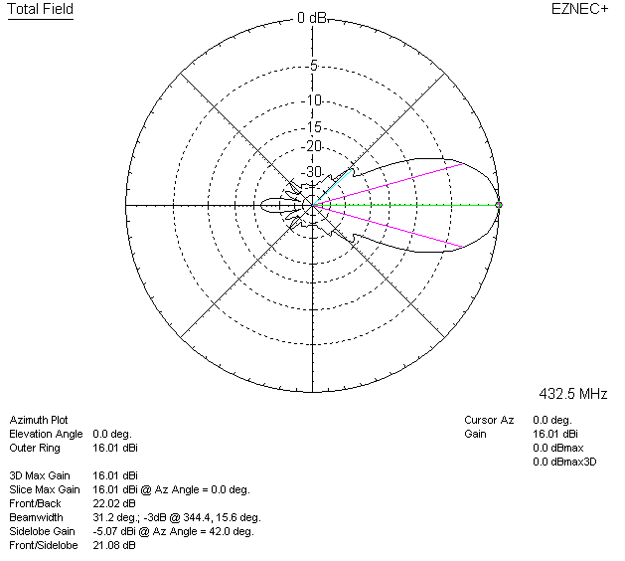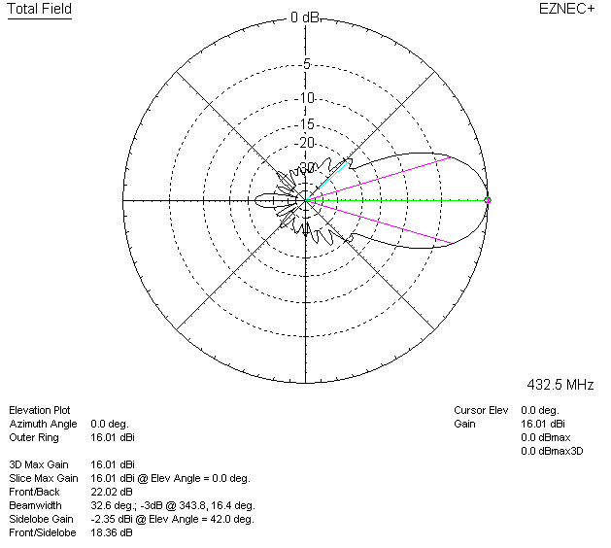

LOSSES INCLUDED (aluminum)
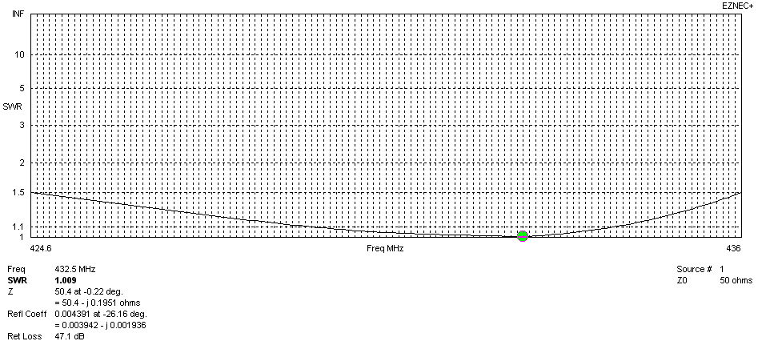
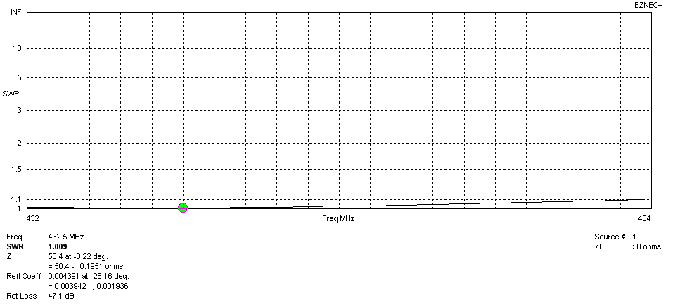
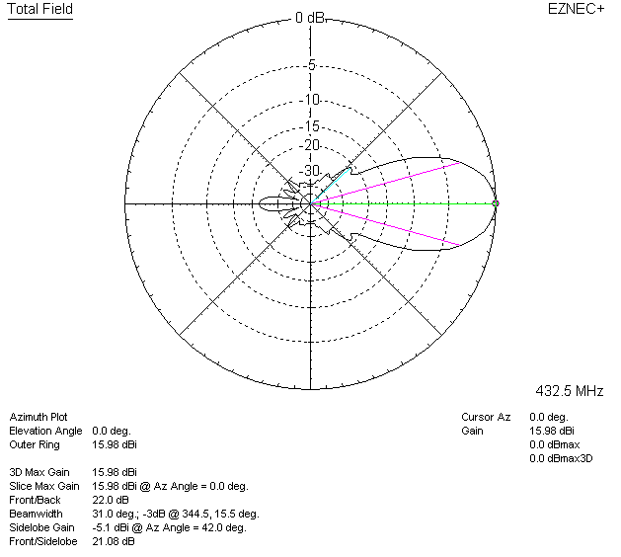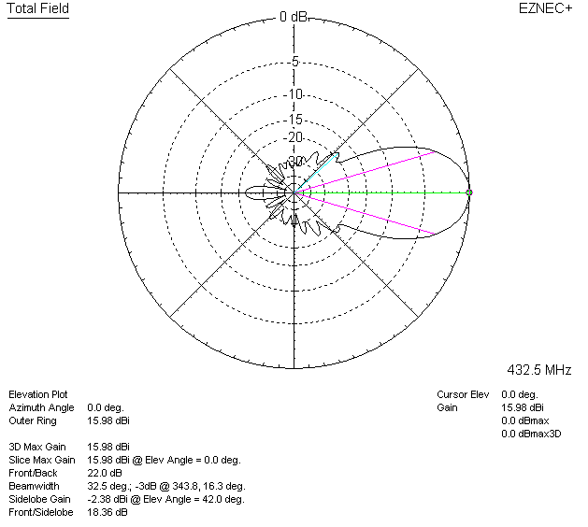

LOSSES INCLUDED (silver)
