ANTENNA Q712B1XL
PERFORMANCES: (No loss condition)
TYPE | ELE | L (mm) | G (dBi) | F/B (dB) | F/Sh (dBi) | F/Sv (dBi) | Hor (◦) | Ver (◦) | Temp (◦K) | G/T (dB) | ΔF * (kHz)
Q712B1XL | 12 | 2394 | 15,80 | 20,91 | 21,94 | 18,59 | 31,8 | 34,1 | 21,7 | +2,45 | 3560
* ΔF given for SWR=1,5

PERFORMANCES: (Losses included)
Element material | G (dBi) | Temp (◦K) | G/T (dB)
Aluminum rods | 15,76 | 24,5 | +1,87
Silvered rods | 15,77 | 23,4 | +2,07

DIMENSIONS:
 | Ref | De | D1 | D2 | D3 | D4 | D5 | D6 | D7 | D8 | D9 | D10
Pos | 0 | 155 | 231 | 329 | 486 | 685 | 925 | 1197 | 1499 | 1808 | 2115 | 2394
Length | 317 | 291 | 285 | 264 | 261 | 257 | 253 | 247 | 240 | 236 | 229 | 222
- All elements made of Al rods Ǿ5 mm
- The height of all rectangles is 40 mm
- All dimensions given in milimetres

COMPARISON
Antenna | Boomlength (mm) | Material | Gain (dBi) | TA (◦K) | G/T (dB) | Bandwidth  (MHz)
Q712B1XL | 2394 | No loss | 15,80 | 21,7 | +2,45 | 430,260-433,820
Q712B1XL | 2394 | Aluminum | 15,76 | 24,5 | +1,87 | 430,260-433,820
Q712B1XL | 2394 | Silver | 15,77 | 23,4 | +2,07 | 430,260-433,820
EF7012-5 | 2417 | No loss | 15,93 | 24,1 | +2,12 | 429,200-434,120
EF7012-5 | 2417 | Aluminum | 15,86 | 28,7 | +1,28 | 429,200-434,120
EF7012-5 | 2417 | Silver | 15,89 | 27,0 | +1,58 | 429,200-434,120

DIAGRAMS
NO LOSS INCLUDED
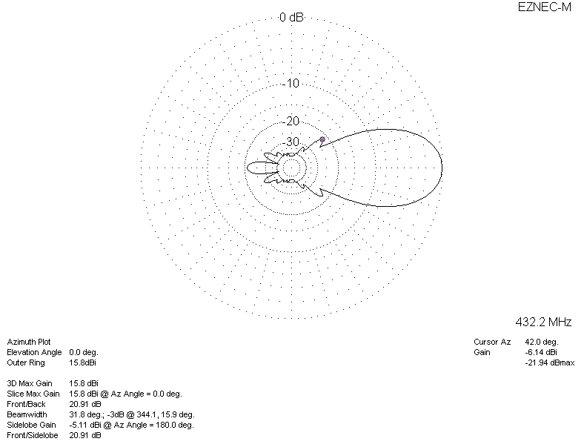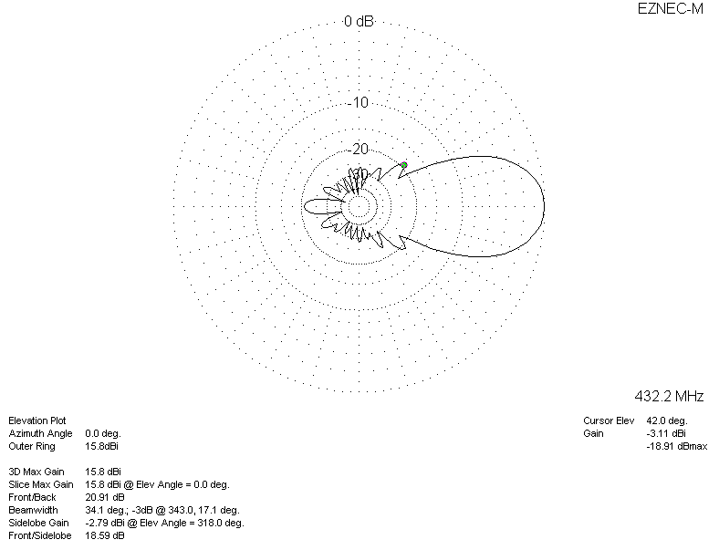

LOSSES INCLUDED (aluminum)
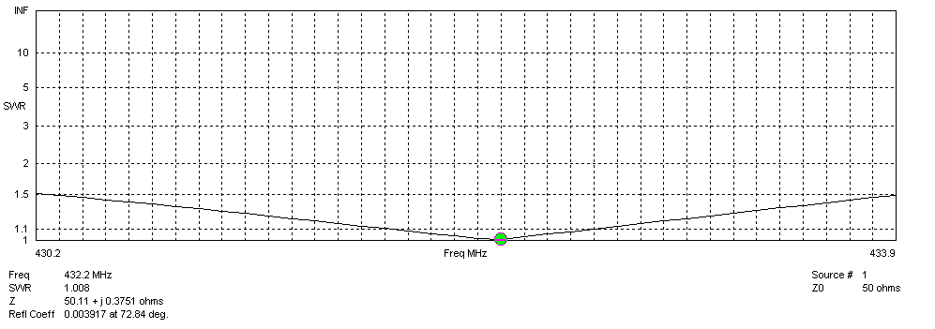
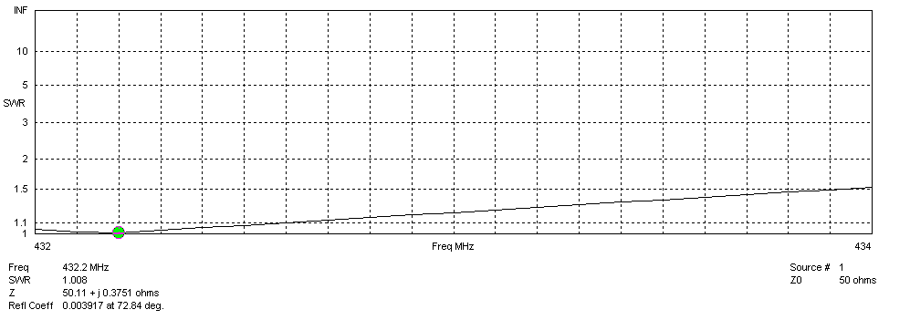
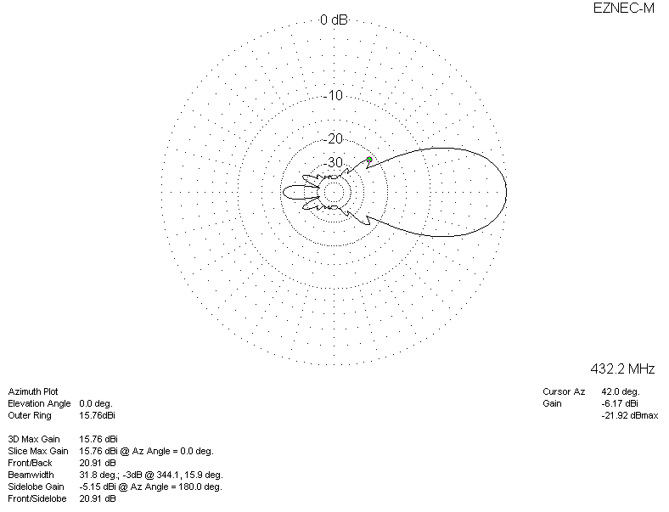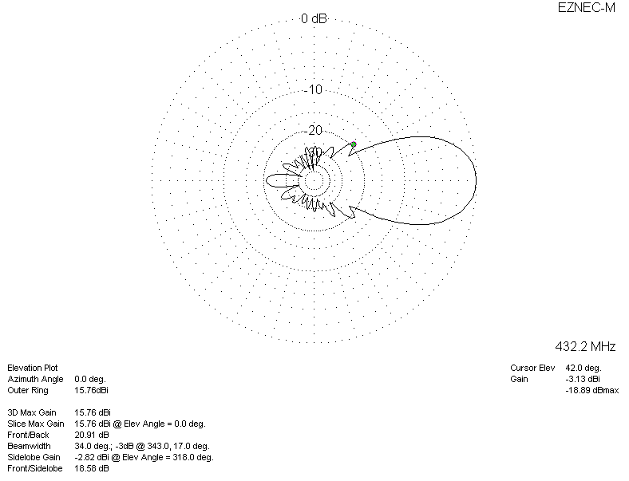

LOSSES INCLUDED (silver)
