ANTENNA Q710G1XL
PERFORMANCES: (No loss condition)
TYPE | ELE | L (mm) | G (dBi) | F/B (dB) | F/Sh (dBi) | F/Sv (dBi) | Hor (◦) | Ver (◦) | Temp (◦K) | G/T (dB) | ΔF * (kHz)
Q710G1XL | 10 | 1800 | 15,11 | 24,84 | 20,23 | 17,29 | 34,6 | 36,3 | 24,5 | +1,21 | 9850
* ΔF given for SWR=1,5

PERFORMANCES: (Losses included)
Element material | G (dBi) | Temp (◦K) | G/T (dB)
Aluminum rods | 15,04 | 29,0 | +0,42
Silvered rods | 15,07 | 27,3 | +0,71

DIMENSIONS:
 | Ref | De | D1 | D2 | D3 | D4 | D5 | D6 | D7 | D8 | - All elements made of Al rods Ǿ4 mm  - The height of all rectangles is 156 mm  - All dimensions given in milimetres
Pos | 0 | 120 | 200 | 305 | 438 | 662 | 961 | 1241 | 1531 | 1800
Length | 225 | 205 | 197 | 186 | 185 | 181 | 175 | 171 | 169 | 167

COMPARISON
Antenna | Boomlength (mm) | Material | Gain (dBi) | TA (◦K) | G/T (dB) | Bandwidth  (MHz)
Q710G1XL | 1800 | No loss | 15,11 | 24,5 | +1,21 | 427,600-437,450
Q710G1XL | 1800 | Aluminum | 15,04 | 29,0 | +0,42 | 427,600-437,450
Q710G1XL | 1800 | Silver | 15,07 | 27,3 | +0,71 | 427,600-437,450
EF7011-5 | 2110 | No loss | 15,28 | 26,0 | +1,12 | 430,050-434,540
EF7011-5 | 2110 | Aluminum | 15,22 | 30,5 | +0,28 | 430,050-434,540
EF7011-5 | 2110 | Silver | 15,24 | 28,9 | +0,63 | 430,050-434,540

DIAGRAMS
NO LOSS INCLUDED

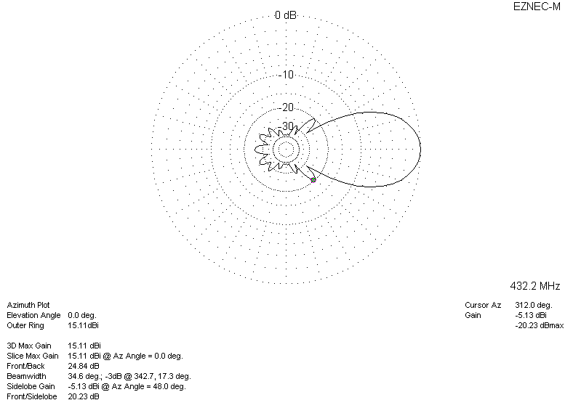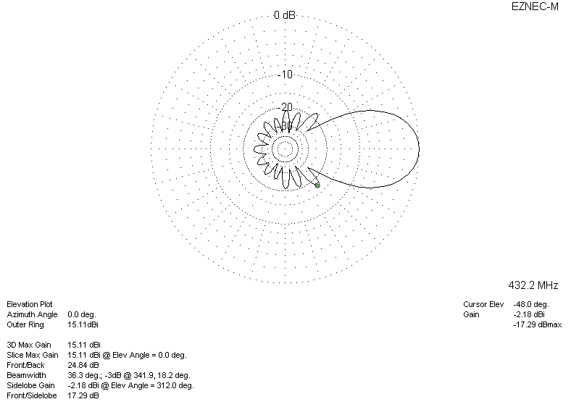

LOSSES INCLUDED (aluminum)
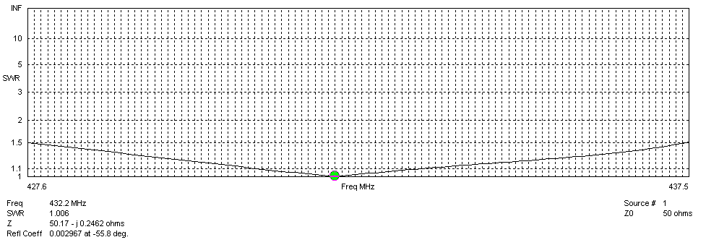
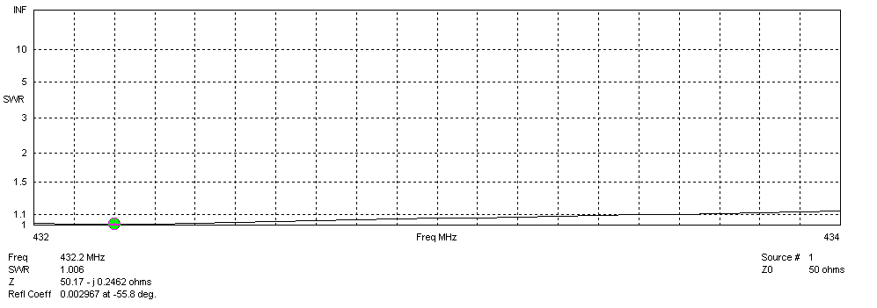
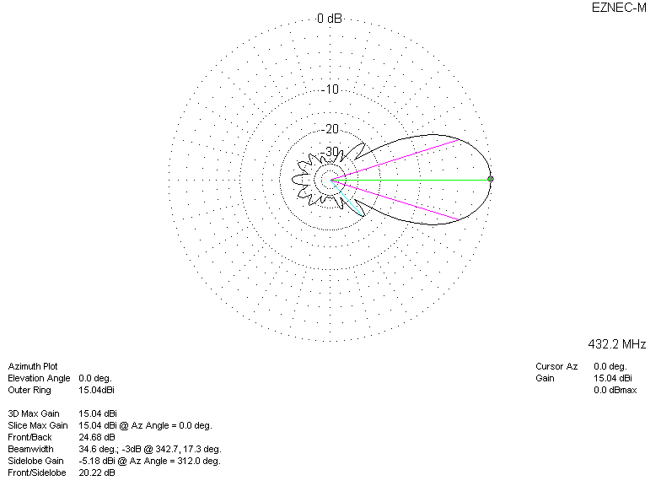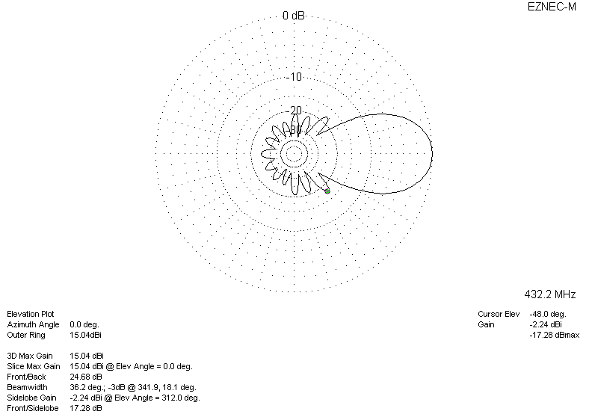

LOSSES INCLUDED (silver)
