ANTENNA Q710E6XL
PERFORMANCES: (No loss condition)
TYPE | ELE | L (mm) | G (dBi) | F/B (dB) | F/Sh (dBi) | F/Sv (dBi) | Hor (◦) | Ver (◦) | Temp (◦K) | G/T (dB) | ΔF * (kHz)
Q710E6XL | 10 | 2084 | 15,21 | 22,86 | 23,19 | 19,58 | 34,8 | 37,1 | 19,5 | +2,31 | 8200
* ΔF given for SWR=1,5

PERFORMANCES: (Losses included)
Element material | G (dBi) | Temp (◦K) | G/T (dB)
Aluminum rods | 15,16 | 22,7 | +1,60
Silvered rods | 15,18 | 21,5 | +1,85

DIMENSIONS:
 | Ref | De | D1 | D2 | D3 | D4 | D5 | D6 | D7 | D8 | - All elements made of Al rods Ǿ5,0 mm  - The height of all rectangles is 100 mm  - All dimensions given in milimetres
Pos | 0 | 101 | 193 | 376 | 618 | 886 | 1189 | 1499 | 1791 | 2084
Length | 278 | 252 | 244 | 227 | 219 | 210 | 201 | 195 | 191 | 182

COMPARISON
Antenna | Boomlength (mm) | Material | Gain (dBi) | TA (◦K) | G/T (dB) | Bandwidth  (MHz)
Q710E6XL | 2084 | No loss | 15,43 | 20,9 | +2,22 | 428,900-437,100
Q710E6XL | 2084 | Aluminum | 15,37 | 24,6 | +1,46 | 428,900-437,100
Q710E6XL | 2084 | Silver | 15,39 | 23,3 | +1,72 | 428,900-437,100
EF7011-5 | 2110 | No loss | 15,28 | 26,0 | +1,12 | 430,050-434,540
EF7011-5 | 2110 | Aluminum | 15,22 | 30,5 | +0,28 | 430,050-434,540
EF7011-5 | 2110 | Silver | 15,24 | 28,9 | +0,63 | 430,050-434,540

DIAGRAMS
NO LOSS INCLUDED

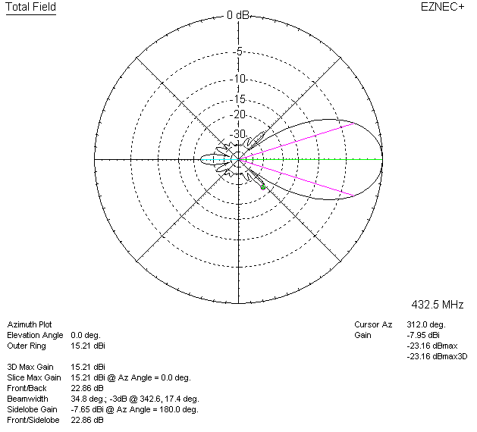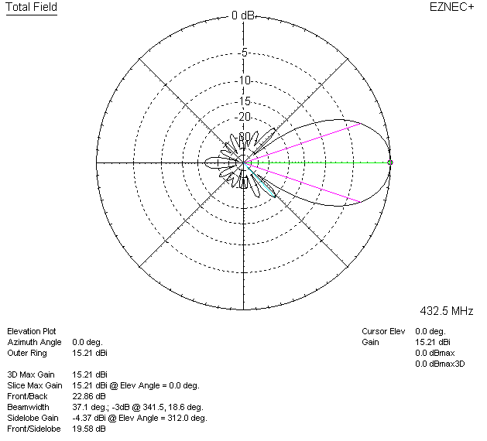

LOSSES INCLUDED (aluminum)
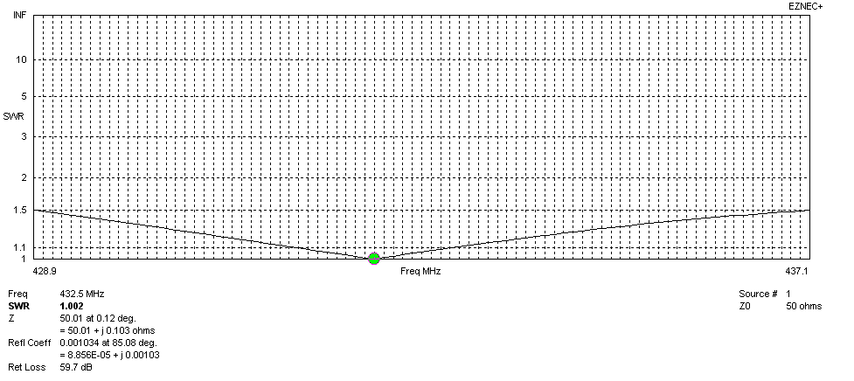
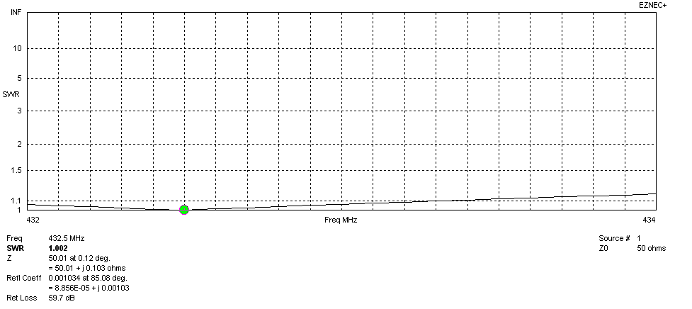
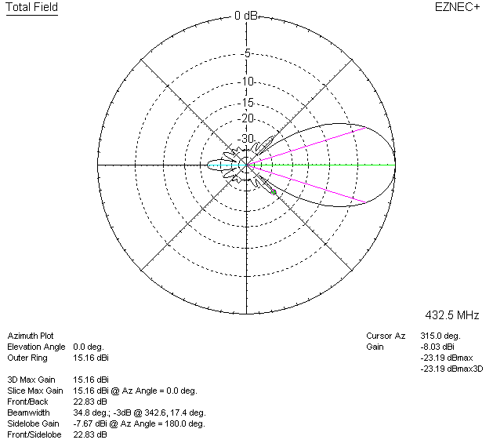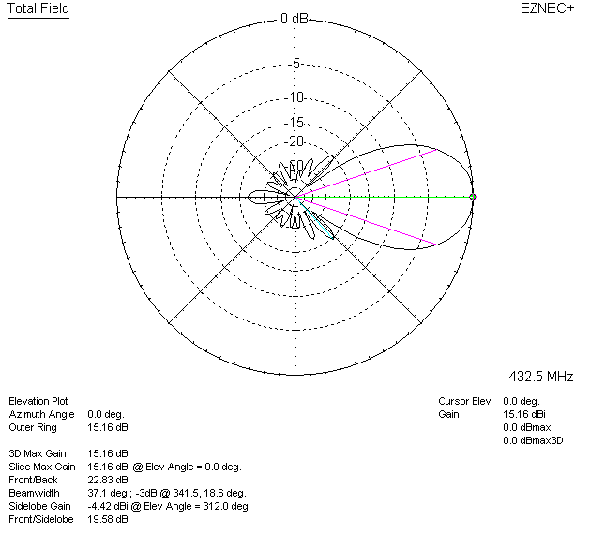

LOSSES INCLUDED (silver)
