ANTENNA Q710E2XL
PERFORMANCES: (No loss condition)
TYPE | ELE | L (mm) | G (dBi) | F/B (dB) | F/Sh (dBi) | F/Sv (dBi) | Hor (◦) | Ver (◦) | Temp (◦K) | G/T (dB) | ΔF * (kHz)
Q710E2XL | 10 | 2050 | 15,39 | 34,95 | 20,91 | 18,08 | 33,8 | 35,7 | 21,1 | +2,14 | 10100
* ΔF given for SWR=1,5

PERFORMANCES: (Losses included)
Element material | G (dBi) | Temp (◦K) | G/T (dB)
Aluminum rods | 15,30 | 27,2 | +0,95
Silvered rods | 15,33 | 25,0 | +1,35

DIMENSIONS:
 | Ref | De | D1 | D2 | D3 | D4 | D5 | D6 | D7 | D8 | - All elements made of Al rods Ǿ3,0 mm  - The height of all rectangles is 135 mm  - All dimensions given in milimetres
Pos | 0 | 102 | 184 | 371 | 623 | 889 | 1195 | 1499 | 1789 | 2050
Length | 242 | 223 | 215 | 205 | 199 | 190 | 184 | 180 | 178 | 174

COMPARISON
Antenna | Boomlength (mm) | Material | Gain (dBi) | TA (◦K) | G/T (dB) | Bandwidth  (MHz)
Q710E2XL | 2050 | No loss | 15,39 | 21,1 | +2,14 | 428,050-438,150
Q710E2XL | 2050 | Aluminum | 15,30 | 27,2 | +0,95 | 428,050-438,150
Q710E2XL | 2050 | Silver | 15,33 | 25,0 | +1,35 | 428,050-438,150
EF7011-5 | 2110 | No loss | 15,28 | 26,0 | +1,12 | 430,050-434,540
EF7011-5 | 2110 | Aluminum | 15,22 | 30,5 | +0,28 | 430,050-434,540
EF7011-5 | 2110 | Silver | 15,24 | 28,9 | +0,63 | 430,050-434,540

DIAGRAMS
NO LOSS INCLUDED

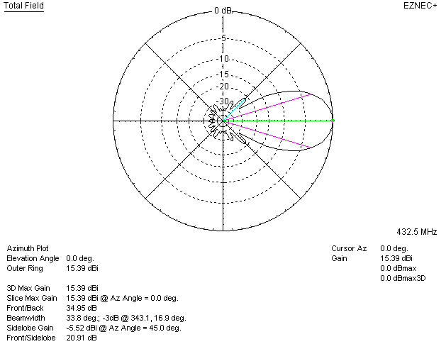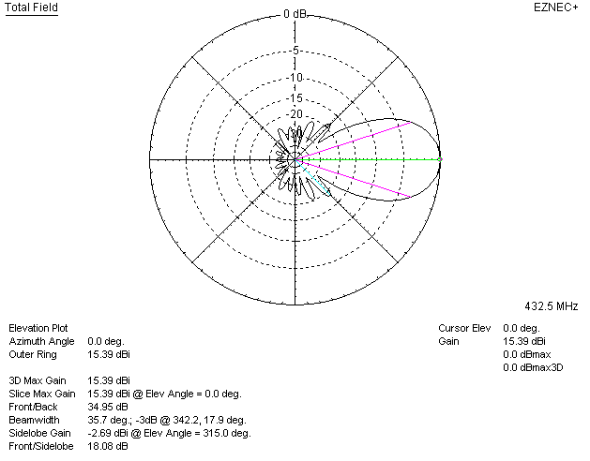

LOSSES INCLUDED (aluminum)
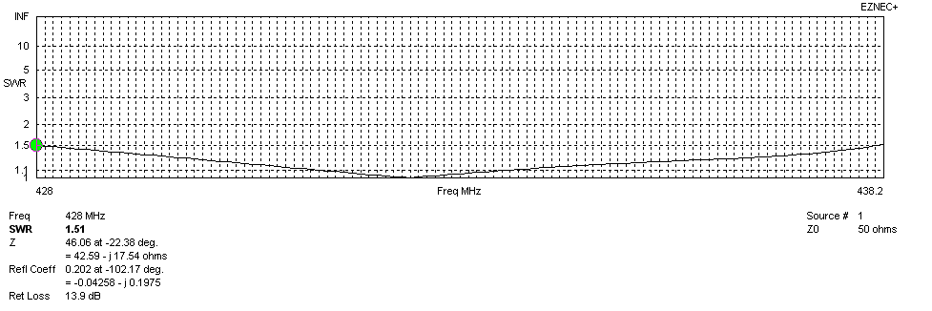
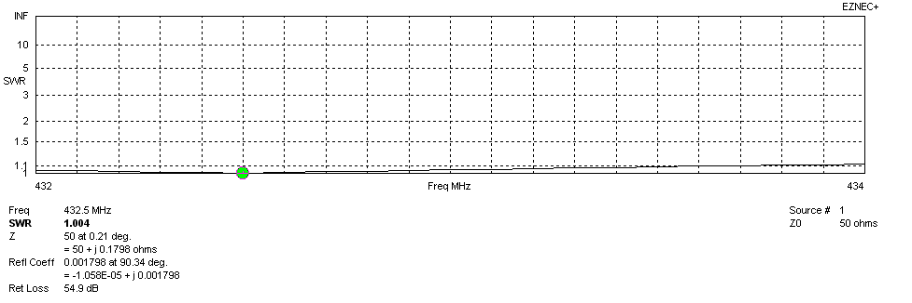
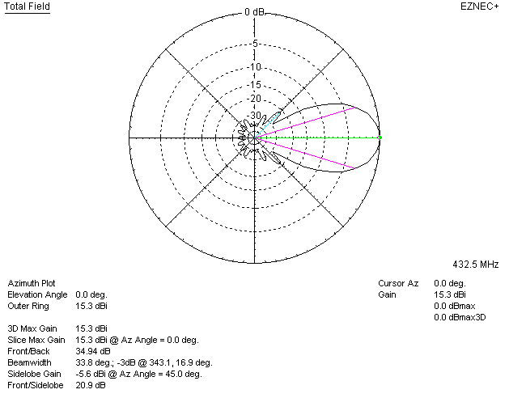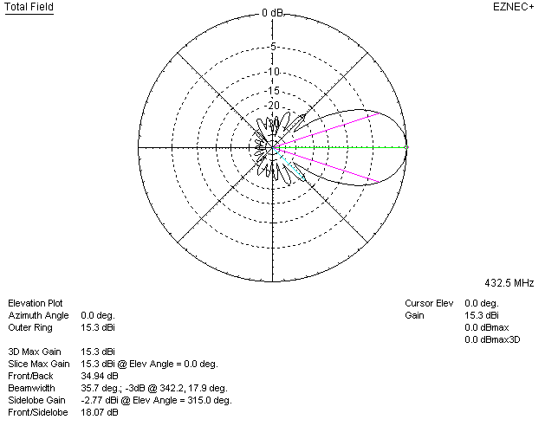

LOSSES INCLUDED (silver)
