ANTENNA Q710E1XL
PERFORMANCES: (No loss condition)
TYPE | ELE | L (mm) | G (dBi) | F/B (dB) | F/Sh (dBi) | F/Sv (dBi) | Hor (◦) | Ver (◦) | Temp (◦K) | G/T (dB) | ΔF * (kHz)
Q710E1XL | 10 | 2052 | 15,42 | 35,10 | 20,82 | 18,01 | 33,4 | 35,1 | 21,8 | +2,11 | 8000
* ΔF given for SWR=1,5

PERFORMANCES: (Losses included)
Element material | G (dBi) | Temp (◦K) | G/T (dB)
Aluminum rods | 15,38 | 29,4 | +0,70
Silvered rods | 15,42 | 26,6 | +1,18

DIMENSIONS:
 | Ref | De | D1 | D2 | D3 | D4 | D5 | D6 | D7 | D8 | - All elements made of Al rods Ǿ2,5 mm  - The height of all rectangles is 135 mm  - All dimensions given in milimetres
Pos | 0 | 105 | 186 | 372 | 621 | 888 | 1195 | 1497 | 1787 | 2052
Length | 240 | 222 | 215 | 206 | 200 | 192 | 186 | 182 | 180 | 178

COMPARISON
Antenna | Boomlength (mm) | Material | Gain (dBi) | TA (◦K) | G/T (dB) | Bandwidth  (MHz)
Q710B1XL | 2052 | No loss | 15,42 | 21,8 | +2,11 | 428,800-436,800
Q710B1XL | 2052 | Aluminum | 15,38 | 29,4 | +0,70 | 428,800-436,800
Q710B1XL | 2052 | Silver | 14,61 | 26,6 | +1,18 | 428,800-436,800
EF7011-5 | 2110 | No loss | 15,28 | 26,0 | +1,12 | 430,050-434,540
EF7011-5 | 2110 | Aluminum | 15,22 | 30,5 | +0,28 | 430,050-434,540
EF7011-5 | 2110 | Silver | 15,24 | 28,9 | +0,63 | 430,050-434,540

DIAGRAMS
NO LOSS INCLUDED
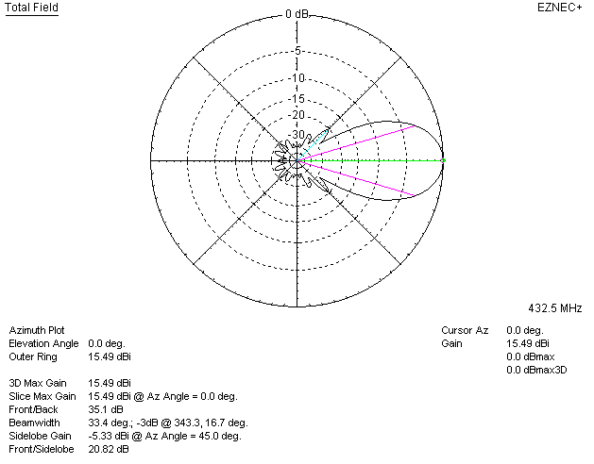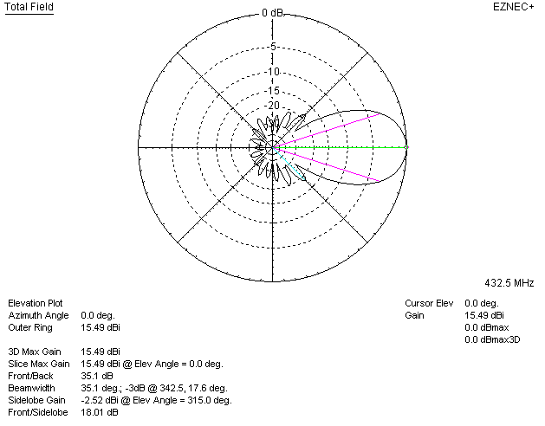

LOSSES INCLUDED (aluminum)
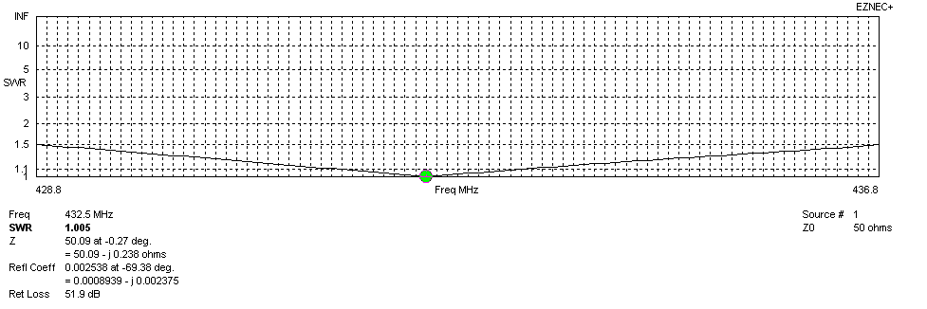
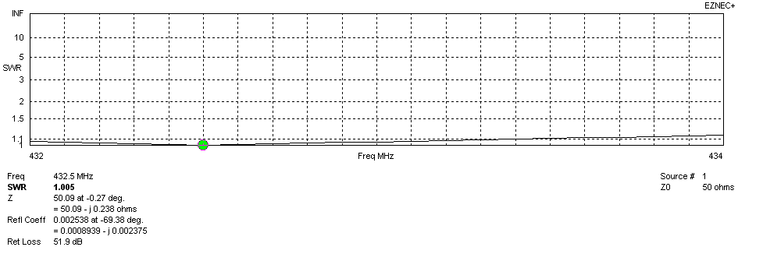
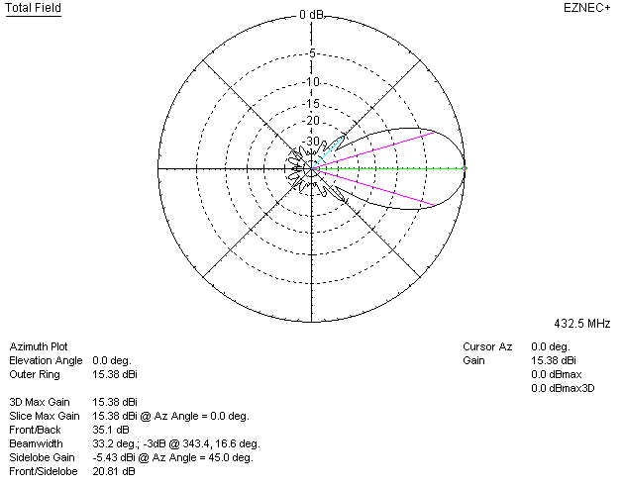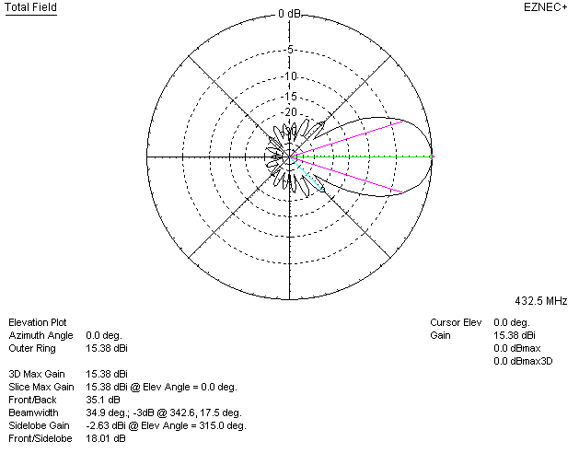

LOSSES INCLUDED (silver)
