ANTENNA Q710D9XL
PERFORMANCES: (No loss condition)
TYPE | ELE | L (mm) | G (dBi) | F/B (dB) | F/Sh (dBi) | F/Sv (dBi) | Hor (◦) | Ver (◦) | Temp (◦K) | G/T (dB) | ΔF * (kHz)
Q710D9XL | 10 | 1800 | 14,95 | 18,74 | 21,68 | 17,86 | 35,0 | 37,2 | 23,1 | +1,31 | 13900
* ΔF given for SWR=1,5

PERFORMANCES: (Losses included)
Element material | G (dBi) | Temp (◦K) | G/T (dB)
Aluminum rods | 14,92 | 25,1 | +0,92
Silvered rods | 14,93 | 24,4 | +1,06

DIMENSIONS:
 | Ref | De | D1 | D2 | D3 | D4 | D5 | D6 | D7 | D8 | - All elements made of Al rods Ǿ10,0 mm  - The height of all rectangles is 100 mm  - All dimensions given in milimetres
Pos | 0 | 123 | 200 | 350 | 487 | 695 | 948 | 1235 | 1515 | 1800
Length | 286 | 264 | 247 | 222 | 218 | 215 | 209 | 203 | 195 | 189

COMPARISON
Antenna | Boomlength (mm) | Material | Gain (dBi) | TA (◦K) | G/T (dB) | Bandwidth  (MHz)
Q710D9XL | 1800 | No loss | 14,95 | 23,1 | +1,31 | 421,900-435,800
Q710D9XL | 1800 | Aluminum | 14,92 | 25,1 | +0,92 | 421,900-435,800
Q710D9XL | 1800 | Silver | 14,93 | 24,4 | +1,06 | 421,900-435,800
EF7011-5 | 2110 | No loss | 15,28 | 26,0 | +1,12 | 430,050-434,540
EF7011-5 | 2110 | Aluminum | 15,22 | 30,5 | +0,28 | 430,050-434,540
EF7011-5 | 2110 | Silver | 15,24 | 28,9 | +0,63 | 430,050-434,540

DIAGRAMS
NO LOSS INCLUDED

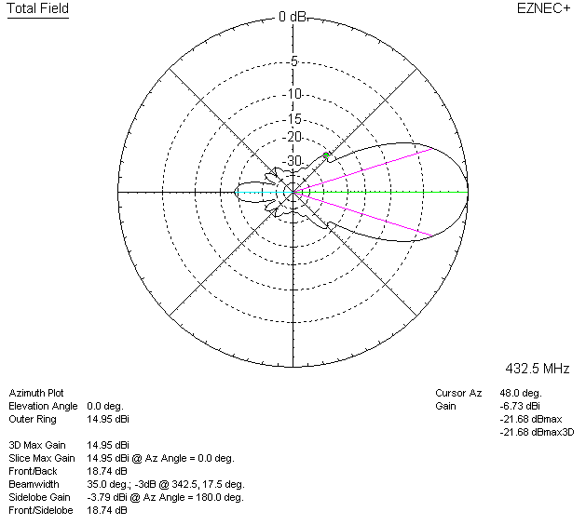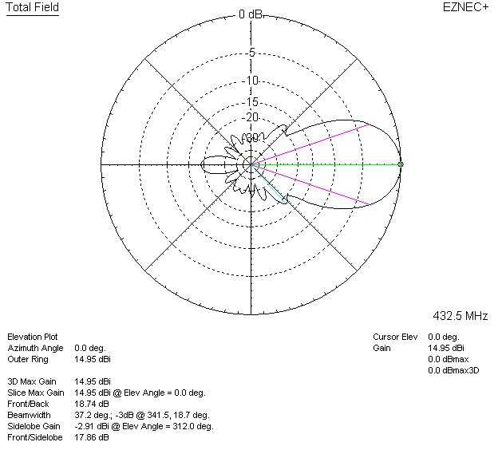

LOSS INCLUDED (aluminum)
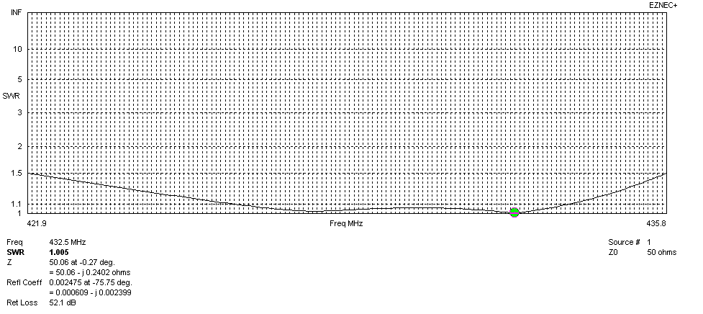
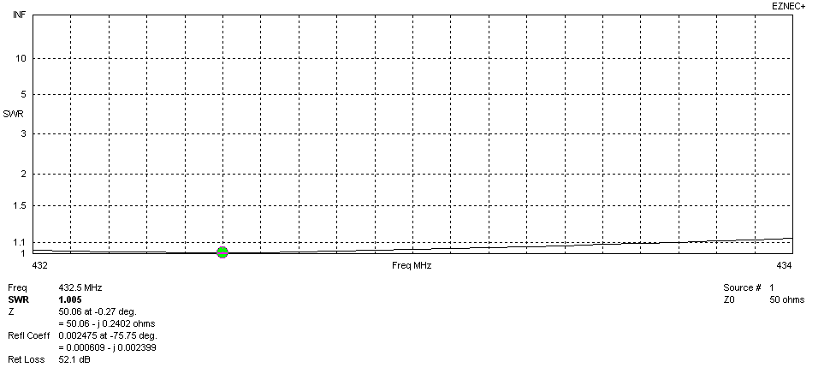
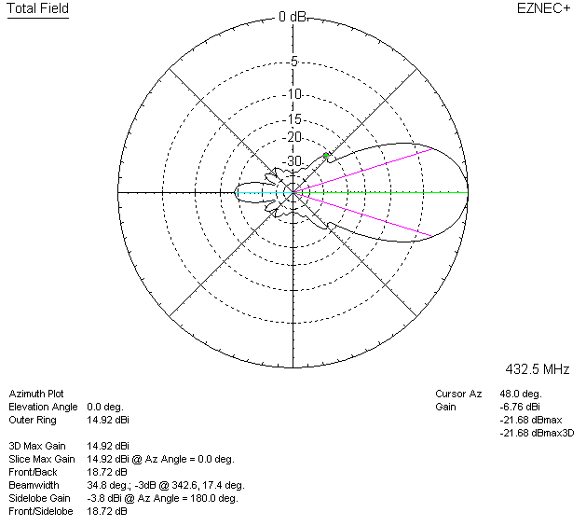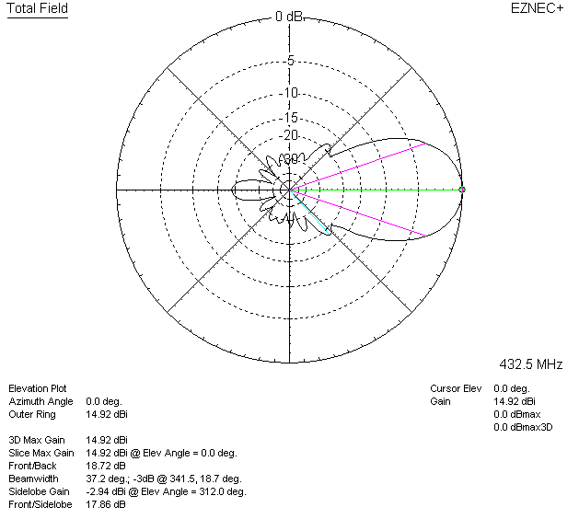

LOSSES INCLUDED (silver)
