ANTENNA Q2326H7XL
DESCRIPTION:
Boomlength | Number of elements | Diameter of elements | Height of elements | Antenna for high gain and broadband characteristic, recommended material: aluminum
2240 mm | 26 | 5,0 mm | 40 mm

PERFORMANCES:
Element material | G (dBi) | F/B  (dB) | F/Sh (dBi) | F/Sv (dBi) | Hor  (◦) | Ver  (◦) | Temp (◦K) | G/T (dB) | Bandwidth (MHz)  for SWR=1,5
No loss | 19,49 | 37,50 | 20,05 | 19,13 | 21,6 | 22,0 | 10,9 | +9,11 | 1274,500-1309,100
Aluminum rods | 19,45 | 37,36 | 20,05 | 19,13 | 21,6 | 22,0 | 13,7 | +8,09 | 1274,500-1309,100
Silvered rods | 19.47 | 37,42 | 20,06 | 19,13 | 21,6 | 22,0 | 12,7 | +8.43 | 1274,500-1309,100

DIMENSIONS:
 | Ref | De | D1 | D2 | D3 | D4 | D5 | D6 | D7 | D8 | D9 | D10 | D11
Pos | 0 | 42 | 66 | 116 | 159 | 226 | 311 | 412 | 507 | 608 | 708 | 809 | 910
Length | 92,5 | 82 | 77 | 69 | 67,5 | 67 | 65 | 63 | 62 | 61 | 600 | 59 | 58,5
 | D12 | D13 | D14 | D15 | D16 | D17 | D18 | D19 | D20 | D21 | D22 | D23 | D24
Pos | 1007 | 1107 | 1208 | 1308 | 1411 | 1517 | 1622 | 1728 | 1839 | 1939 | 2044 | 2149 | 2240
Length | 57,5 | 56,5 | 55,5 | 54,5 | 53,5 | 52,5 | 52 | 51,5 | 51 | 50,5 | 50 | 49 | 47
All measures given in milimeters

DIAGRAMS
NO LOSS INCLUDED
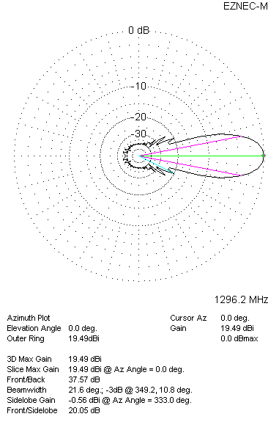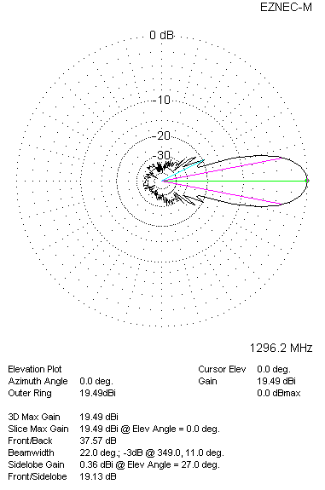

LOSSES INCLUDED (aluminum)
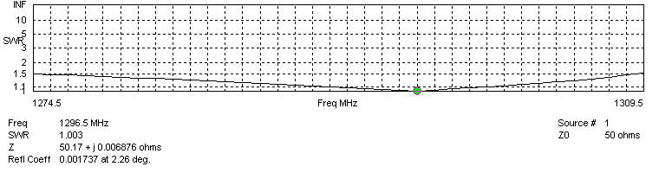
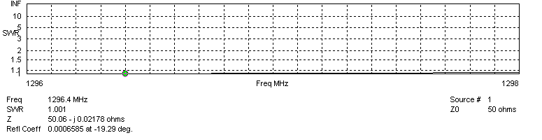

LOSSES INCLUDED (silver)
