PERFORMANCES: (No loss condition)
TYPE | ELE | L (mm) | G (dBi) | F/B (dB) | F/Sh (dBi) | F/Sv (dBi) | Hor (◦) | Ver (◦) | Temp (◦K) | G/T (dB) | ΔF * (kHz)
QQ210E1XL | 10 | 6455 | 15,71 | 26,97 | 18,74 | 17,73 | 31,8 | 32,3 | 229,9 | -7,91 | 2080
* ΔF given for SWR=1,5

PERFORMANCES: (Losses included)
Element material | G (dBi) | Temp (◦K) | G/T (dB)
Aluminum rods | 15,62 | 231,2 | -8,02

DIMENSIONS:
 | Ref | De | D1 | D2 | D3 | D4 | D5 | D6 | D7 | D8 | - All elements made of Al rods Ǿ5 mm  - The height of all rectangles ±400 mm  - All dimensions given in milimetres  - This is double element oblong
Pos | 0 | 382 | 765 | 1455 | 2229 | 3006 | 3895 | 4768 | 5575 | 6455
Length | 640 | 592 | 575 | 543 | 523 | 511 | 496 | 487 | 480 | 472

COMPARISON
Antenna | Boomlength (mm) | Material | Gain (dBi) | TA (◦K) | G/T (dB) | BANDWIDTH  (MHz)
QQ210E1XL | 6455 | No loss | 15,71 | 229,9 | -7,91 | 143,420-145,500
QQ210E1XL | 6455 | Aluminum | 15,62 | 231,2 | -8,02 | 143,420-145,500
EF0211-5 | 6325 | No loss | 15,24 | 226,7 | -8,31 | 142,500-144,750
EF0211-5 | 6325 | Aluminum | 15,14 | 228,5 | -8,45 | 142,500-144,750

DIAGRAMS (no loss included)
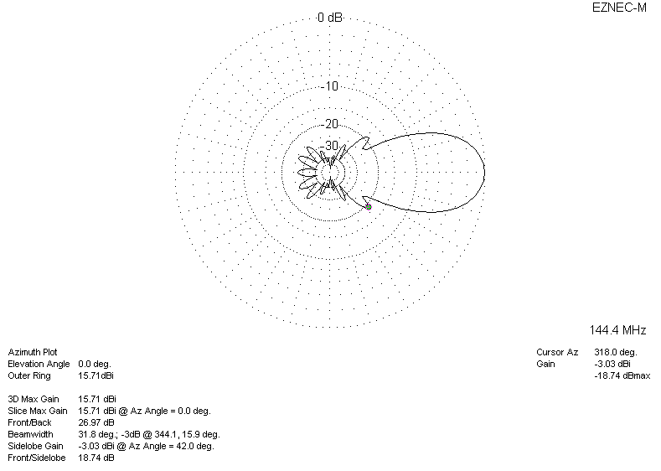
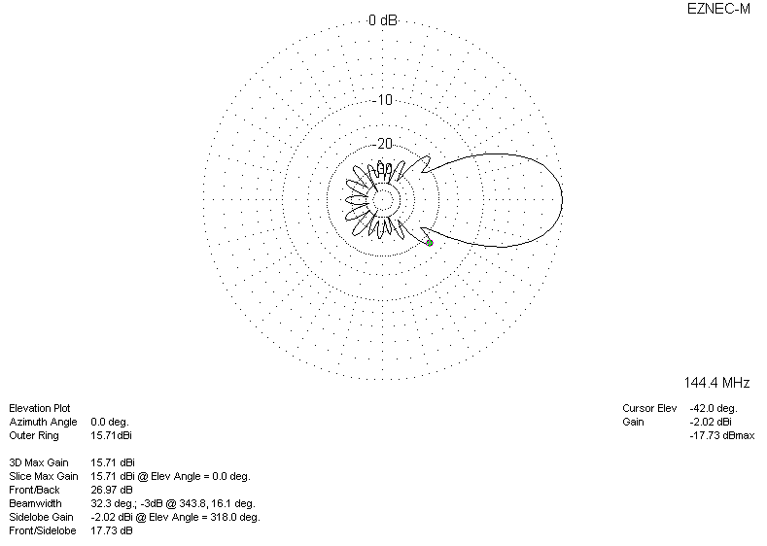
DIAGRAMS (losses included)
