PERFORMANCES: (No loss condition)
TYPE | ELE | L (mm) | G (dBi) | F/B (dB) | F/Sh (dBi) | F/Sv (dBi) | Hor (◦) | Ver (◦) | Temp (◦K) | G/T (dB) | ΔF * (kHz)
QQ206H1XL | 6 | 2881 | 13,12 | 22,41 | 22,55 | 17,31 | 42,0 | 44,8 | 251,1 | -10,88 | 1850
* ΔF given for SWR=1,5

PERFORMANCES: (Losses included)
Element material | G (dBi) | Temp (◦K) | G/T (dB)
Aluminum rods | 13,04 | 251,7 | -10,97

DIMENSIONS:
 | Ref | De | D1 | D2 | D3 | D4 | REMARKS: : - All elements made of Al rods Ǿ5 mm  - The height of all rectangles is ±300 mm  - All dimensions given in milimetres  - This is double element oblong
Pos | 0 | 243 | 685 | 1435 | 2205 | 2881
Length | 744 | 699 | 652 | 610 | 586 | 570

COMPARISON
Antenna | Boomlength (mm) | Material | Gain (dBi) | TA (◦K) | G/T (dB) | BANDWIDTH  (MHz)
QQ206H1XL | 2881 | No loss | 13,12 | 251,1 | -10,88 | 143,450-145,300
QQ206H1XL | 2881 | Aluminum | 13,04 | 251,7 | -10,97 | 143,450-145,300
EF0206-5 | 2377 | No loss | 11,91 | 283,0 | -12,61 | 140,200-145,300
EF0206-5 | 2377 | Aluminum | 11,84 | 283,3 | -12,68 | 140,200-145,300
EF0207-5 | 3274 | No loss | 12,95 | 255,9 | -11,13 | 140,500-145,100
EF0207-5 | 3274 | Aluminum | 12,86 | 256,8 | -11,25 | 140,500-145,100

DIAGRAMS (no loss included)
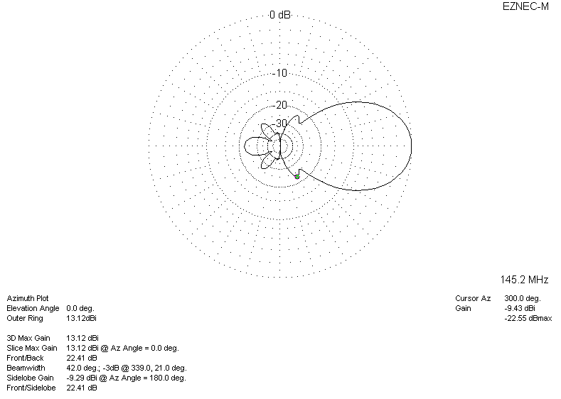
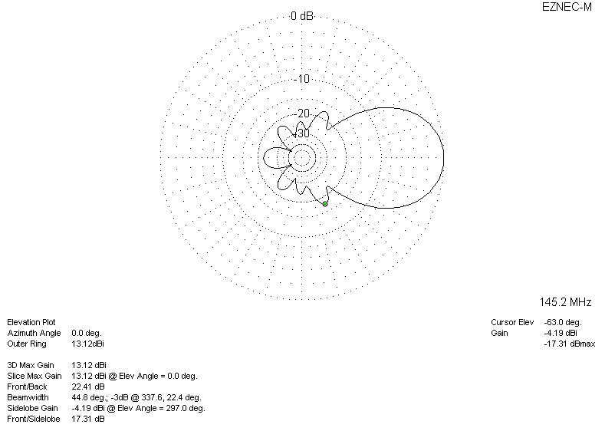
DIAGRAMS (losses included)
