PERFORMANCES: (No loss condition)
TYPE | ELE | L (mm) | G (dBi) | F/B (dB) | F/Sh (dBi) | F/Sv (dBi) | Hor (◦) | Ver (◦) | Temp (◦K) | G/T (dB) | ΔF * (kHz)
QQ205H1XL | 5 | 2080 | 12,27 | 21,41 | 24,79 | 17,38 | 45,6 | 49,6 | 266,6 | -11,99 | 1700
* ΔF given for SWR=1,5

PERFORMANCES: (Losses included)
Element material | G (dBi) | Temp (◦K) | G/T (dB)
Aluminum rods | 12,19 | 266,9 | -12,07

DIMENSIONS:
 | Ref | De | D1 | D2 | D3 |  | REMARKS: : - All elements made of Al rods Ǿ5 mm  - The height of all rectangles is ±400 mm  - All dimensions given in milimetres  - This is double-element oblong
Pos | 0 | 241 | 687 | 1435 | 2080
Length | 752 | 698 | 652 | 610 | 586

COMPARISON
Antenna | Boomlength (mm) | Material | Gain (dBi) | TA (◦K) | G/T (dB) | BEAMWIDTH  (MHz)
QQ205H1XL | 2080 | No loss | 12,27 | 266,6 | -11,99 | 143,550-145,250
QQ205H1XL | 2080 | Aluminum | 12,19 | 266,9 | -12,07 | 143,550-145,250
EF0206-5 | 2377 | No loss | 11,91 | 283,0 | -12,61 | 140,200-145,300
EF0206-5 | 2377 | Aluminum | 11,84 | 283,3 | -12,68 | 140,200-145,300

DIAGRAMS (no loss included)
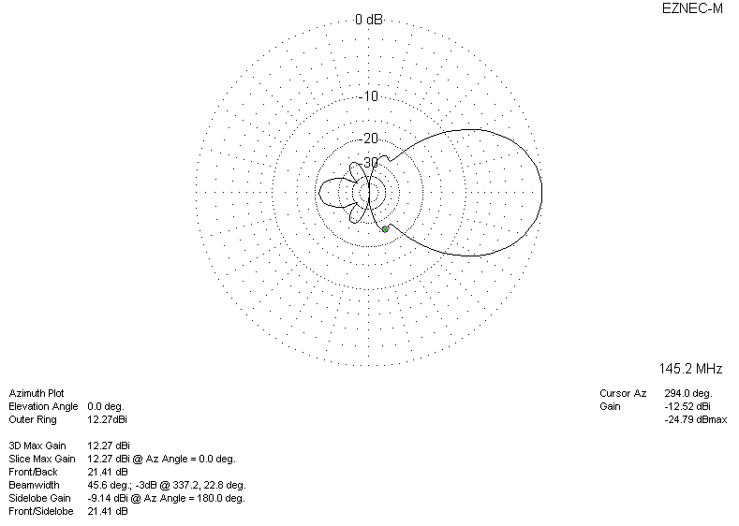
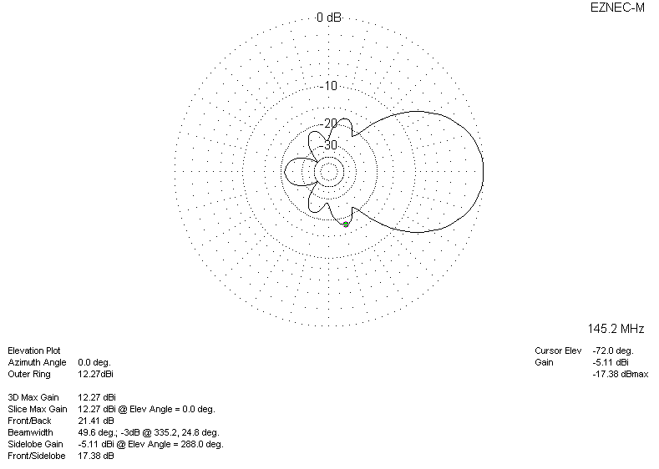
DIAGRAMS (losses included)
