PERFORMANCES: (No loss condition)
TYPE | ELE | L (mm) | G (dBi) | F/B (dB) | F/Sh (dBi) | F/Sv (dBi) | Hor (◦) | Ver (◦) | Temp (◦K) | G/T (dB) | ΔF * (kHz)
Q225D1XL | 25 | 19519 | 19,69 | 32,67 | 18,99 | 17,97 | 20,6 | 21,0 | 213,2 | -3,62 | 2,600
* ΔF given for SWR=1,5

PERFORMANCES: (Losses included)
Element material | G (dBi) | Temp (◦K) | G/T (dB)
Aluminum rods | 19,56 | 215,3 | -3,77

COMPARISON
Antenna | Boomlength (mm) | Material | Gain (dBi) | TA (◦K) | G/T (dB) | Bandwith (MHz)
Q225D1XL | 19519 | No loss | 19,69 | 213,2 | -3,62 | 143,470-146,070
Q225D1XL | 19519 | Aluminum | 19,56 | 215,4 | -3,77 | 143,470-146,070
EF0215-5 | 10060 | No loss | 17,26 | 223,0 | -6,22 | 143,750-144,460
EF0215-5 | 10060 | Aluminum | 17,06 | 226,7 | -6,49 | 143,750-144,460

DIMENSIONS:
 | Ref | De | D1 | D2 | D3 | D4 | D5 | D6 | D7 | D8 | D9 | D10 | D11
Pos | 0 | 275 | 480 | 862 | 1489 | 2189 | 2973 | 3805 | 4678 | 5597 | 6528 | 7455 | 8387
Length | 786 | 734 | 708 | 691 | 673 | 659 | 645 | 633 | 625 | 611 | 609 | 605 | 597
 | D12 | D13 | D14 | D15 | D16 | D17 | D18 | D19 | D20 | D21 | D22 | D23
Pos | 9318 | 10271 | 11205 | 12175 | 13135 | 14065 | 15065 | 15975 | 16895 | 17855 | 18745 | 19519
Length | 594 | 588 | 578 | 576 | 564 | 564 | 562 | 562 | 560 | 560 | 558 | 558

REMARKS: : - All elements made of Al rods Ǿ5 mm
- The height of all rectangles is 320 mm
- All dimensions given in milimetres

DIAGRAMS (no losses included)
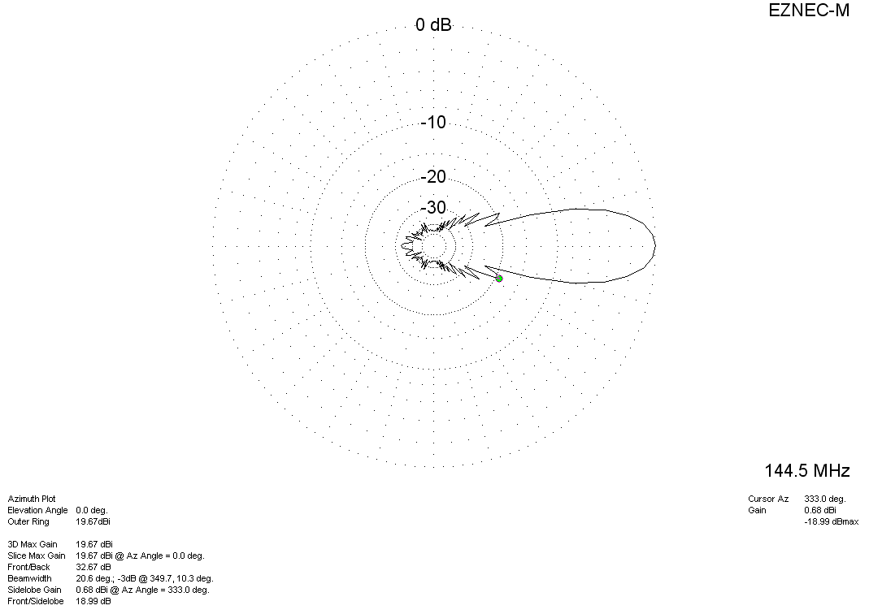
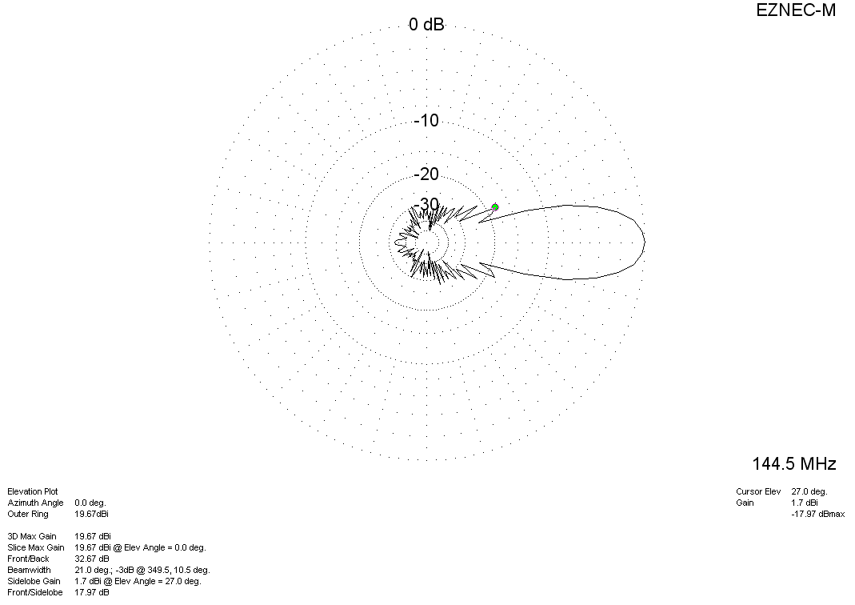

DIAGRAMS (losses included)
