ANTENNA Q224D1XL
PERFORMANCES: (No loss condition)
TYPE | ELE | L (mm) | G (dBi) | F/B (dB) | F/Sh (dBi) | F/Sv (dBi) | Hor (◦) | Ver (◦) | Temp (◦K) | G/T (dB) | ΔF * (kHz)
Q224D1XL | 24 | 19 | 19,48 | 30,90 | 18,53 | 17,51 | 21,2 | 21,6 | 213,2 | -3,81 | 2780
* ΔF given for SWR=1,5 (from 143,400 to 146,180 MHz)

PERFORMANCES: (Losses included)
Element material | G (dBi) | Temp (◦K) | G/T (dB)
Aluminum rods | 19,37 | 215,4 | -3,96

COMPARISON
Antenna | Boomlength (mm) | Material | Gain (dBi) | TA (◦K) | G/T (dB) | Bandwith (MHz)
Q224D1XL | 18585 | No loss | 19,69 | 213,2 | -3,62 | 143,400-146,180
Q224D1XL | 18585 | Aluminum | 19,37 | 215,4 | -3,96 | 143,400-146,180
EF0215-5 | 10060 | No loss | 17,26 | 223,0 | -6,22 | 143,750-144,460
EF0215-5 | 10060 | Aluminum | 17,06 | 226,7 | -6,49 | 143,750-144,460

DIMENSIONS:
 | Ref | De | D1 | D2 | D3 | D4 | D5 | D6 | D7 | D8 | D9 | D10 | D11
Pos | 0 | 274 | 477 | 862 | 1484 | 2189 | 2973 | 3805 | 4678 | 5597 | 6528 | 7455 | 8387
Length | 788 | 735 | 708 | 690 | 672 | 658 | 644 | 632 | 624 | 612 | 608 | 604 | 598
 | D12 | D13 | D14 | D15 | D16 | D17 | D18 | D19 | D20 | D21 | D22
Pos | 9318 | 10271 | 11215 | 12185 | 13135 | 14065 | 15055 | 15975 | 16885 | 17795 | 18585
Length | 594 | 582 | 576 | 574 | 566 | 564 | 562 | 562 | 560 | 558 | 556

REMARKS: : - All elements made of Al rods Ǿ5 mm
- The height of all rectangles is 320 mm
- All dimensions given in milimetres

DIAGRAMS (no losses included)
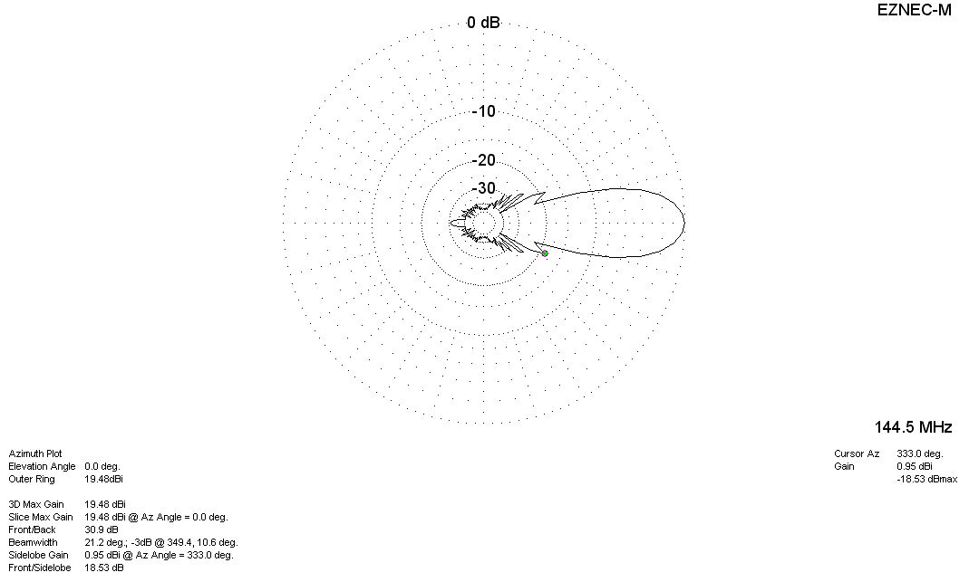
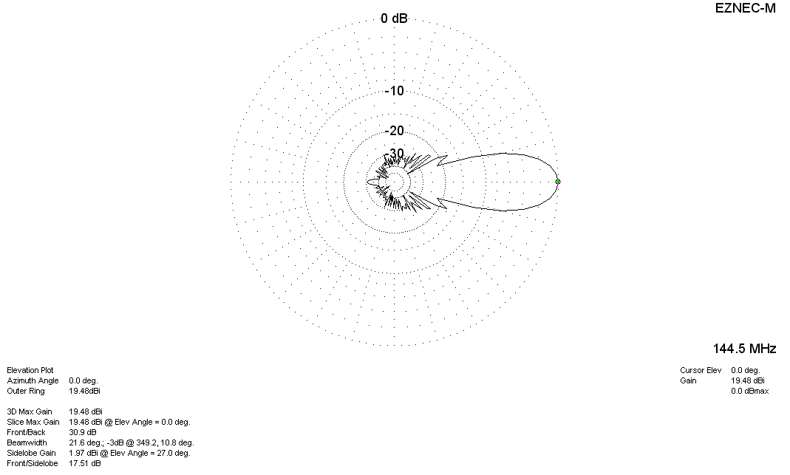

DIAGRAMS (losses included)
