ANTENNA Q221D1XL
PERFORMANCES: (No loss condition)
TYPE | ELE | L (mm) | G (dBi) | F/B (dB) | F/Sh (dBi) | F/Sv (dBi) | Hor (◦) | Ver (◦) | Temp (◦K) | G/T (dB) | ΔF * (kHz)
Q221D1XL | 21 | 15665 | 18,87 | 34,16 | 19,17 | 17,90 | 22,6 | 23,3 | 214,9 | -4,45 | 2660
* ΔF given for SWR=1,5

PERFORMANCES: (Losses included)
Element material | G (dBi) | Temp (◦K) | G/T (dB)
Aluminum rods | 18,76 | 217,2 | -4,61

COMPARISON
Antenna | Boomlength (mm) | Material | Gain (dBi) | TA (◦K) | G/T (dB) | Bandwith (MHz)
Q222D1XL | 15665 | No loss | 18,87 | 214,9 | -4,45 | 143,350-146,010
Q222D1XL | 15665 | Aluminum | 18,76 | 217,2 | -4,61 | 143,350-146,010
EF0215-5 | 10060 | No loss | 17,26 | 223,0 | -6,22 | 143,750-144,460
EF0215-5 | 10060 | Aluminum | 17,06 | 226,7 | -6,49 | 143,750-144,460

DIMENSIONS:
 | Ref | De | D1 | D2 | D3 | D4 | D5 | D6 | D7 | D8 | D9 | D10 | D11
Pos | 0 | 277 | 468 | 855 | 1486 | 2189 | 2973 | 3805 | 4678 | 5597 | 6528 | 7455 | 8387
Length | 788 | 736 | 709 | 693 | 676 | 662 | 646 | 634 | 626 | 612 | 606 | 600 | 596
 | D12 | D13 | D14 | D15 | D16 | D17 | D18 | D19
Pos | 9318 | 10301 | 11205 | 12185 | 13105 | 14005 | 14935 | 15665
Length | 590 | 584 | 578 | 586 | 570 | 566 | 564 | 562

REMARKS: : - All elements made of Al rods Ǿ5 mm
- The height of all rectangles is 320 mm
- All dimensions given in milimetres

DIAGRAMS (no losses included)
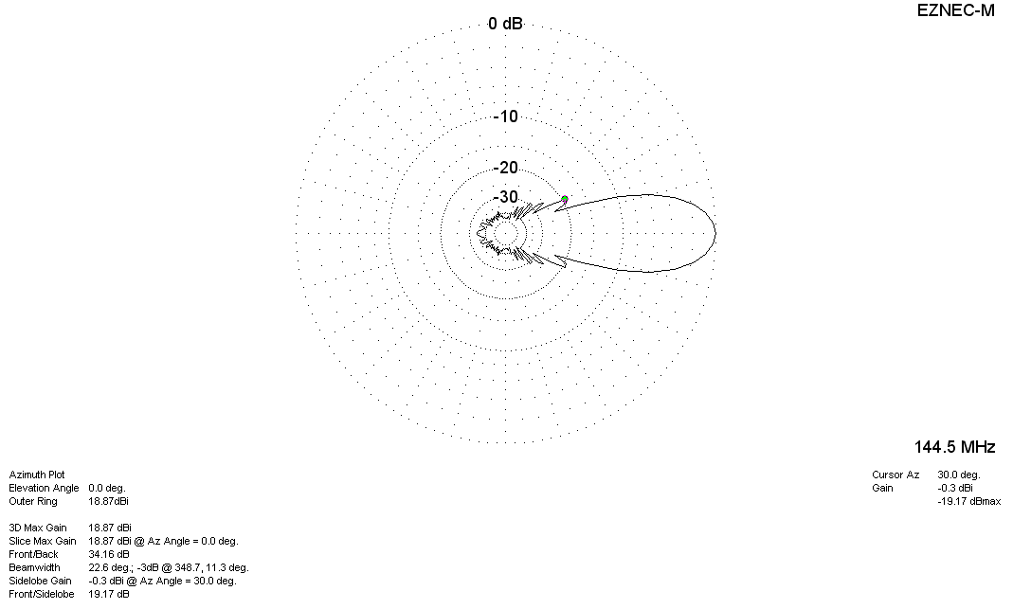
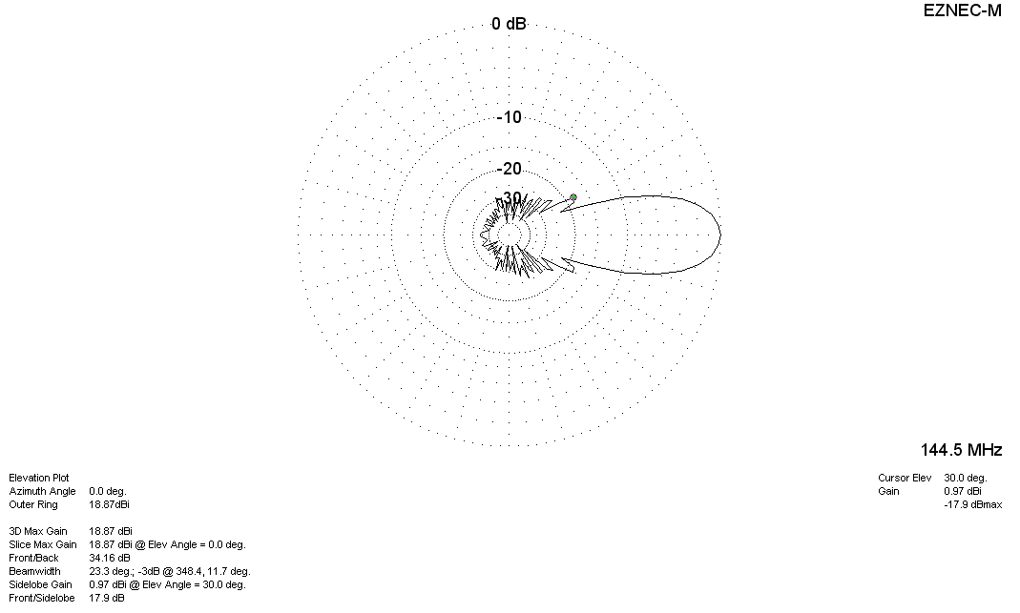

DIAGRAMS (losses included)
