ANTENNA Q218D1XL
PERFORMANCES: (No loss condition)
TYPE | ELE | L (mm) | G (dBi) | F/B (dB) | F/Sh (dBi) | F/Sv (dBi) | Hor (◦) | Ver (◦) | Temp (◦K) | G/T (dB) | ΔF * (kHz)
Q218D1XL | 18 | 12940 | 18,24 | 36,47 | 18,69 | 17,46 | 24,2 | 24,8 | 217,5 | -4,67 | 2620
* ΔF given for SWR=1,5

PERFORMANCES: (Losses included)
Element material | G (dBi) | Temp (◦K) | G/T (dB)
Aluminum rods | 18,13 | 219,7 | -5,29

COMPARISON
Antenna | Boomlength (mm) | Material | Gain (dBi) | TA (◦K) | G/T (dB) | Bandwith (MHz)
Q218D1XL | 12940 | No loss | 18,24 | 217,5 | -5,14 | 143,470-145,720
Q218D1XL | 12940 | Aluminum | 18,13 | 219,7 | -5,29 | 143,470-145,720
EF0215-5 | 10060 | No loss | 17,26 | 223,0 | -6,22 | 143,750-144,460
EF0215-5 | 10060 | Aluminum | 17,06 | 226,7 | -6,49 | 143,750-144,460

DIMENSIONS:
 | Ref | De | D1 | D2 | D3 | D4 | D5 | D6 | D7 | D8 | D9 | D10 | D11 | D12
Pos | 0 | 264 | 450 | 855 | 1486 | 2189 | 2973 | 3805 | 4678 | 5597 | 6528 | 7455 | 8397 | 9318
Length | 786 | 736 | 710 | 693 | 676 | 662 | 646 | 634 | 626 | 612 | 606 | 600 | 596 | 590
 | D13 | D14 | D15 | D16 | REMARKS: : - All elements made of Al rods Ǿ5 mm  - The height of all rectangles is 320 mm  - All dimensions given in milimetres
Pos | 10311 | 11205 | 12145 | 12940
Length | 584 | 578 | 576 | 570

DIAGRAMS (no losses included)
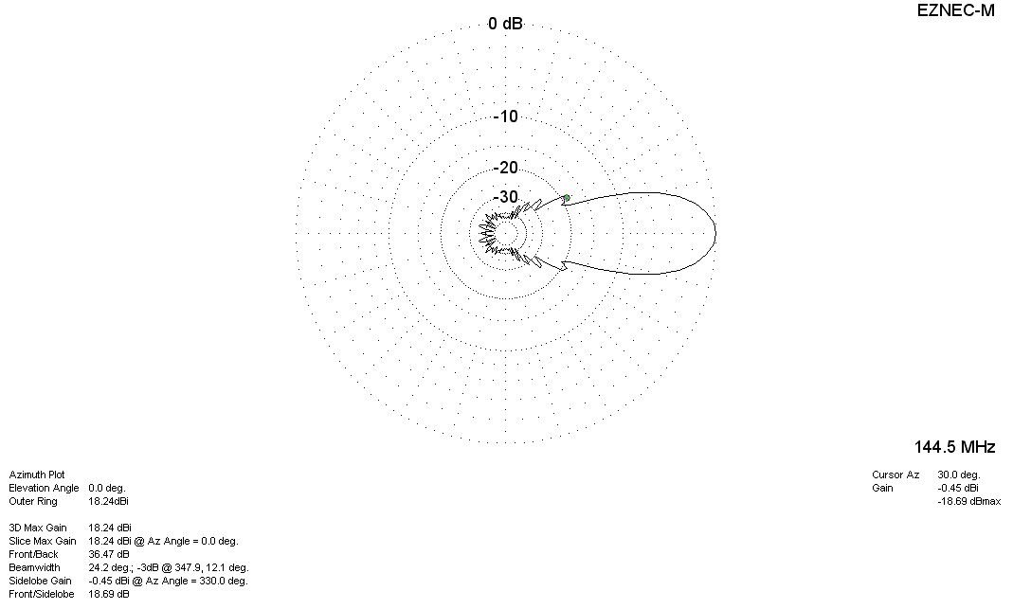
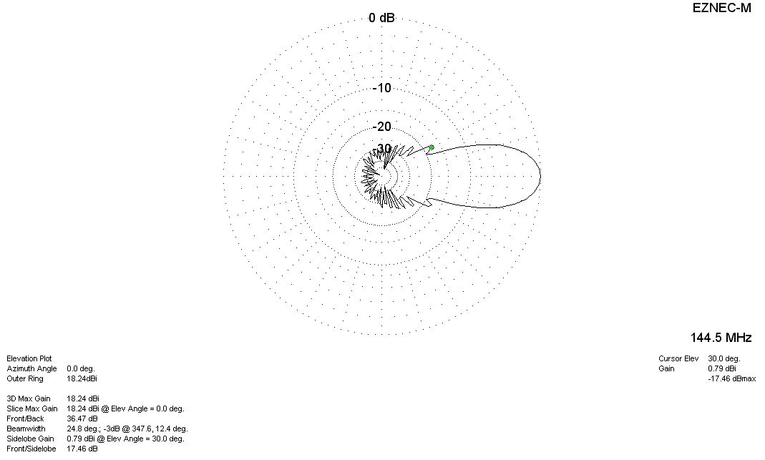

DIAGRAMS (losses included)
