ANTENNA Q216D1XL
PERFORMANCES: (No loss condition)
TYPE | ELE | L (mm) | G (dBi) | F/B (dB) | F/Sh (dBi) | F/Sv (dBi) | Hor (◦) | Ver (◦) | Temp (◦K) | G/T (dB) | ΔF * (kHz)
Q216D1XL | 16 | 11145 | 17,72 | 21,27 | 18,96 | 17,41 | 25,6 | 26,3 | 222,1 | -5,44 | 1500
* ΔF given for SWR=1,5

PERFORMANCES: (Losses included)
Element material | G (dBi) | Temp (◦K) | G/T (dB)
Aluminum rods | 17,59 | 224,3 | -5,92

COMPARISON
Antenna | Boomlength (mm) | Material | Gain (dBi) | TA (◦K) | G/T (dB) | Bandwith  (MHz)
Q216D1XL | 11145 | No loss | 17,72 | 222,1 | -5,74 | 143,730-145,230
Q216D1XL | 11145 | Aluminum | 17,59 | 224,3 | -5,92 | 143,730-145,230
EF0215-5 | 10060 | No loss | 17,26 | 223,0 | -6,22 | 143,750-144,460
EF0215-5 | 10060 | Aluminum | 17,06 | 226,7 | -6,49 | 143,750-144,460

DIMENSIONS:
 | Ref | De | D1 | D2 | D3 | D4 | D5 | D6 | D7 | D8 | D9 | D10 | D11 | D12
Pos | 0 | 261 | 421 | 841 | 1472 | 2179 | 2963 | 3805 | 4678 | 5597 | 6528 | 7455 | 8397 | 9298
Length | 784 | 738 | 718 | 698 | 679 | 659 | 643 | 631 | 620 | 610 | 606 | 600 | 594 | 588
 | D13 | D14 | REMARKS: : - All elements made of Al rods Ǿ5 mm  - The height of all rectangles is 320 mm  - All dimensions given in milimetres
Pos | 10289 | 11145
Length | 582 | 576

DIAGRAMS (no losses included)
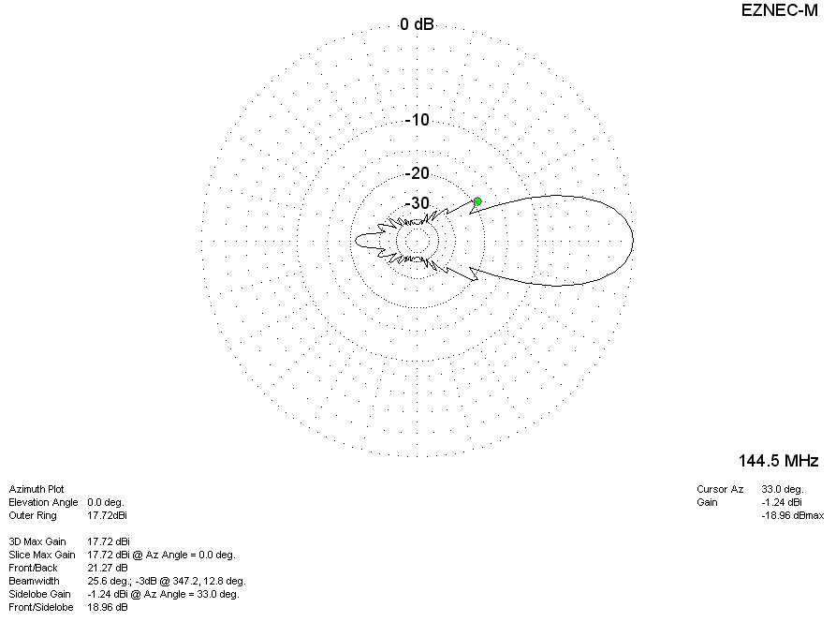
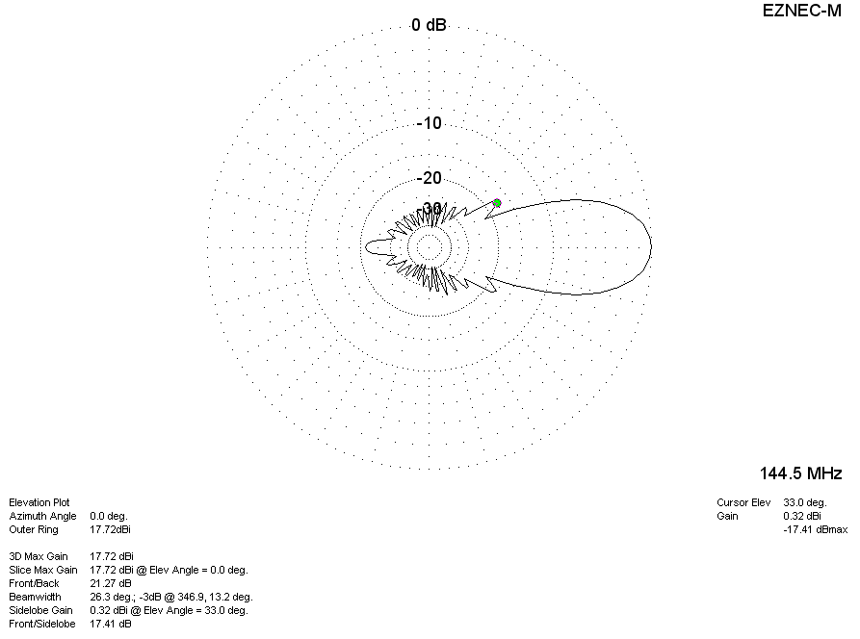

DIAGRAMS (losses included)
