ANTENNA Q215D2XL
PERFORMANCES: (No loss condition)
TYPE | ELE | L (mm) | G (dBi) | F/B (dB) | F/Sh (dBi) | F/Sv (dBi) | Hor (◦) | Ver (◦) | Temp (◦K) | G/T (dB) | ΔF * (kHz)
Q215D2XL | 15 | 10150 | 17,31 | 25,22 | 19,65 | 17,78 | 26,6 | 27,7 | 223,0 | -6,17 | 2170
* ΔF given for SWR=1,5

PERFORMANCES: (Losses included)
Element material | G (dBi) | Temp (◦K) | G/T (dB)
Aluminum rods | 17,19 | 225,1 | -6,33

COMPARISON
Antenna | Boomlength (mm) | Material | Gain (dBi) | TA (◦K) | G/T (dB) | Bandwidth (MHz)
Q215D2XL | 10150 | No loss | 17,31 | 223,0 | -6,17 | 143,200-145,370
Q215D2XL | 10150 | Aluminum | 17,19 | 225,1 | -6,33 | 143,200-145,370
EF0215-5 | 10060 | No loss | 17,26 | 223,0 | -6,22 | 143,750-144,460
EF0215-5 | 10060 | Aluminum | 17,06 | 226,7 | -6,49 | 143,750-144,460

DIMENSIONS:
 | Ref | De | D1 | D2 | D3 | D4 | D5 | D6 | D7 | D8 | D9 | D10 | D11 | D12
Pos | 0 | 250 | 415 | 841 | 1485 | 2183 | 2982 | 3791 | 4659 | 5593 | 6484 | 7475 | 8355 | 9215
Length | 784 | 738 | 718 | 698 | 678 | 658 | 642 | 632 | 620 | 608 | 604 | 598 | 594 | 590
 | D13 | REMARKS: : - All elements made of Al rods Ǿ5 mm  - The height of all rectangles is 320 mm  - All dimensions given in milimetres
Pos | 10150
Length | 582

DIAGRAMS (no losses included)
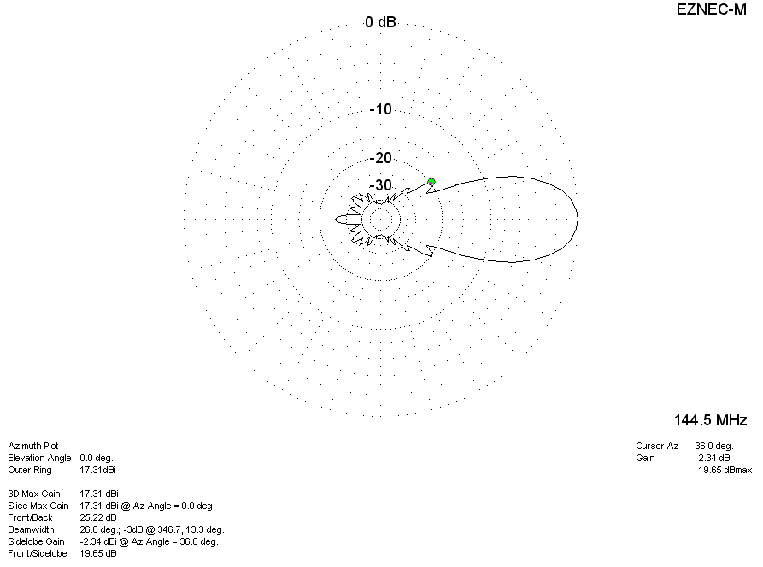
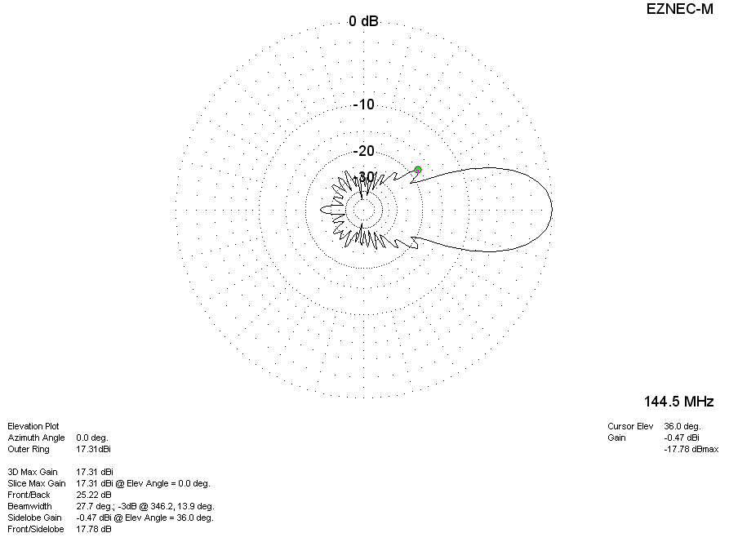

DIAGRAMS (losses included)
