ANTENNA Q214E1XL
PERFORMANCES: (No loss condition)
TYPE | ELE | L (mm) | G (dBi) | F/B (dB) | F/Sh (dBi) | F/Sv (dBi) | Hor (◦) | Ver (◦) | Temp (◦K) | G/T (dB) | ΔF * (kHz)
Q214E1XL | 14 | 9185 | 16,83 | 30,80 | 19,92 | 18,08 | 28,8 | 29,9 | 219,9 | -6,59 | 2120
* ΔF given for SWR=1,5

PERFORMANCES: (Losses included)
Element material | G (dBi) | Temp (◦K) | G/T (dB)
Aluminum rods | 16,73 | 222,0 | -6,74

DIMENSIONS:
 | Ref | De | D1 | D2 | D3 | D4 | D5 | D6 | D7 | D8 | D9 | D10 | D11 | D12
Pos | 0 | 393 | 580 | 955 | 1359 | 1996 | 2835 | 2659 | 4595 | 5509 | 6935 | 7389 | 8260 | 9185
Length | 720 | 668 | 646 | 618 | 604 | 596 | 588 | 572 | 564 | 552 | 542 | 532 | 520 | 510

REMARKS: : - All elements made of Al rods Ǿ5 mm
- The height of all rectangles is 400 mm
- All dimensions given in milimetres

COMPARISON
Antenna | Boomlength (mm) | Material | Gain (dBi) | TA (◦K) | G/T (dB) | Bandwidth  (MHz)
Q214E1XL | 9185 | No loss | 16,83 | 219,9 | -6,59 | 143,430-145,550
Q214E1XL | 9185 | Aluminum | 16,73 | 222,0 | -6,74 | 143,430-145,550
EF0214-5 | 9100 | No loss | 16,81 | 220,7 | -6,63 | 143,720-144,620
EF0214-5 | 9100 | Aluminum | 16,67 | 223,3 | -6,82 | 143,720-144,620

DIAGRAMS (no losses included)
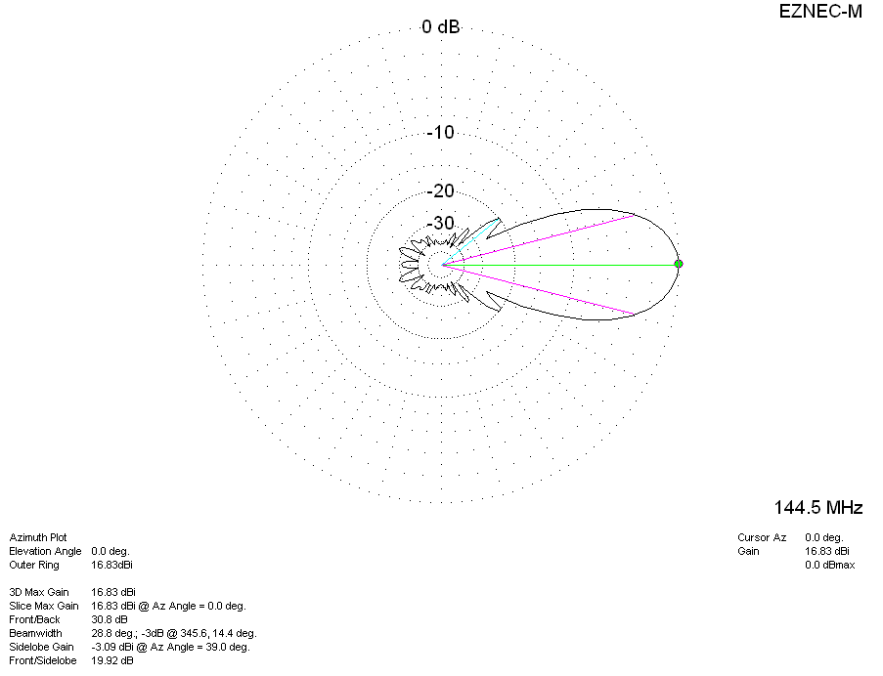
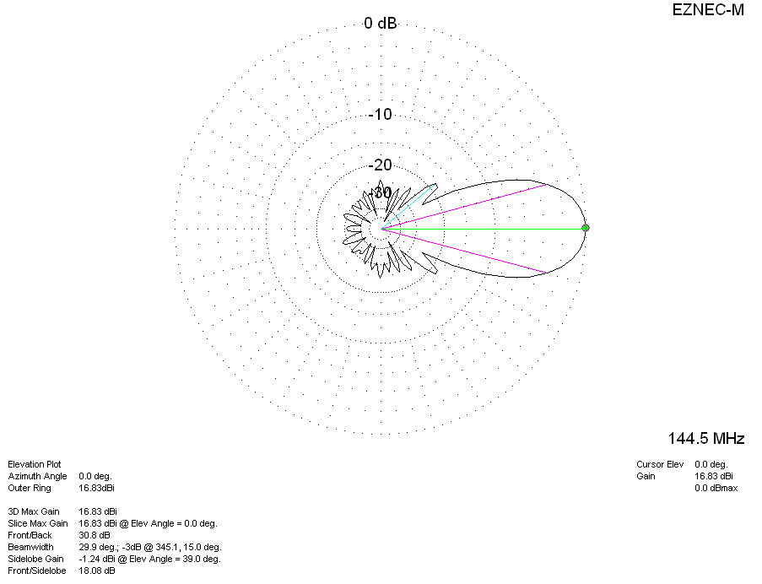
DIAGRAMS (losses included)
