ANTENNA Q214D2XL
PERFORMANCES: (No loss condition)
TYPE | ELE | L (mm) | G (dBi) | F/B (dB) | F/Sh (dBi) | F/Sv (dBi) | Hor (◦) | Ver (◦) | Temp (◦K) | G/T (dB) | ΔF * (kHz)
Q214D2XL | 14 | 9135 | 16,92 | 24,40 | 20,13 | 18,30 | 28,0 | 29,3 | 221,4 | -6,53 | 2300
* ΔF given for SWR=1,5

PERFORMANCES: (Losses included)
Element material | G (dBi) | Temp (◦K) | G/T (dB)
Aluminum rods | 16,80 | 223,6 | -6,69

COMPARISON
Antenna | Boomlength (mm) | Material | Gain (dBi) | TA (◦K) | G/T (dB) | Bandwidth (MHz)
Q214D2XL | 9135 | No loss | 16,92 | 221,4 | -6,53 | 143,400-145,700
Q214D2XL | 9135 | Aluminum | 16,80 | 223,6 | -6,69 | 143,400-145,700
EF0215-5 | 9100 | No loss | 16,81 | 220,7 | -6,63 | 143,720-144,620
EF0215-5 | 9100 | Aluminum | 16,67 | 223,3 | -6,82 | 143,720-144,620

DIMENSIONS:
 | Ref | De | D1 | D2 | D3 | D4 | D5 | D6 | D7 | D8 | D9 | D10 | D11 | D12
Pos | 0 | 245 | 417 | 841 | 1485 | 2183 | 2982 | 3791 | 4670 | 5573 | 6464 | 7455 | 8295 | 9135
Length | 786 | 739 | 718 | 698 | 678 | 658 | 642 | 632 | 618 | 608 | 602 | 596 | 592 | 588
REMARKS: : - All elements made of Al rods Ǿ5 mm
- The height of all rectangles is 320 mm
- All dimensions given in milimetres

DIAGRAMS (no losses included)
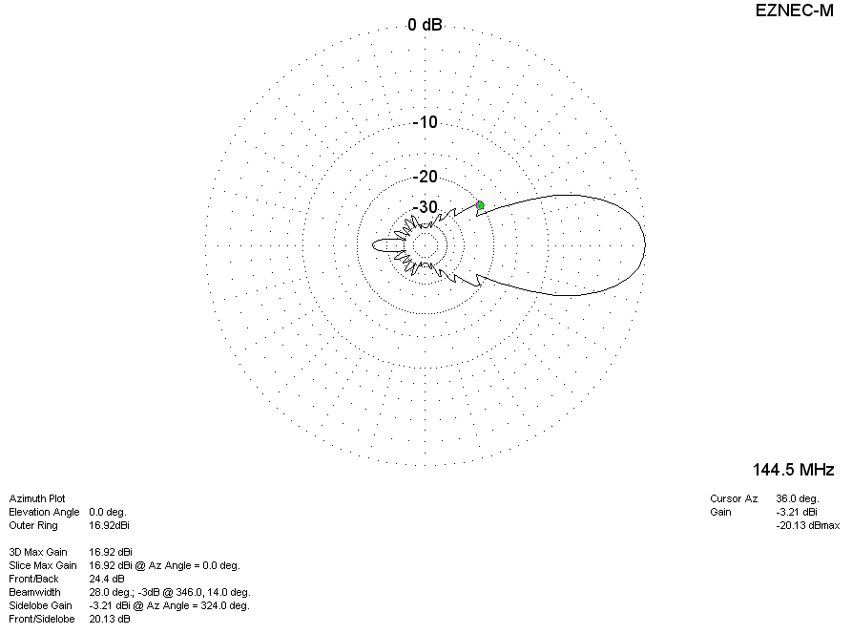
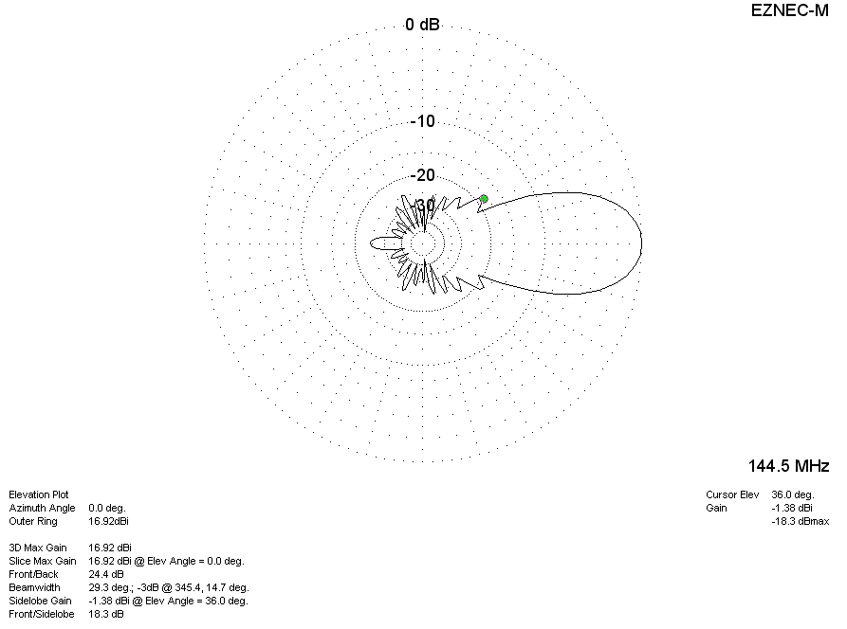

DIAGRAMS (losses included)
