ANTENNA Q213E3XL
PERFORMANCES: (No loss condition)
TYPE | ELE | L (mm) | G (dBi) | F/B (dB) | F/Sh (dBi) | F/Sv (dBi) | Hor (◦) | Ver (◦) | Temp (◦K) | G/T (dB) | ΔF * (kHz)
Q213E3XL | 14 | 9980 | 17,39 | 26,66 | 18,84 | 17,33 | 26,4 | 27,3 | 220,2 | -6,04 | 1,200
* ΔF given for SWR=1,5

PERFORMANCES: (Losses included)
Element material | G (dBi) | Temp (◦K) | G/T (dB)
Aluminum rods | 17,23 | 223,1 | -6,25

COMPARISON
Antenna | Boomlength (mm) | Material | Gain (dBi) | TA (◦K) | G/T (dB) | Bandwith (MHz)
Q213E3XL | 9980 | No loss | 17,39 | 220,2 | -6,04 | 143,800-145,000
Q213E3XL | 9980 | Aluminum | 17,23 | 223,1 | -6,25 | 143,800-145,000
EF0215-5 | 10060 | No loss | 17,26 | 223,0 | -6,22 | 143,750-144,460
EF0215-5 | 10060 | Aluminum | 17,06 | 226,7 | -6,49 | 143,750-144,460

DIMENSIONS:
 | Ref | De | D1 | D2 | D3 | D4 | D5 | D6 | D7 | D8 | D9 | D10 | D11
Pos | 0 | 344 | 544 | 1125 | 1875 | 2705 | 3572 | 4499 | 5409 | 6325 | 7315 | 8212 | 9178
Length | 714 | 668 | 652 | 625 | 608 | 591 | 581 | 572 | 562 | 548 | 542 | 536 | 530

REMARKS: : - All elements made of Al rods Ǿ5 mm
- The height of all rectangles is 400 mm
- All dimensions given in milimetres

DIAGRAMS (no losses included)
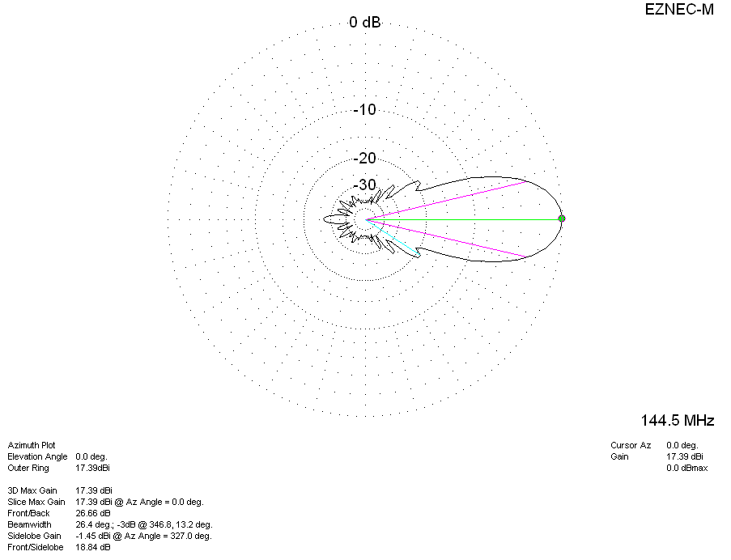
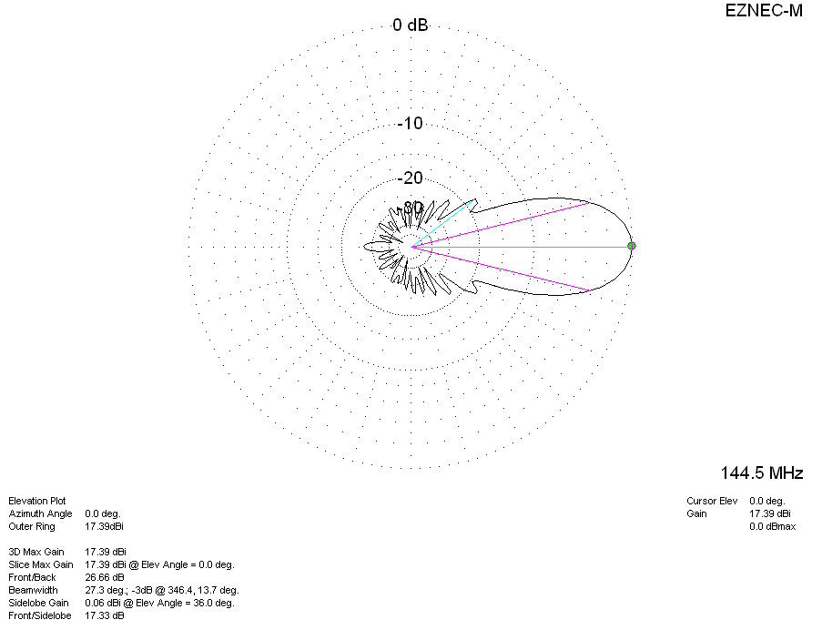

DIAGRAMS (losses included)
