ANTENNA Q213E2XL
PERFORMANCES: (No loss condition)
TYPE | ELE | L (mm) | G (dBi) | F/B (dB) | F/Sh (dBi) | F/Sv (dBi) | Hor (◦) | Ver (◦) | Temp (◦K) | G/T (dB) | ΔF * (kHz)
Q213E2XL | 13 | 9045 | 17,05 | 23,87 | 20,44 | 19,12 | 28,8 | 29,6 | 221,9 | -6,41 | 1310
* ΔF given for SWR=1,5

PERFORMANCES: (Losses included)
Element material | G (dBi) | Temp (◦K) | G/T (dB)
Aluminum rods | 16,90 | 224,6 | -6,61

COMPARISON
Antenna | Boomlength (mm) | Material | Gain (dBi) | TA (◦K) | G/T (dB) | Bandwith (MHz)
Q213E2XL | 9045 | No loss | 17,05 | 221,9 | -6,41 | 143,720-145,030
Q213E2XL | 9045 | Aluminum | 16,90 | 224,6 | -6,61 | 143,720-145,030
EF0214-5 | 9100 | No loss | 16,81 | 220,7 | -6,62 | 143,720-144,620
EF0214-5 | 9100 | Aluminum | 16,67 | 223,3 | -6,82 | 143,720-144,620

DIMENSIONS:
 | Ref | De | D1 | D2 | D3 | D4 | D5 | D6 | D7 | D8 | D9 | D10 | D11
Pos | 0 | 338 | 545 | 1118 | 1878 | 2699 | 3569 | 4495 | 5409 | 6321 | 7305 | 8205 | 9045
Length | 716 | 668 | 652 | 625 | 607 | 590 | 580 | 570 | 558 | 546 | 540 | 536 | 530

REMARKS: : - All elements made of Al rods Ǿ5 mm
- The height of all rectangles is 400 mm
- All dimensions given in milimetres

DIAGRAMS (no losses included)
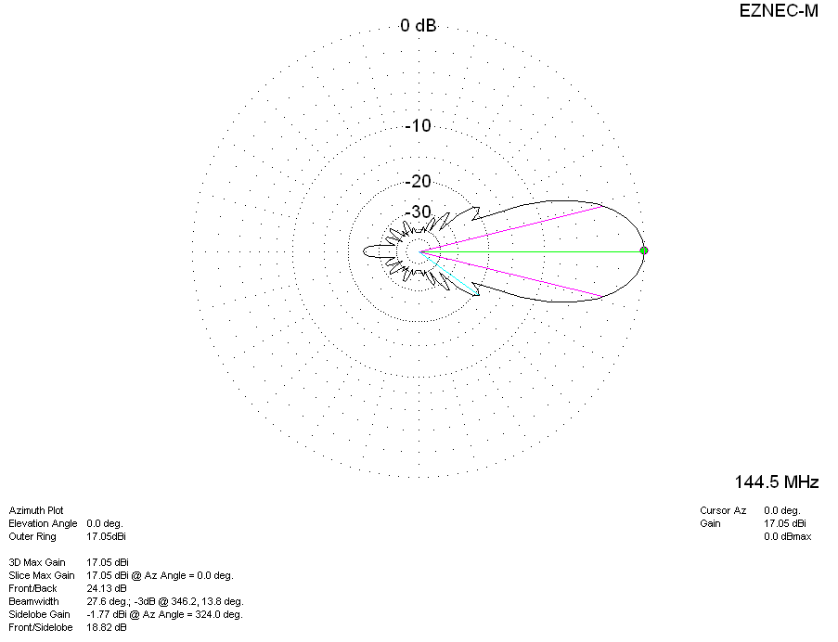
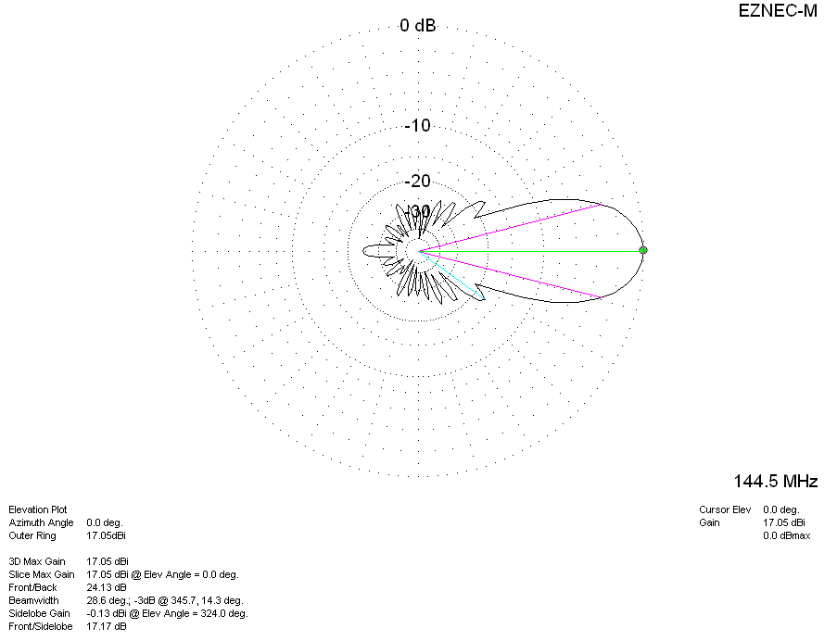
DIAGRAMS (losses included)
