PERFORMANCES: (No loss condition)
TYPE | ELE | L (mm) | G (dBi) | F/B (dB) | F/Sh (dBi) | F/Sv (dBi) | Hor (◦) | Ver (◦) | Temp (◦K) | G/T (dB) | ΔF * (kHz)
Q213XLD3 | 14 | 8165 | 16,49 | 27,89 | 19,43 | 17,42 | 30,0 | 31,0 | 221,5 | -6,96 | 2310
* ΔF given for SWR=1,5

PERFORMANCES: (Losses included)
Element material | G (dBi) | Temp (◦K) | G/T (dB)
Aluminum rods | 16,38 | 223,5 | -7,11

DIMENSIONS:
 | Ref | De | D1 | D2 | D3 | D4 | D5 | D6 | D7 | D8 | D9 | D10 | D11
Pos | 0 | 390 | 574 | 955 | 1359 | 1998 | 2839 | 3699 | 4574 | 5499 | 6429 | 7374 | 8165
Length | 717 | 670 | 646 | 614 | 606 | 596 | 586 | 572 | 564 | 552 | 542 | 530 | 520

REMARKS: : - All elements made of Al rods Ǿ5 mm
- The height of all rectangles is 400 mm
- All dimensions given in milimetres

COMPARISON
Antenna | Boomlength (mm) | Material | Gain (dBi) | TA (◦K) | G/T (dB) | Bandwidth  (MHz)
Q213XLD3 | 8165 | No loss | 16,49 | 221,5 | -6,96 | 143,390-145,700
Q213XLD3 | 8165 | Aluminum | 16,38 | 223,5 | -7,11 | 143,390-145,700
EF0213-5 | 8150 | No loss | 16,40 | 224,8 | -7,12 | 143,660-144,620
EF0213-5 | 8150 | Aluminum | 16,25 | 227,6 | -7,32 | 143,660-144,620

DIAGRAMS (no loss included)
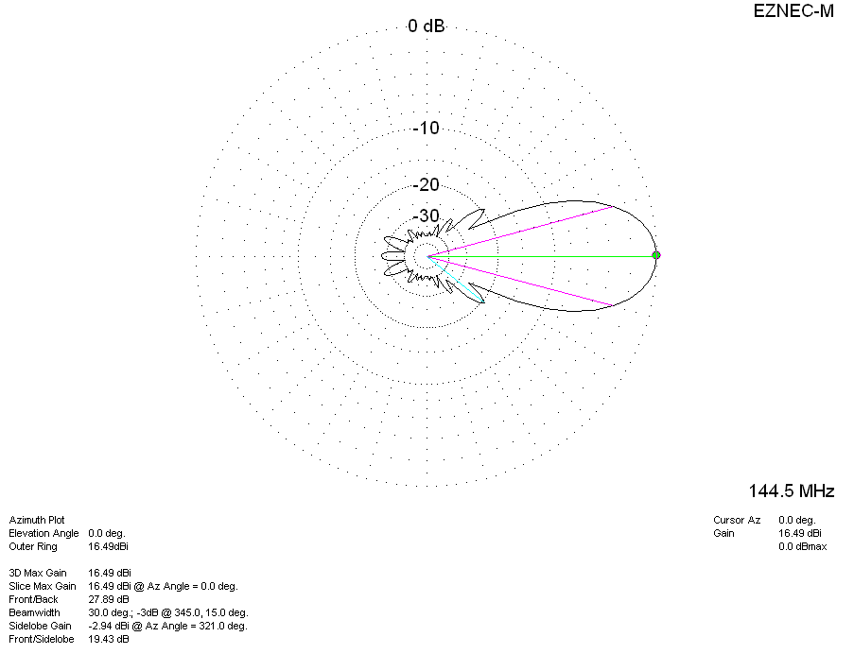
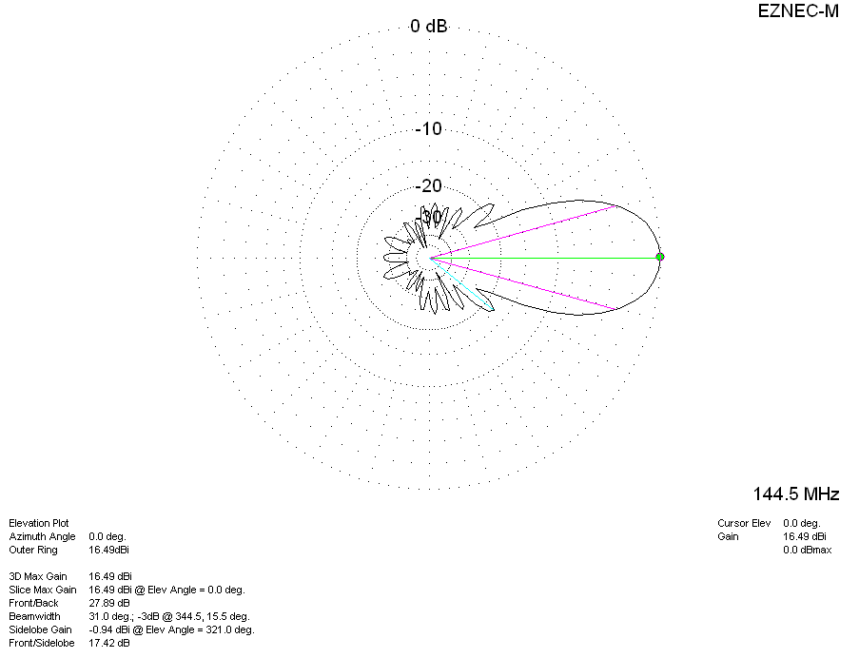
DIAGRAMS (losses included)
