ANTENNA Q213D5XL
PERFORMANCES: (No loss condition)
TYPE | ELE | L (mm) | G (dBi) | F/B (dB) | F/Sh (dBi) | F/Sv (dBi) | Hor (◦) | Ver (◦) | Temp (◦K) | G/T (dB) | ΔF * (kHz)
Q213D5XL | 13 | 8185 | 16,53 | 23,59 | 20,39 | 18,22 | 29,2 | 30,6 | 222,8 | -6,95 | 2420
* ΔF given for SWR=1,5

PERFORMANCES: (Losses included)
Element material | G (dBi) | Temp (◦K) | G/T (dB)
Aluminum rods | 16,41 | 224,9 | -7,11

DIMENSIONS:
 | Ref | De | D1 | D2 | D3 | D4 | D5 | D6 | D7 | D8 | D9 | D10 | D11
Pos | 0 | 242 | 422 | 841 | 1485 | 2183 | 2982 | 3791 | 4682 | 5573 | 6454 | 7415 | 8185
Length | 784 | 740 | 718 | 698 | 678 | 658 | 642 | 632 | 618 | 608 | 602 | 596 | 592

REMARKS : - All elements made of Al rods Ǿ5 mm
- The height of all rectangles is 320 mm
- All dimensions given in milimetres

COMPARISON
Antenna | Boomlength (mm) | Material | Gain (dBi) | TA (◦K) | G/T (dB) | Bandwidth  (MHz)
Q213D5XL | 8185 | No loss | 16,53 | 222,8 | -6,95 | 143,300-145,720
Q213D5XL | 8185 | Aluminum | 16,41 | 224,9 | -7,11 | 143,300-145,720
EF0213-5 | 8150 | No loss | 16,40 | 224,8 | -7,12 | 143,660-144,620
EF0213-5 | 8150 | Aluminum | 16,25 | 227,6 | -7,32 | 143,660-144,620

DIAGRAMS (no loss included)
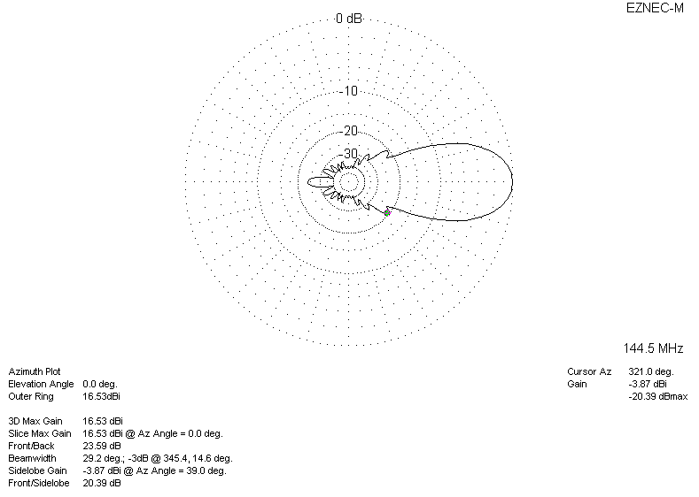
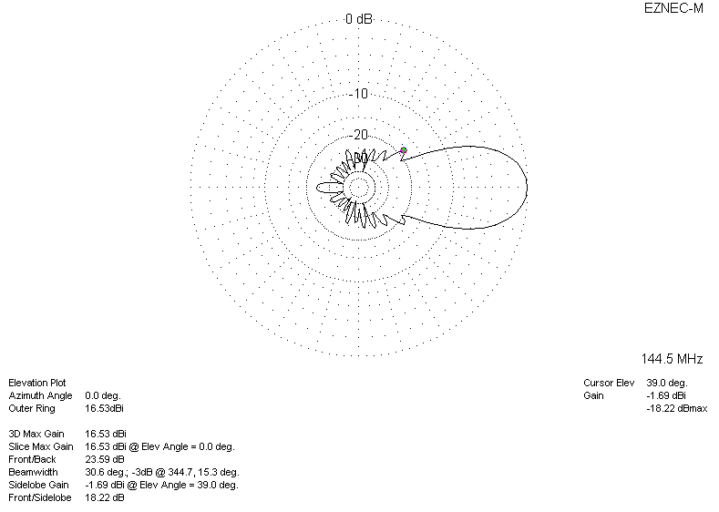
DIAGRAMS (losses included)
