ANTENNA Q213D3XL
PERFORMANCES: (No loss condition)
TYPE | ELE | L (mm) | G (dBi) | F/B (dB) | F/Sh (dBi) | F/Sv (dBi) | Hor (◦) | Ver (◦) | Temp (◦K) | G/T (dB) | ΔF * (kHz)
Q213D3XL | 14 | 8145 | 16,49 | 24,22 | 20,23 | 18,05 | 29,4 | 30,7 | 221,7 | -6,97 | 2650
* ΔF given for SWR=1,5

PERFORMANCES: (Losses included)
Element material | G (dBi) | Temp (◦K) | G/T (dB)
Aluminum rods | 16,38 | 223,7 | -7,12

COMPARISON
Antenna | Boomlength (mm) | Material | Gain (dBi) | TA (◦K) | G/T (dB) | Bandwidth (MHz)
Q213D3XL | 8145 | No loss | 16,49 | 221,7 | -6,97 | 143,200-145,850
Q213D3XL | 8145 | Aluminum | 16,38 | 223,7 | -7,12 | 143,200-145,850
EF0213-5 | 8150 | No loss | 16,40 | 224,8 | -7,12 | 143,660-144,620
EF0213-5 | 8150 | Aluminum | 16,25 | 227,6 | -7,32 | 143,660-144,620

DIMENSIONS:
 | Ref | De | D1 | D2 | D3 | D4 | D5 | D6 | D7 | D8 | D9 | D10 | D11
Pos | 0 | 260 | 438 | 845 | 1488 | 2183 | 2982 | 3781 | 4678 | 5563 | 6464 | 7395 | 8145
Length | 786 | 740 | 718 | 698 | 678 | 658 | 642 | 632 | 618 | 608 | 602 | 596 | 590
REMARKS : - All elements made of Al rods Ǿ5 mm
- The height of all rectangles is 320 mm
- All dimensions given in milimetres

DIAGRAMS (no losses included)
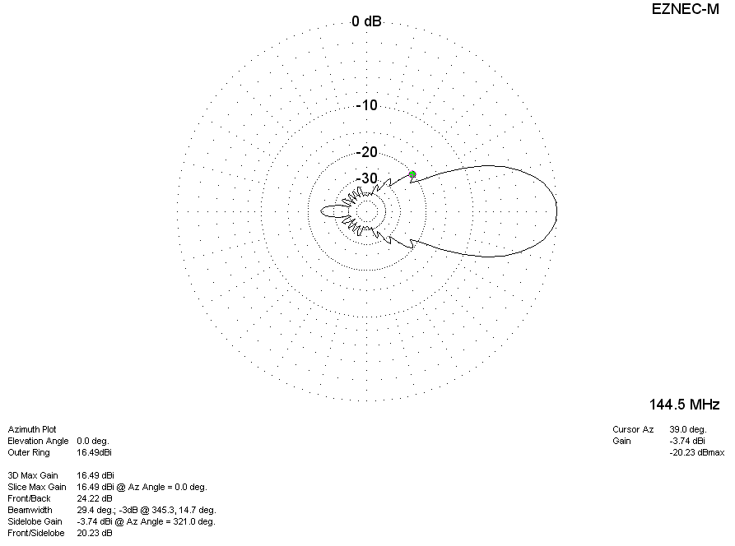
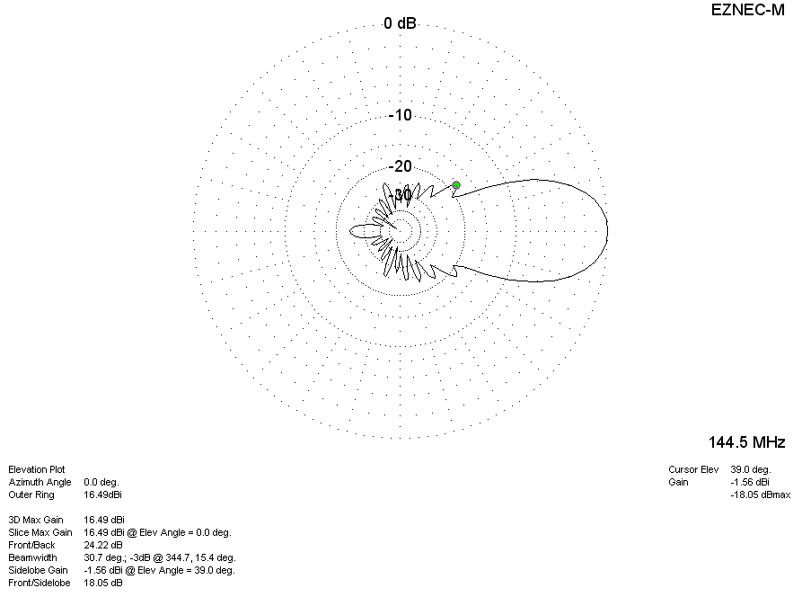

DIAGRAMS (losses included)
