ANTENNA Q213C4XL
PERFORMANCES: (No loss condition)
TYPE | ELE | L (mm) | G (dBi) | F/B (dB) | F/Sh (dBi) | F/Sv (dBi) | Hor (◦) | Ver (◦) | Temp (◦K) | G/T (dB) | ΔF * (kHz)
Q213C4XL | 13 | 8105 | 16,45 | 31,83 | 20,49 | 18,29 | 29,6 | 30,9 | 222,3 | -7,02 | 2310
* ΔF given for SWR=1,5

PERFORMANCES: (Losses included)
Element material | G (dBi) | Temp (◦K) | G/T (dB)
Aluminum rods | 16,36 | 223,9 | -7,14

DIMENSIONS:
 | Ref | De | D1 | D2 | D3 | D4 | D5 | D6 | D7 | D8 | D9 | D10 | D11
Pos | 0 | 263 | 440 | 845 | 1468 | 2183 | 2982 | 3781 | 4678 | 5563 | 6454 | 7366 | 8105
Length | 810 | 756 | 724 | 710 | 692 | 670 | 658 | 640 | 626 | 616 | 612 | 606 | 604

REMARKS: : - All elements made of Al rods Ǿ6 mm
- The height of all rectangles is 300 mm
- All dimensions given in milimetres

COMPARISON
Antenna | Boomlength (mm) | Material | Gain (dBi) | TA (◦K) | G/T (dB) | Bandwidth  (MHz)
Q213C4XL | 8105 | No loss | 16,45 | 222,3 | -7,02 | 143,100-146,43
Q213C4XL | 8105 | Aluminum | 16,36 | 223,9 | -7,14 | 143,100-146,43
EF0213-5 | 8150 | No loss | 16,40 | 224,8 | -7,12 | 143,660-144,620
EF0213-5 | 8150 | Aluminum | 16,25 | 227,6 | -7,32 | 143,660-144,620

DIAGRAMS (no loss included)
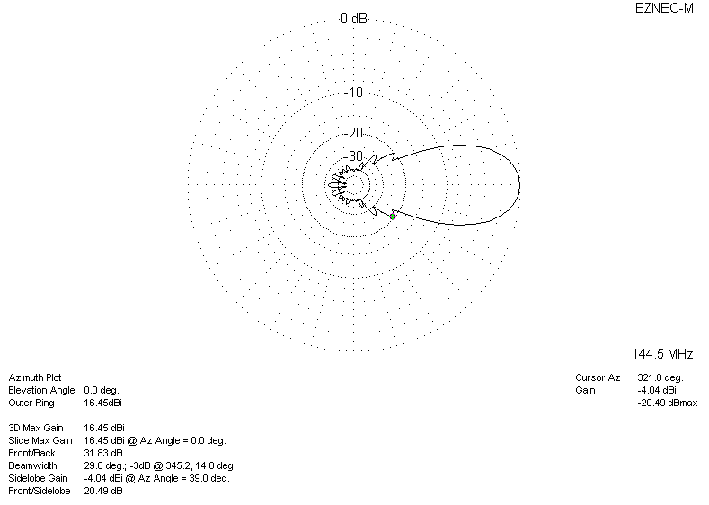
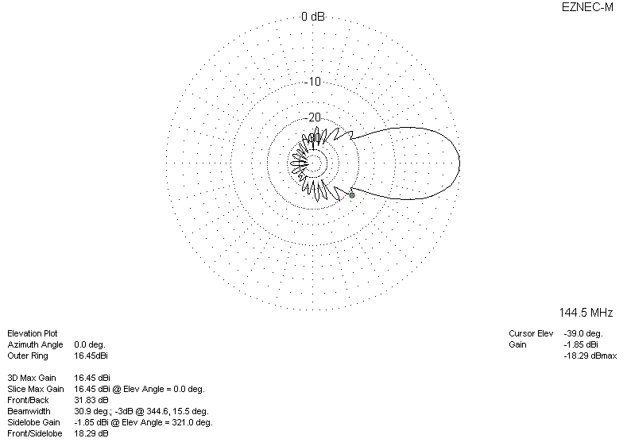
DIAGRAMS (losses included)
