ANTENNA Q213C3XL
PERFORMANCES: (No loss condition)
TYPE | ELE | L (mm) | G (dBi) | F/B (dB) | F/Sh (dBi) | F/Sv (dBi) | Hor (◦) | Ver (◦) | Temp (◦K) | G/T (dB) | ΔF * (kHz)
Q213C3XL | 13 | 8105 | 16,42 | 28,49 | 20,74 | 18,54 | 29,8 | 31,2 | 220,7 | -7,02 | 3310
* ΔF given for SWR=1,5

PERFORMANCES: (Losses included)
Element material | G (dBi) | Temp (◦K) | G/T (dB)
Aluminum rods | 16,32 | 222,6 | -7,16

DIMENSIONS:
 | Ref | De | D1 | D2 | D3 | D4 | D5 | D6 | D7 | D8 | D9 | D10 | D11
Pos | 0 | 263 | 434 | 845 | 1468 | 2183 | 2982 | 3781 | 4678 | 5563 | 6454 | 7366 | 8105
Length | 810 | 756 | 726 | 710 | 694 | 672 | 656 | 642 | 628 | 618 | 612 | 606 | 600

REMARKS: : - All elements made of Al rods Ǿ5 mm
- The height of all rectangles is 300 mm
- All dimensions given in milimetres

COMPARISON
Antenna | Boomlength (mm) | Material | Gain (dBi) | TA (◦K) | G/T (dB) | Bandwidth  (MHz)
Q213C3XL | 8105 | No loss | 16,42 | 220,7 | -7,02 | 143,190-146,500
Q213C3XL | 8105 | Aluminum | 16,32 | 222,6 | -7,16 | 143,190-146,500
EF0213-5 | 8150 | No loss | 16,40 | 224,8 | -7,12 | 143,660-144,620
EF0213-5 | 8150 | Aluminum | 16,25 | 227,6 | -7,32 | 143,660-144,620

DIAGRAMS (no loss included)
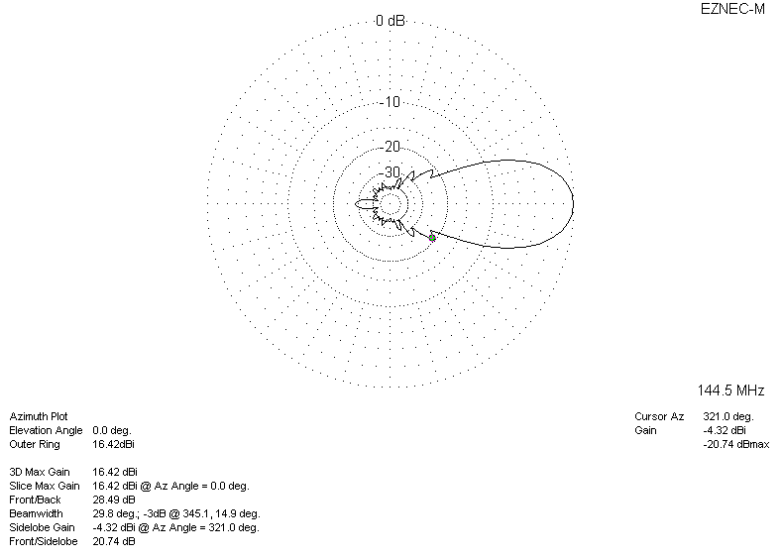
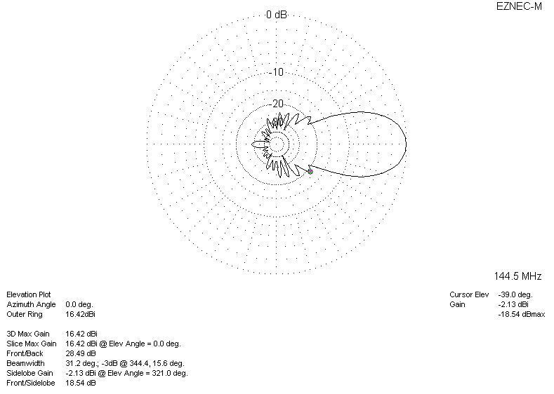
DIAGRAMS (losses included)
