ANTENNA Q212D5XL
PERFORMANCES: (No loss condition)
TYPE | ELE | L (mm) | G (dBi) | F/B (dB) | F/Sh (dBi) | F/Sv (dBi) | Hor (◦) | Ver (◦) | Temp (◦K) | G/T (dB) | ΔF * (kHz)
Q212D5XL | 12 | 7284 | 16,11 | 21,61 | 20,64 | 18,35 | 30,6 | 32,0 | 226,2 | -7,44 | 2330
* ΔF given for SWR=1,5

PERFORMANCES: (Losses included)
Element material | G (dBi) | Temp (◦K) | G/T (dB)
Aluminum rods | 15,99 | 228,1 | -7,59

DIMENSIONS:
 | Ref | De | D1 | D2 | D3 | D4 | D5 | D6 | D7 | D8 | D9 | D10
Pos | 0 | 246 | 426 | 845 | 1475 | 2193 | 2982 | 3791 | 4692 | 5563 | 6434 | 7284
Length | 786 | 738 | 716 | 698 | 678 | 656 | 640 | 630 | 616 | 608 | 602 | 598

REMARKS: : - All elements made of Al rods Ǿ5 mm
- The height of all rectangles is 320 mm
- All dimensions given in milimetres

COMPARISON
Antenna | Boomlength (mm) | Material | Gain (dBi) | TA (◦K) | G/T (dB) | Bandwidth  (MHz)
Q212D5XL | 7284 | No loss | 16,11 | 226,2 | -7,44 | 143,330-146,100
Q212D5XL | 7284 | Aluminum | 15,99 | 228,1 | -7,59 | 143,330-146,100
EF0212-5 | 7260 | No loss | 15,91 | 224,0 | -7,59 | 143,300-144,820
EF0212-5 | 7260 | Aluminum | 15,81 | 226,0 | -7,73 | 143,300-144,820

DIAGRAMS (no loss included)
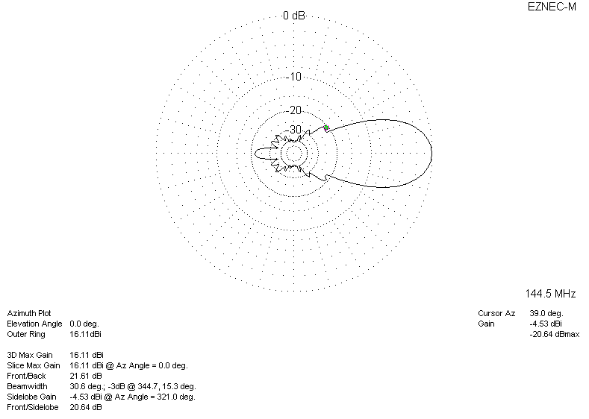
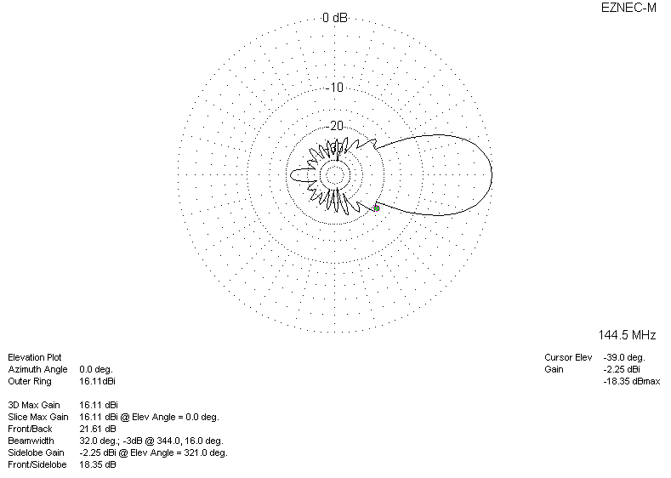
DIAGRAMS (loss included)

