ANTENNA Q2212D2XL
PERFORMANCES: (No loss condition)
TYPE | ELE | L (mm) | G (dBi) | F/B (dB) | F/Sh (dBi) | F/Sv (dBi) | Hor (◦) | Ver (◦) | Temp (◦K) | G/T (dB) | ΔF * (kHz)
Q212D2XL | 12 | 7225 | 15,98 | 22,85 | 21,42 | 18,75 | 31,4 | 32,9 | 220,0 | -7,44 | 2630
* ΔF given for SWR=1,5

PERFORMANCES: (Losses included)
Element material | G (dBi) | Temp (◦K) | G/T (dB)
Aluminum rods | 15,87 | 222,0 | -7,59

COMPARISON
Antenna | Boomlength (mm) | Material | Gain (dBi) | TA (◦K) | G/T (dB) | Bandwidth (MHz)
Q212D2XL | 7225 | No loss | 15,98 | 220,0 | -7,44 | 142,850-145,480
Q212D2XL | 7225 | Aluminum | 15,87 | 222,0 | -7,59 | 142,850-145,480
EF0212-5 | 7260 | No loss | 15,91 | 224,0 | -7,59 | 143,300-144,820
EF0212-5 | 7260 | Aluminum | 15,81 | 226,0 | -7,73 | 143,300-144,820

DIMENSIONS:
 | Ref | De | D1 | D2 | D3 | D4 | D5 | D6 | D7 | D8 | D9 | D10
Pos | 0 | 400 | 568 | 932 | 1385 | 2011 | 2808 | 3666 | 4532 | 5453 | 6355 | 7225
Length | 792 | 750 | 723 | 686 | 676 | 658 | 642 | 630 | 618 | 602 | 598 | 596

REMARKS: | - All elements made of Al rods Ǿ5 mm  - The height of all rectangles is 320 mm  - All dimensions given in milimetres

DIAGRAMS (no loss included)
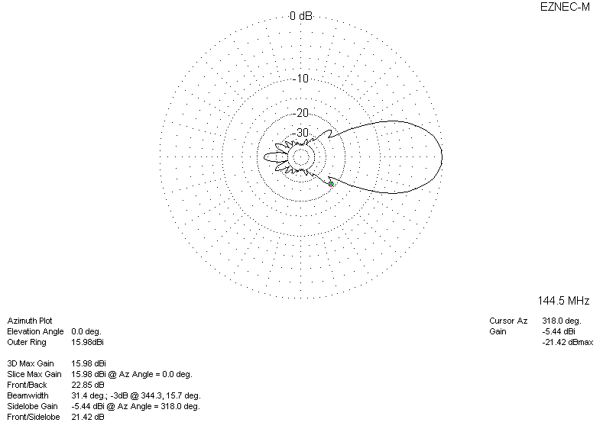
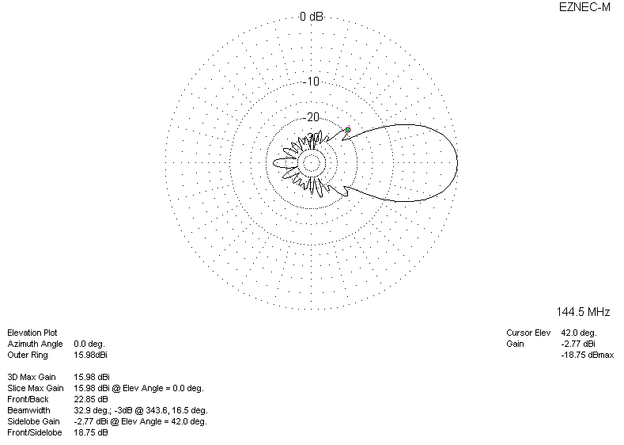

LOSSES INCLUDED
