ANTENNA Q211G2XL
PERFORMANCES: (No loss condition)
TYPE | ELE | L (mm) | G (dBi) | F/B (dB) | F/Sh (dBi) | F/Sv (dBi) | Hor (◦) | Ver (◦) | Temp (◦K) | G/T (dB) | ΔF * (kHz)
Q211G2XL | 11 | 7558 | 16,11 | 22,28 | 20,16 | 18,31 | 31,2 | 32,2 | 226,3 | -7,43 | 2880
* ΔF given for SWR=1,5

PERFORMANCES: (Losses included)
Element material | G (dBi) | Temp (◦K) | G/T (dB)
Aluminum rods | 15,99 | 228,2 | -7,59

DIMENSIONS:
 | Ref | De | D1 | D2 | D3 | D4 | D5 | D6 | D7 | D8 | D9
Pos | 0 | 438 | 769 | 1425 | 2179 | 3031 | 3973 | 4846 | 5800 | 6675 | 7558
Length | 628 | 586 | 562 | 543 | 525 | 503 | 494 | 486 | 478 | 470 | 462

REMARKS: : - All elements made of Al rods Ǿ5 mm
- The height of all rectangles is 500 mm
- All dimensions given in milimetres

COMPARISON
Antenna | Boomlength (mm) | Material | Gain (dBi) | TA (◦K) | G/T (dB) | Bandwidth  (MHz)
Q211G2XL | 7558 | No loss | 15,50 | 226,3 | -7,43 | 142,450-145,330
Q211G2XL | 7558 | Aluminum | 15,39 | 228,2 | -7,59 | 142,450-145,330
EF0212-5 | 7260 | No loss | 15,24 | 224,0 | -7,59 | 143,300-144,820
EF0212-5 | 7260 | Aluminum | 15,14 | 226,0 | -7,73 | 143,300-144,820

DIAGRAMS (no loss included)
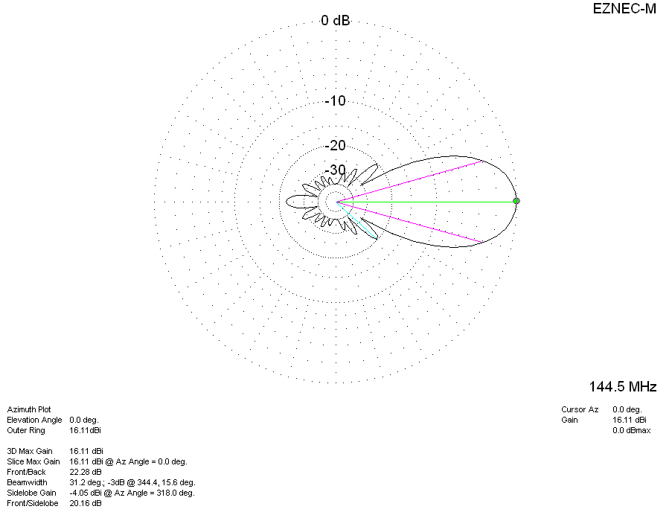
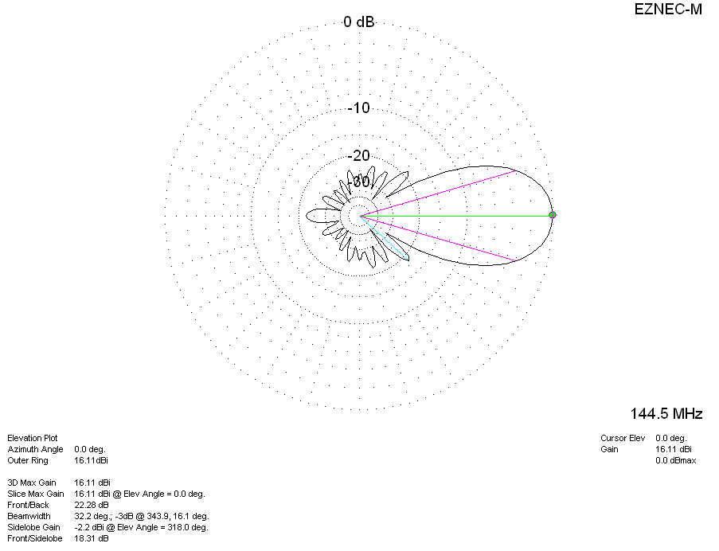

LOSSES INCLUDED
