ANTENNA Q211G1XL
PERFORMANCES: (No loss condition)
TYPE | ELE | L (mm) | G (dBi) | F/B (dB) | F/Sh (dBi) | F/Sv (dBi) | Hor (◦) | Ver (◦) | Temp (◦K) | G/T (dB) | ΔF * (kHz)
Q211G1XL | 11 | 7510 | 16,04 | 26,21 | 19,95 | 18,04 | 31,4 | 32,3 | 228,2 | -7,54 | 2530
* ΔF given for SWR=1,5

PERFORMANCES: (Losses included)
Element material | G (dBi) | Temp (◦K) | G/T (dB)
Aluminum rods | 15,87 | 231,3 | -7,77

COMPARISON
Antenna | Boomlength (mm) | Material | Gain (dBi) | TA (◦K) | G/T (dB) | Bandwidth  (MHz)
Q211G1XL | 7510 | No loss | 16,04 | 228,2 | -8,07 | 143,250-145,780
Q211G1XL | 7510 | Aluminum | 15,87 | 231,3 | -8,21 | 143,250-145,780
EF0211-5 | 6325 | No loss | 15,24 | 226,7 | -8,31 | 142,500-144,750
EF0211-5 | 6325 | Aluminum | 15,14 | 228,5 | -8,45 | 142,500-144,750
EF0212-5 | 7260 | No loss | 15,91 | 224,0 | -7,59 | 143,300-144,820
EF0212-5 | 7260 | Aluminum | 15,81 | 226,0 | -7,73 | 143,300-144,820

DIMENSIONS:
 | Ref | De | D1 | D2 | D3 | D4 | D5 | D6 | D7 | D8 | D9
Pos | 0 | 400 | 770 | 1374 | 2170 | 3015 | 3845 | 4787 | 5669 | 6579 | 7510
Length | 616 | 574 | 558 | 542 | 522 | 514 | 502 | 492 | 482 | 468 | 460

REMARKS: | - All elements made of Al rods Ǿ5 mm  - The height of all rectangles is 500 mm  - All dimensions given in milimetres

DIAGRAMS (no loss included)
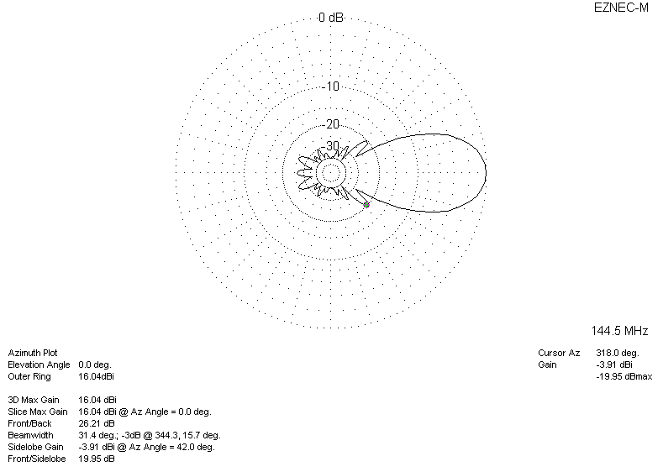
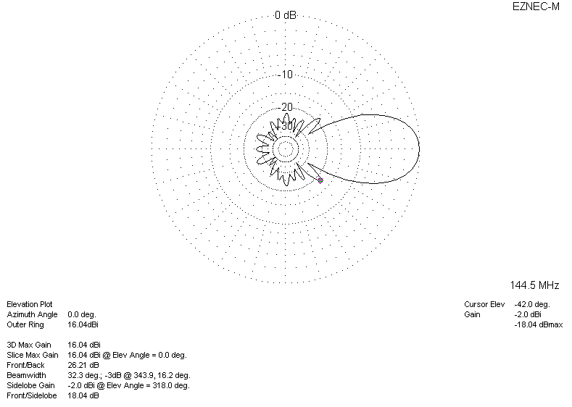

LOSSES INCLUDED
