ANTENNA Q211E1XL
PERFORMANCES: (No loss condition)
TYPE | ELE | L (mm) | G (dBi) | F/B (dB) | F/Sh (dBi) | F/Sv (dBi) | Hor (◦) | Ver (◦) | Temp (◦K) | G/T (dB) | ΔF * (kHz)
Q211E1XL | 11 | 7100 | 16,18 | 25,33 | 19,50 | 17,19 | 30,6 | 31,7 | 224,8 | -7,34 | 1620
* ΔF given for SWR=1,5

PERFORMANCES: (Losses included)
Element material | G (dBi) | Temp (◦K) | G/T (dB)
Aluminum rods | 16,05 | 227,1 | -7,51

COMPARISON
Antenna | Boomlength (mm) | Material | Gain (dBi) | TA (◦K) | G/T (dB) | Bandwidth (MHz)
Q211E1XL | 7100 | No loss | 16,18 | 224,8 | -7,34 | 143,600-145,220
Q211E1XL | 7100 | Aluminum | 16,05 | 227,1 | -7,51 | 143,600-145,220
EF0211-5 | 6325 | No loss | 15,24 | 226,7 | -8,31 | 142,500-144,750
EF0211-5 | 6325 | Aluminum | 15,14 | 228,5 | -8,45 | 142,500-144,750
EF0212-5 | 7260 | No loss | 15,91 | 224,0 | -7,59 | 143,300-144,820
EF0212-5 | 7260 | Aluminum | 15,81 | 226,0 | -7,73 | 143,300-144,820

DIMENSIONS:
 | Ref | De | D1 | D2 | D3 | D4 | D5 | D6 | D7 | D8 | D9 | - All elements made of Al rods Ǿ5 mm  - The height of all rectangles is 320 mm  - All dimensions given in milimetres
Pos | 0 | 335 | 551 | 1115 | 1876 | 2692 | 3566 | 4489 | 5405 | 6315 | 7100
Length | 712 | 668 | 652 | 624 | 606 | 588 | 576 | 562 | 556 | 548 | 544

DIAGRAMS (no loss included)
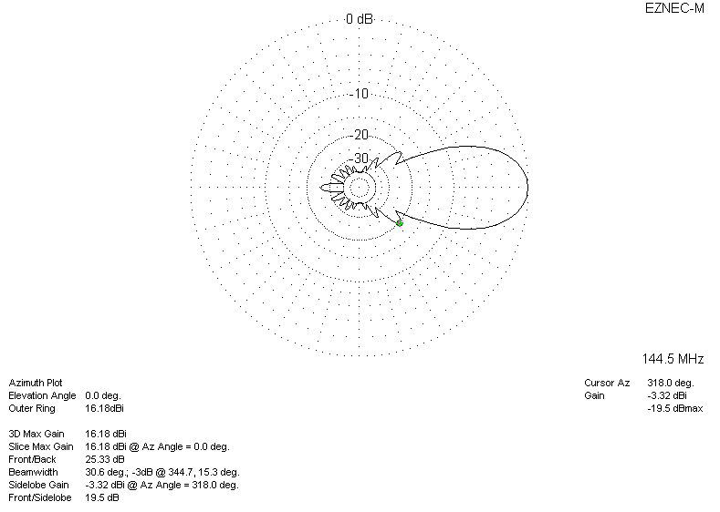
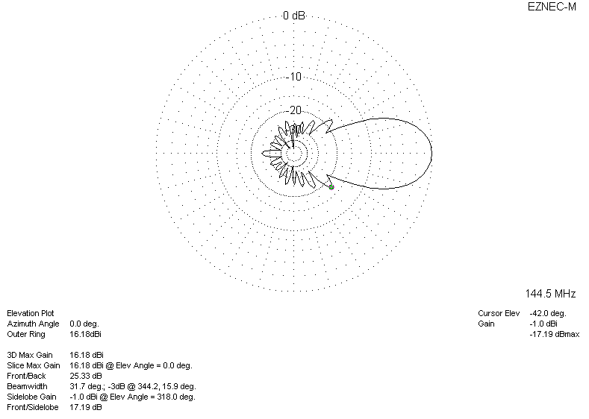

LOSSES INCLUDED
